**CLASS 1(Day 20):**

<https://demo.automationtesting.in/Register.html>

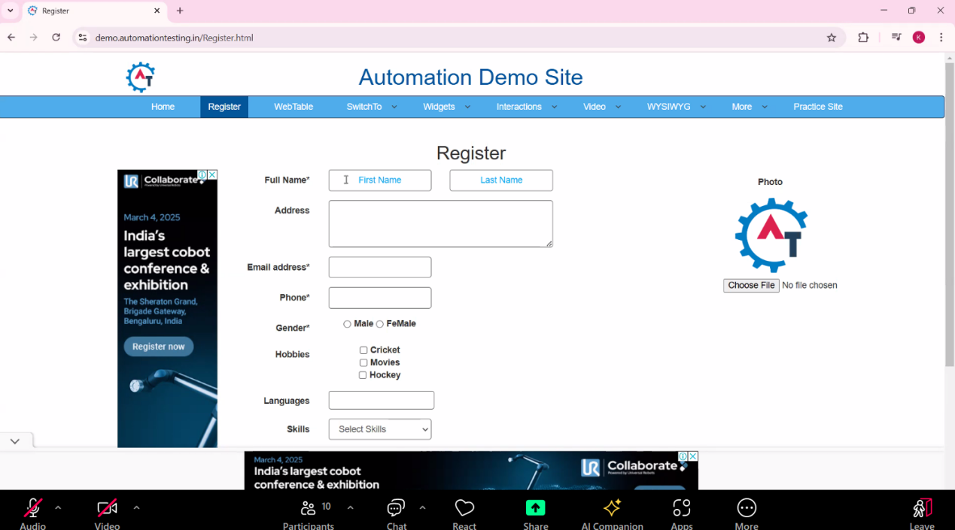

Selenium -> UI Automation tool - which does all types of web operations.

Example -> Human Eye => Xpath

Human Brain => Selenium

**Why Automation is needed?:**

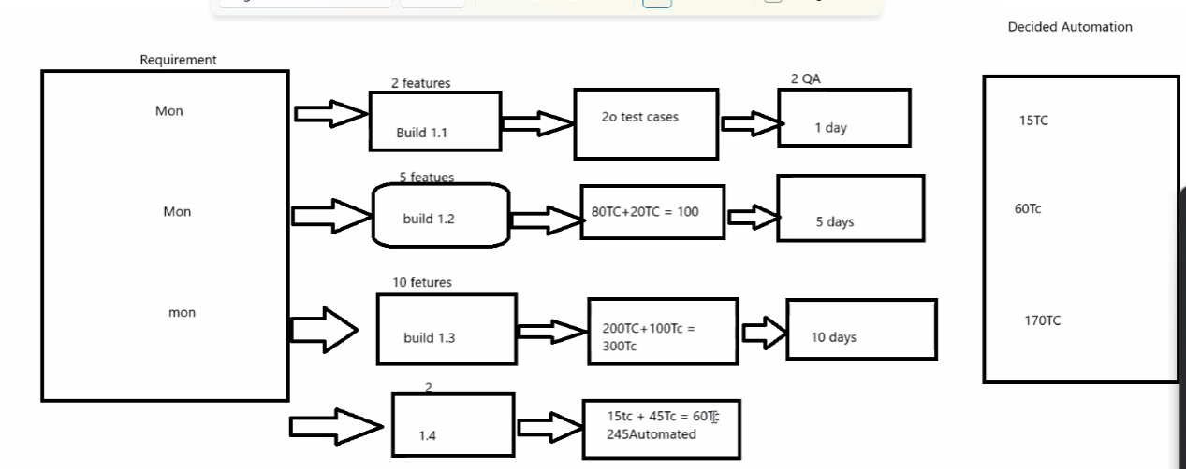

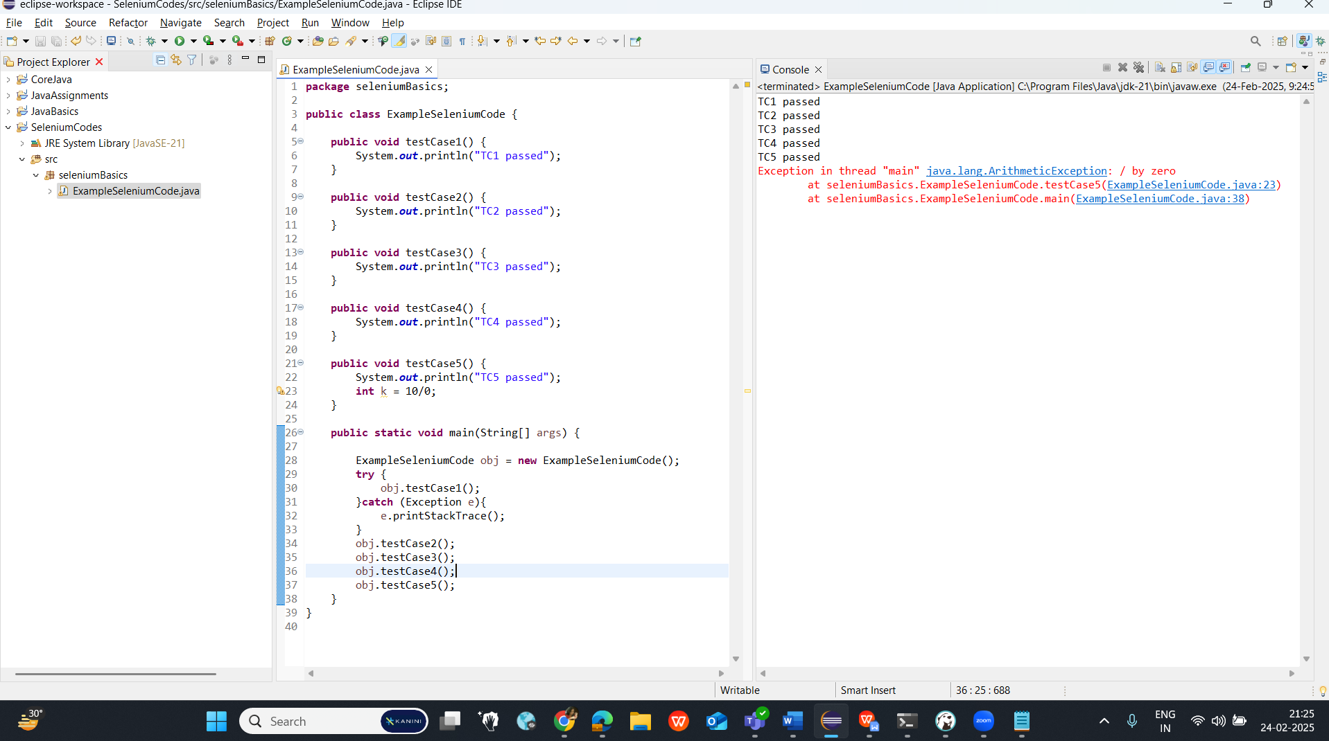

To overcome from the two challenges explained in the above code, we use TestNG tool -  
**Two challenges:**

1. If we get any failure / problematic code / exception at anyline, we cannot keep on scrolling down manually to reach to that particular line & On each object/method, we cannot keep on declaring try catch method in case of multiple TCs.
2. Read the logs in case of 100/1000 or more TCs.

**TestNG** -

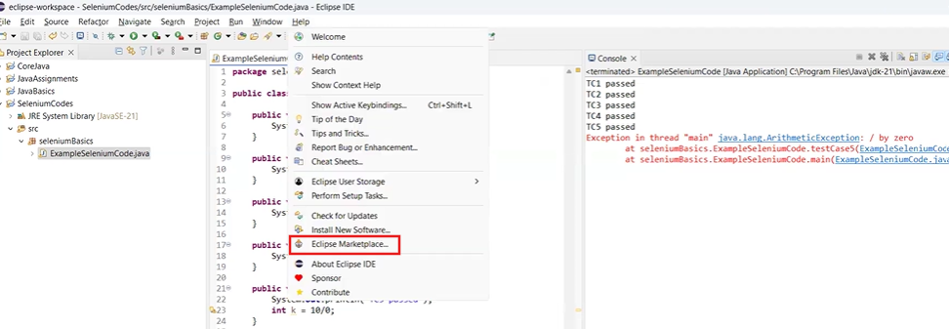

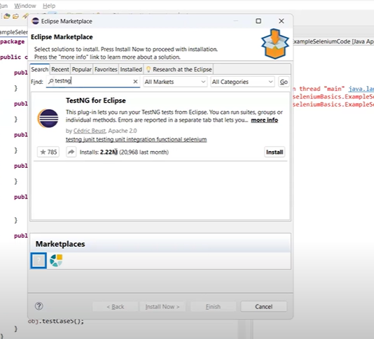

Click on Install.

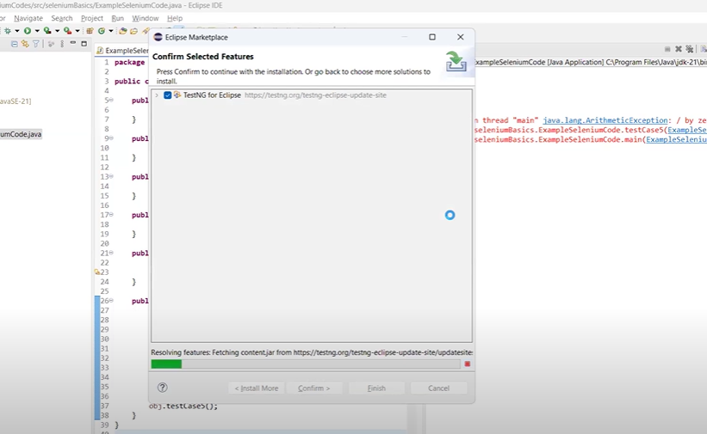

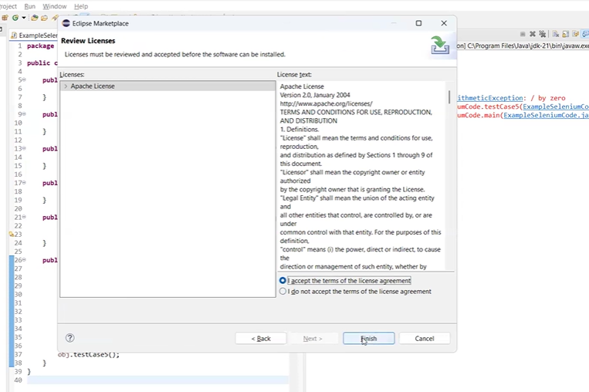

Repeat the following step twice -> Select all and >> Trust Selected.

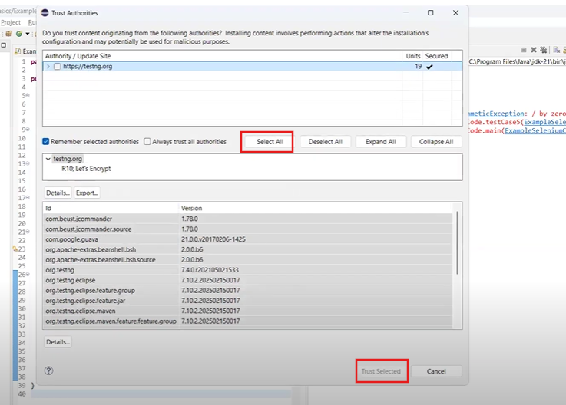

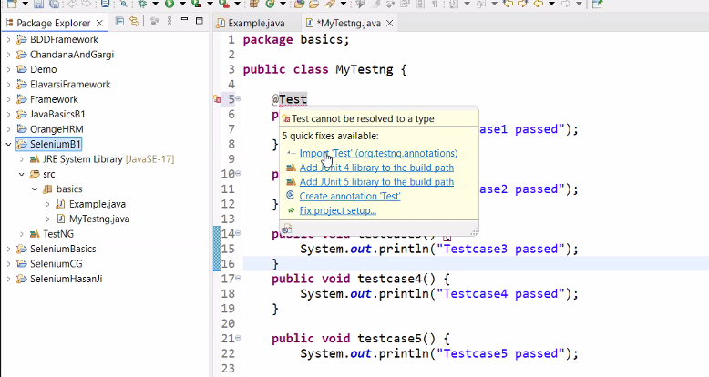

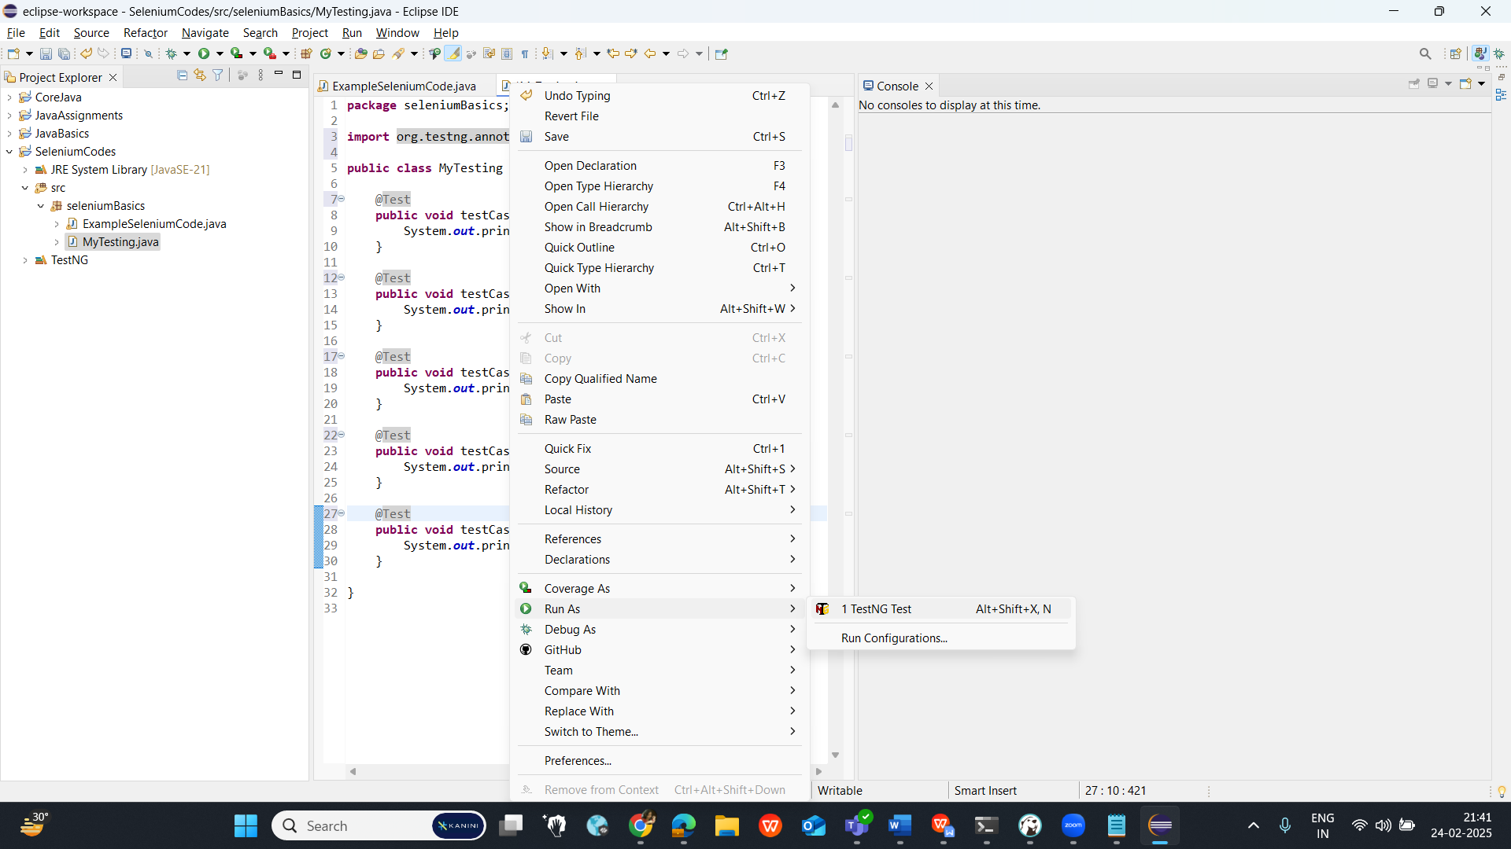

// Whenever we add @Test annotation to any method, that method will be executed in TestNG

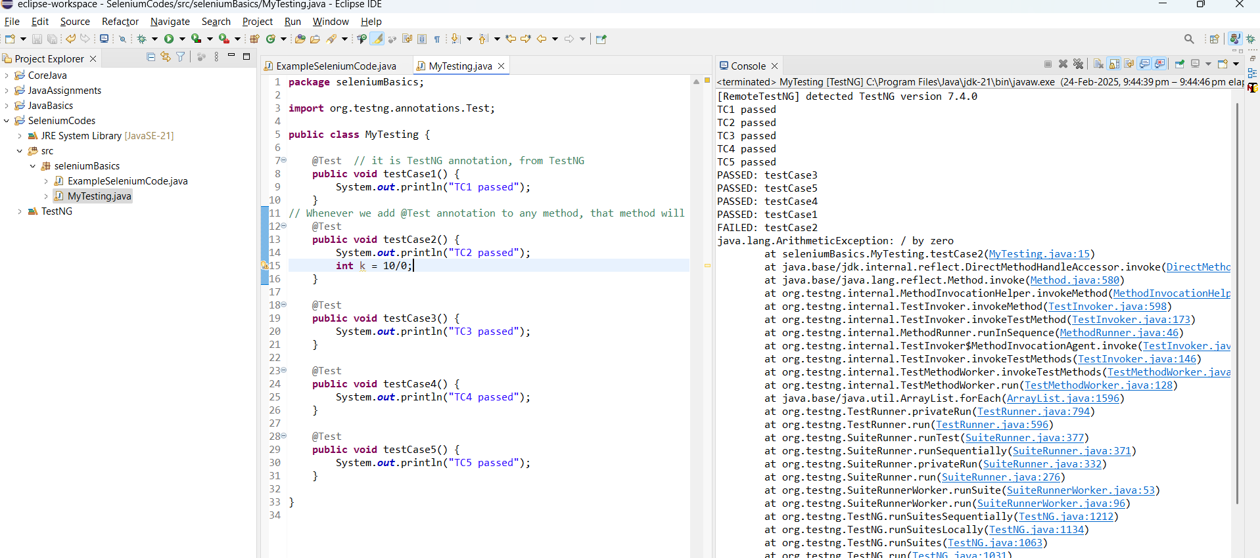

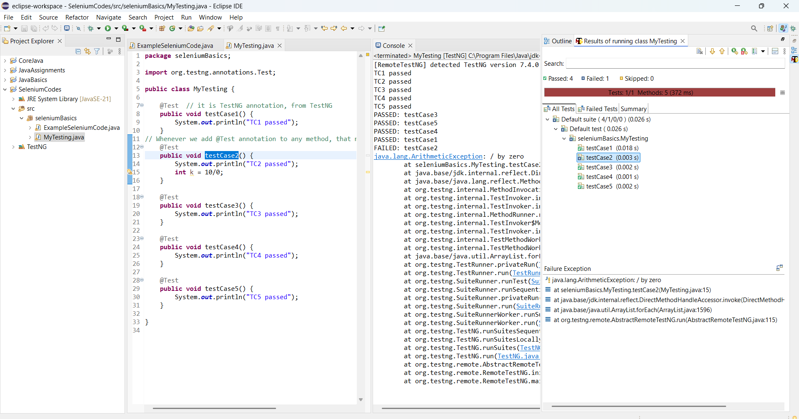

**TestNG Advantages:**

1. Creates the Report for - Passed, failed, skipped and logs for the failure TCs.

2. No Need of Main Method

3. It gives us proper infrastructure

**TestNG Competitors:**

Junit & Cucumber

**CLASS 2(Day 21):**

**DOM Structure:**  
The Document Object Model (DOM) I  
It’s a cross-platform and language-independent interface that treats an HTML or XML document as a tree structure wherein each node is an object representing a part of the document.

The DOM represents a document with a logical tree.

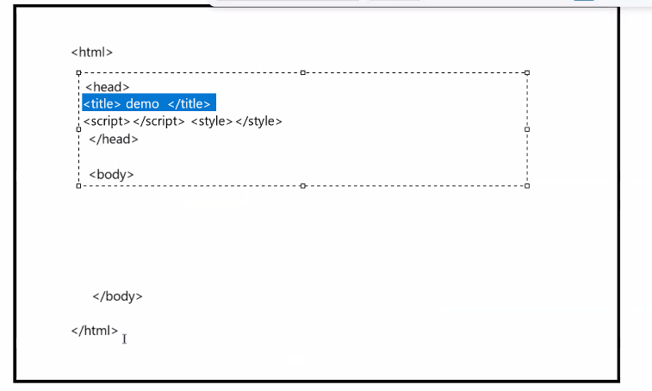

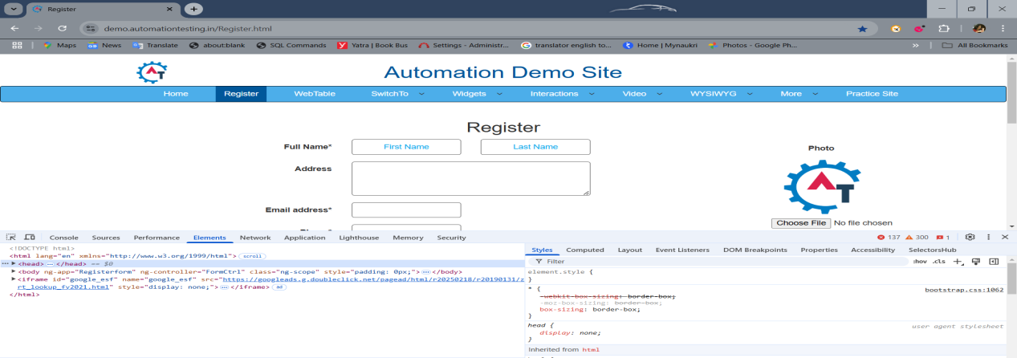

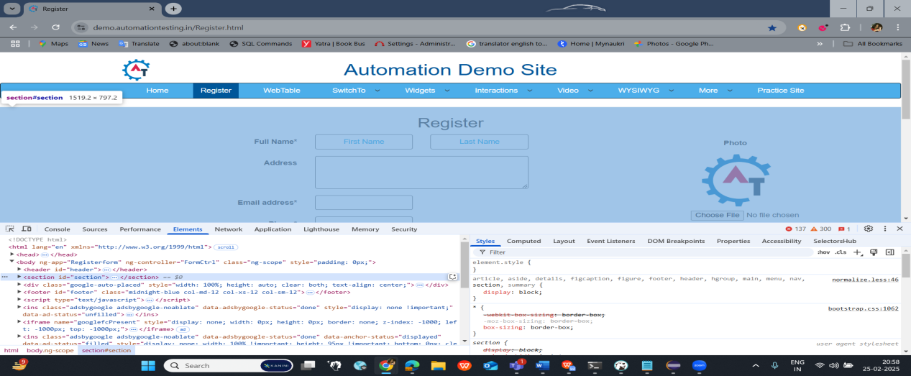

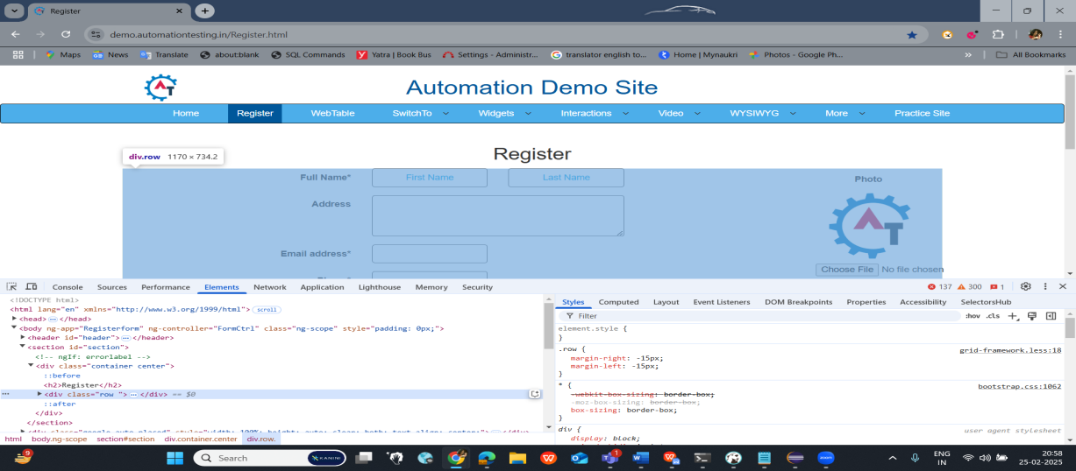  
  
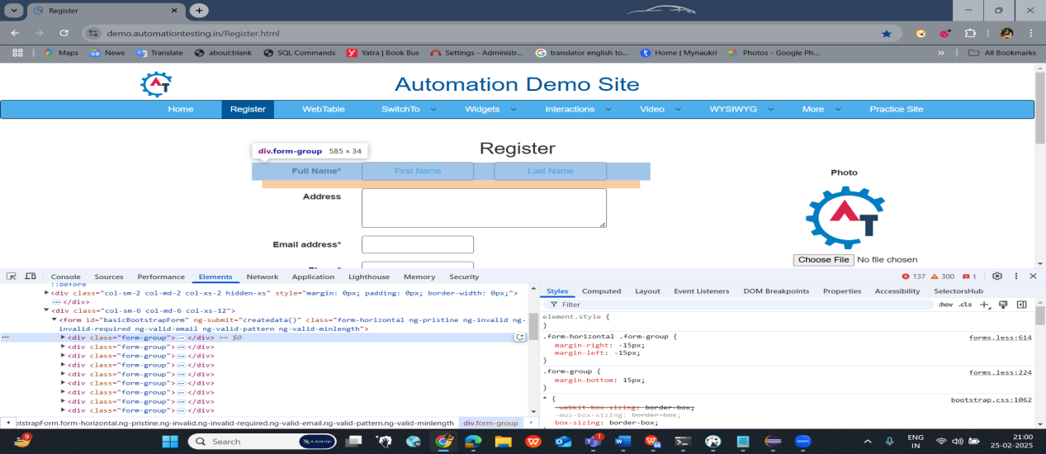

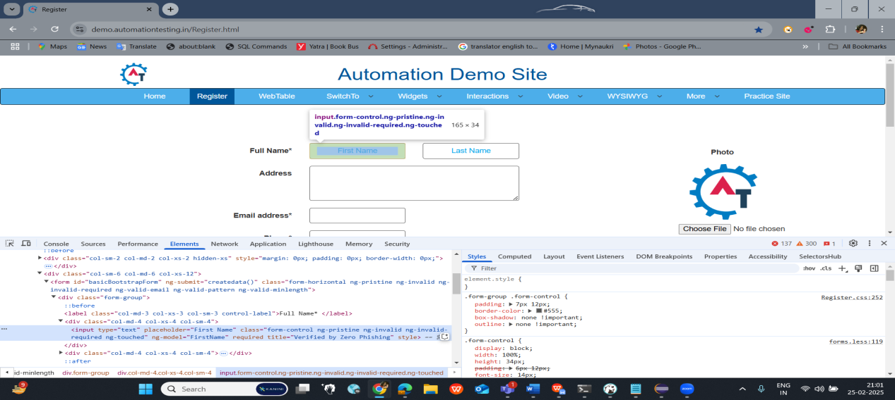

**XPATH   
  
Basic Xpath :**

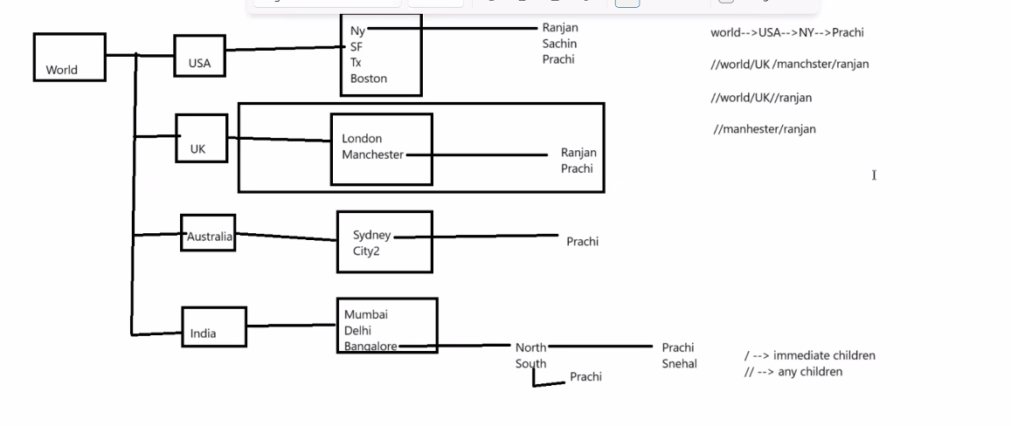

/ (single slash) => Immediate Childred

// (Double slash) => Any children

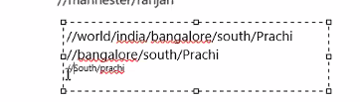

Incase of same name:

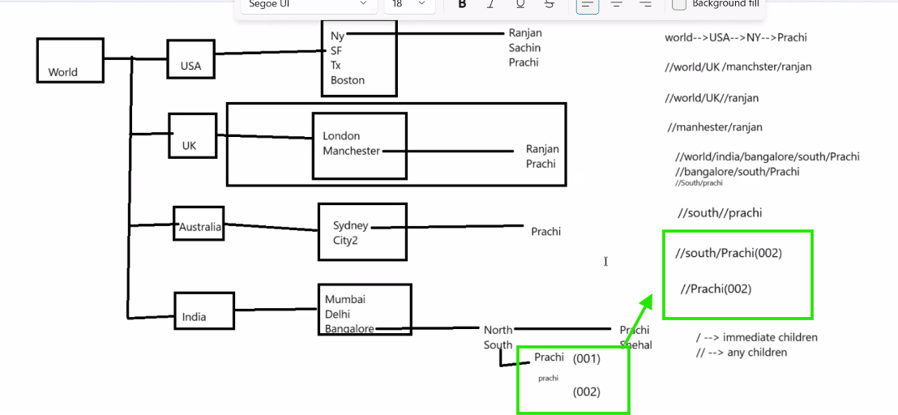

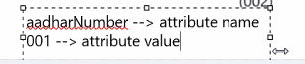   
  
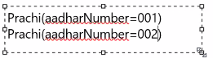

Xpath Syntax to get the unique path :  
  
**div[@attribute_Name='Attriute_Value']**

HTML File > Control+F  
  
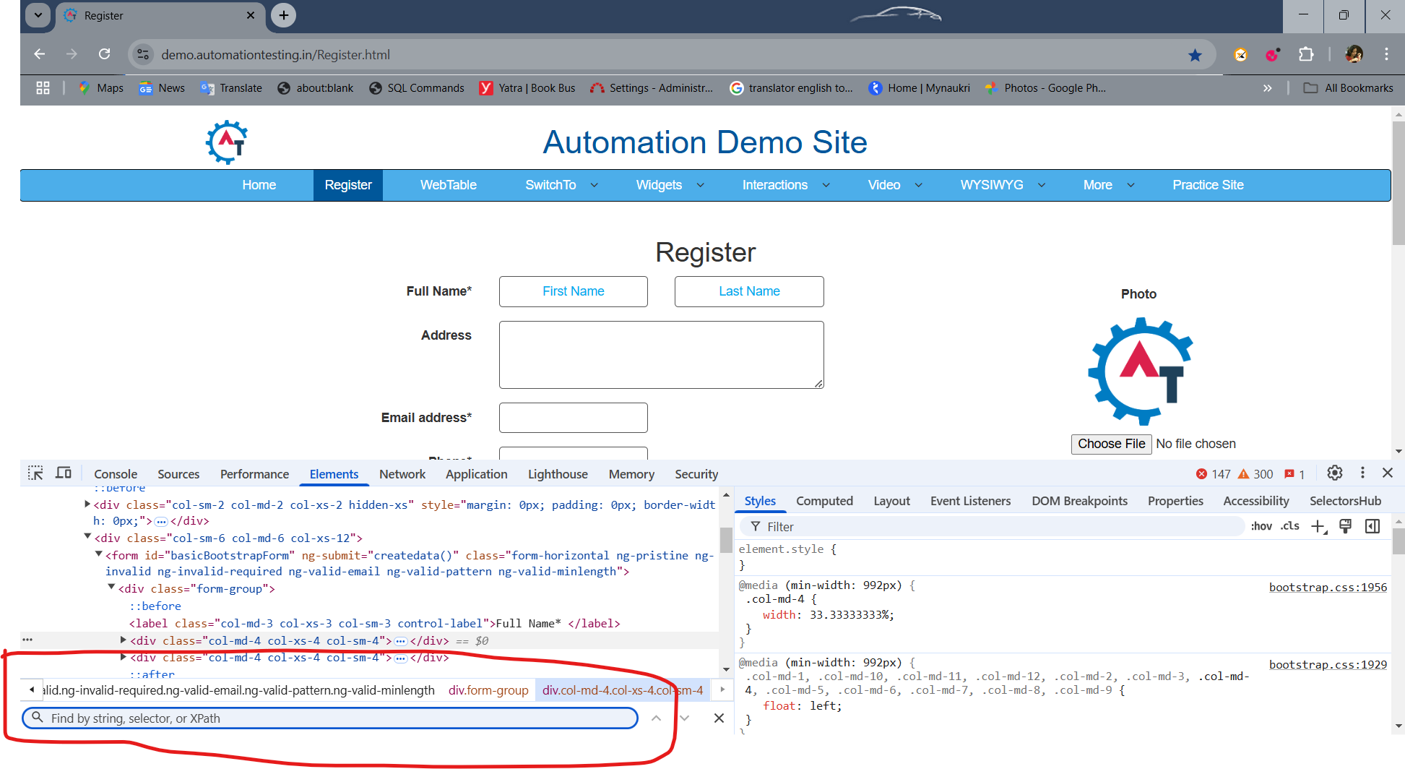

//html/body/section/div/div/div[@class='col-sm-6 col-md-6 col-xs-12']/form//input[@placeholder='First Name']

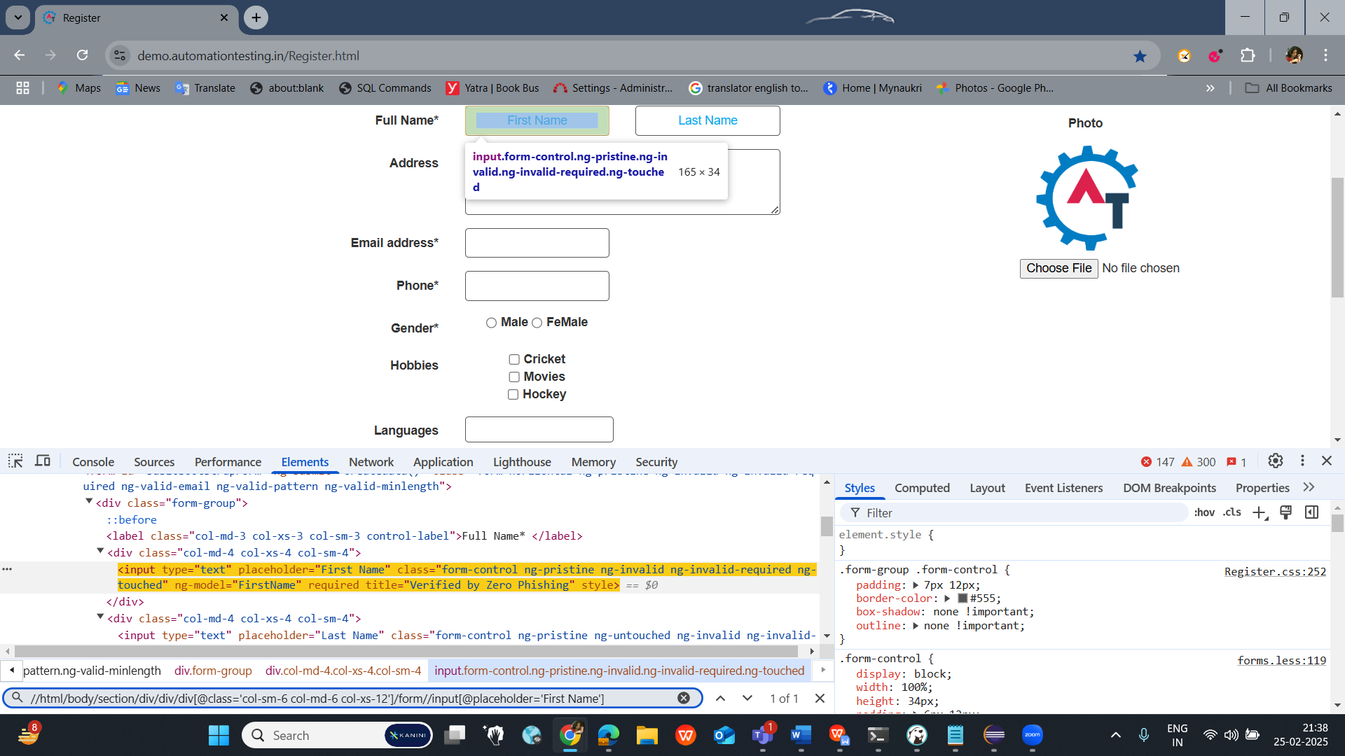

//form//input[@placeholder='First Name']  
  
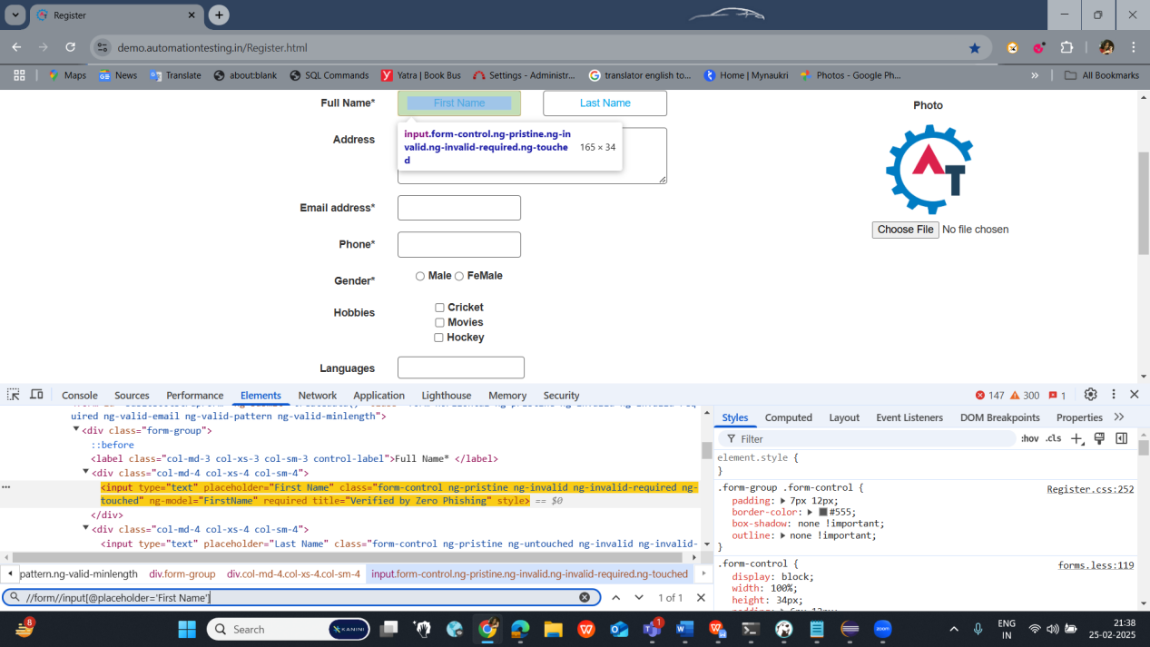  
  
//input[@placeholder='First Name']  
  
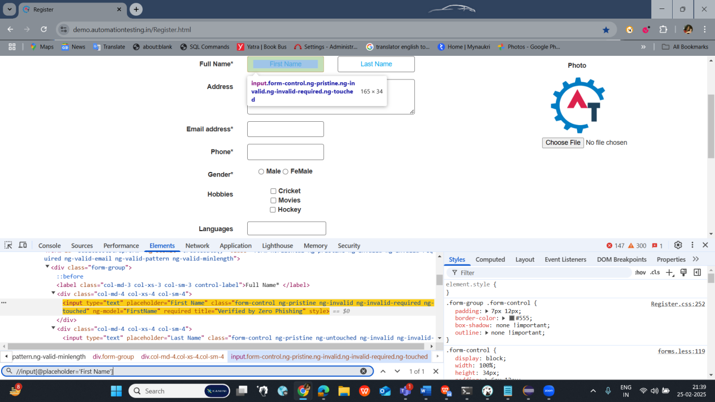  
  
//input[@ng-model='FirstName']

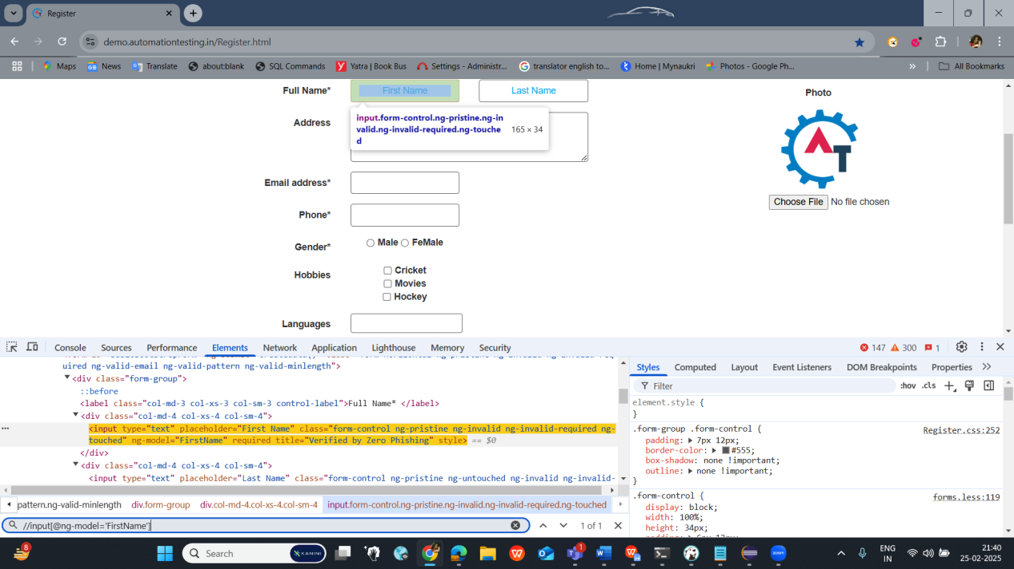

Inspect:>>  
  
Email Address field:  
  
//input[@type='email']

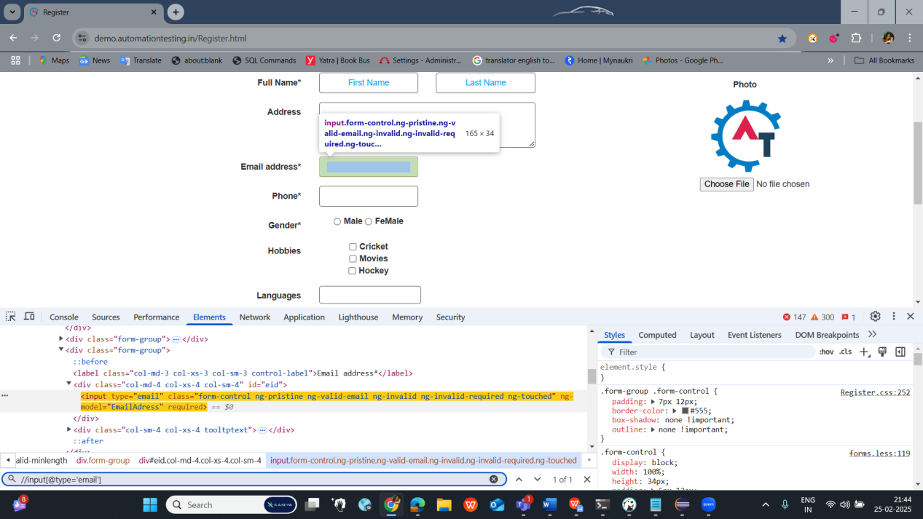

**CLASS 3(Day 22):**

**Advance ways of finding Xpath:**

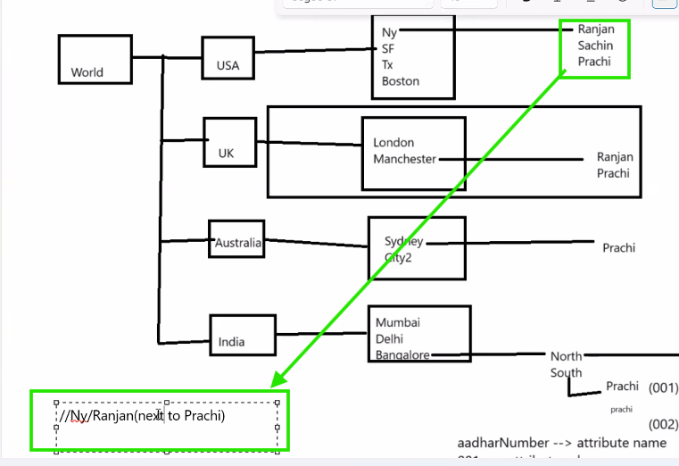  
  
example: //Ny/prachi(previous to Sachin)  
  
**Assignment :**   
Find the Xpath for all the elements on the Demo Automation testing website -  
<https://demo.automationtesting.in/Register.html>

**CLASS 4(Day 23):**

**Advance XPATH -->**Finding the xpath for the hard coded value: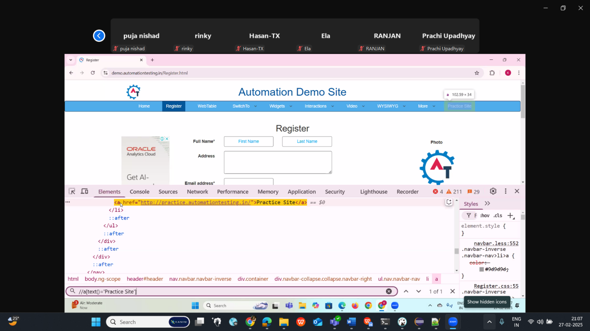

//a[text()='Practice Site']

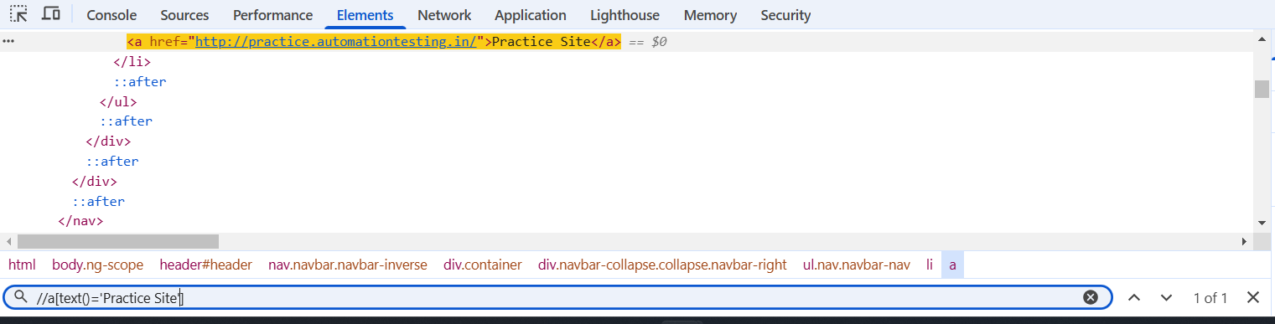

//button[text()=' Submit ']

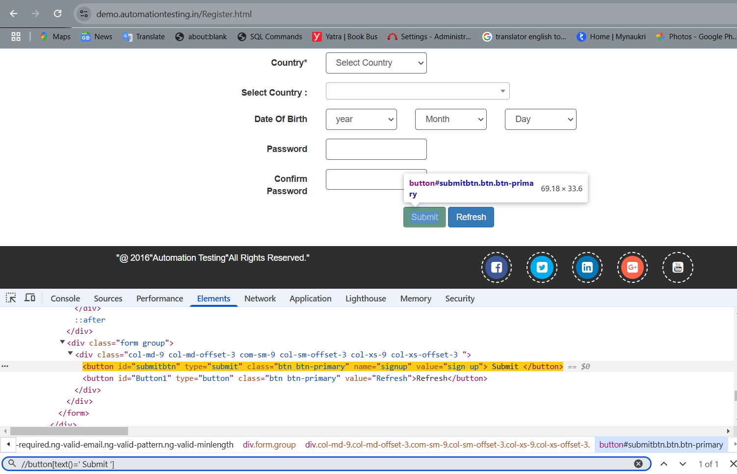

**For Text Xpath one more way :**

//button[contains(text(),'Submit')]

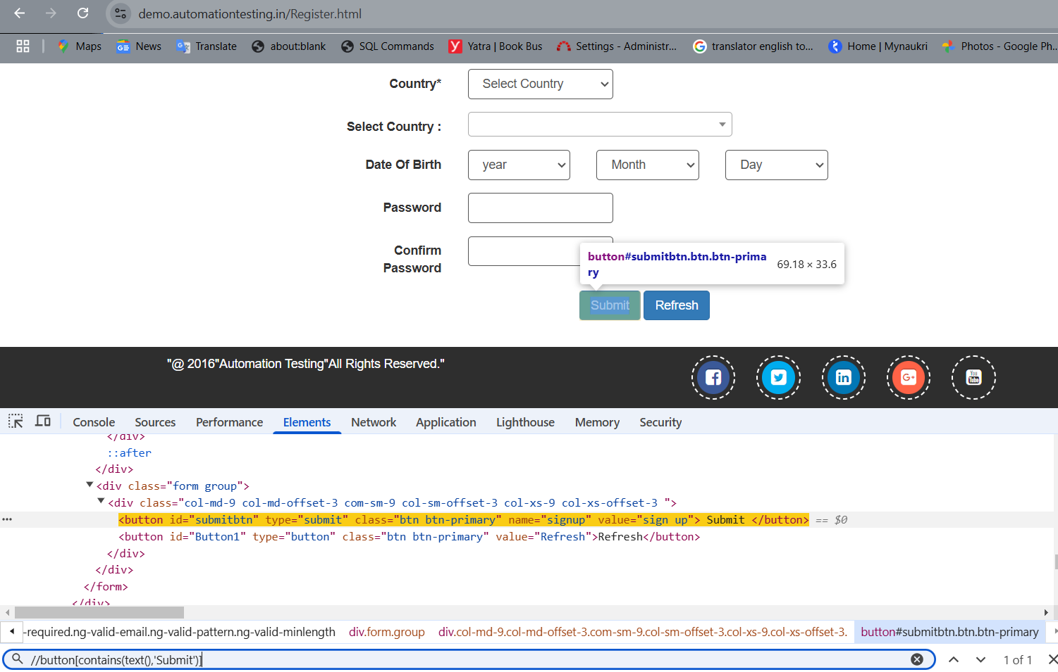

//a[contains(text(),'Site')]

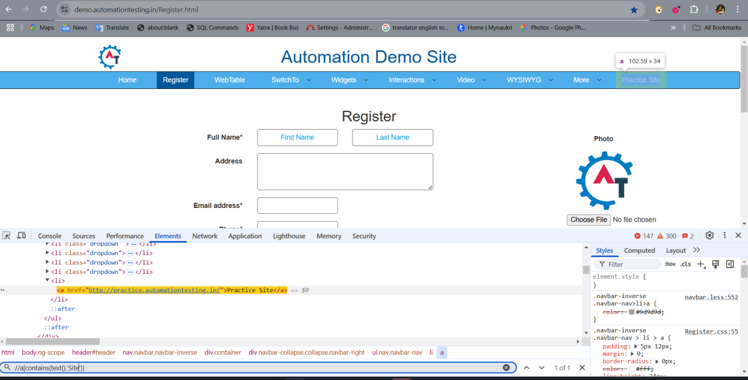

**Sibling Concept in Xpath:**

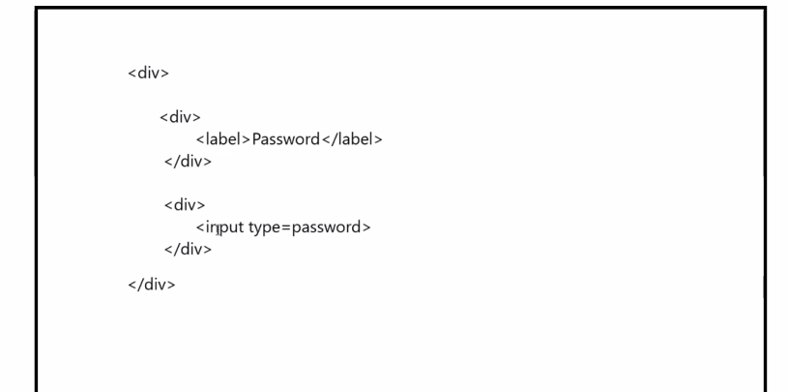

//div[label[text()='Password']]//following-sibling::div/input

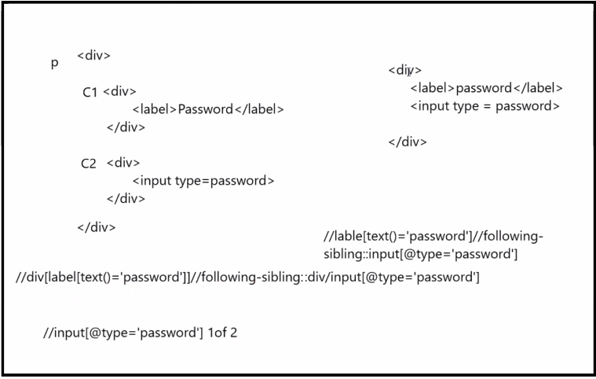

**Confirm Password Field:**  
//div[label[text()='Confirm Password']]//following-sibling::div/input[@class='oxd-input oxd-input--active']  
  
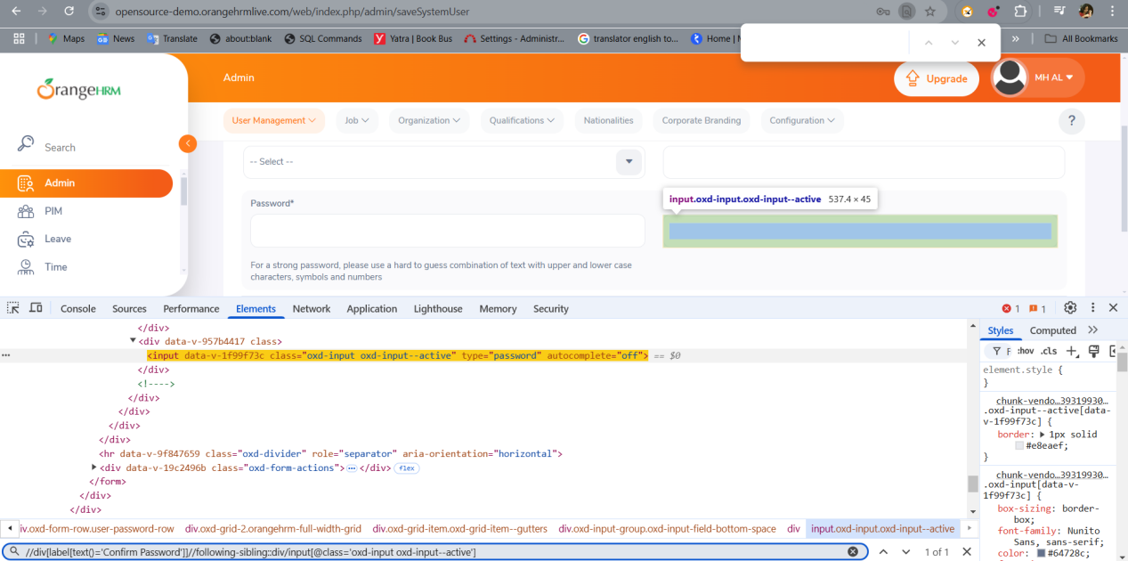

Advance Xpath in **Reverse order** ->> (Previous Sibling or **Preceding Sibling**)

//div[input[@type='password']]//preceding-sibling::div/label[text()='Password']

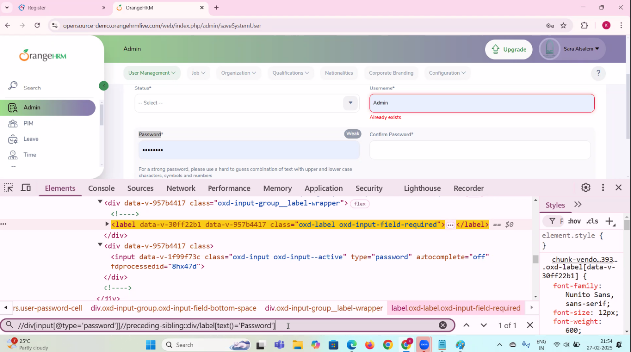

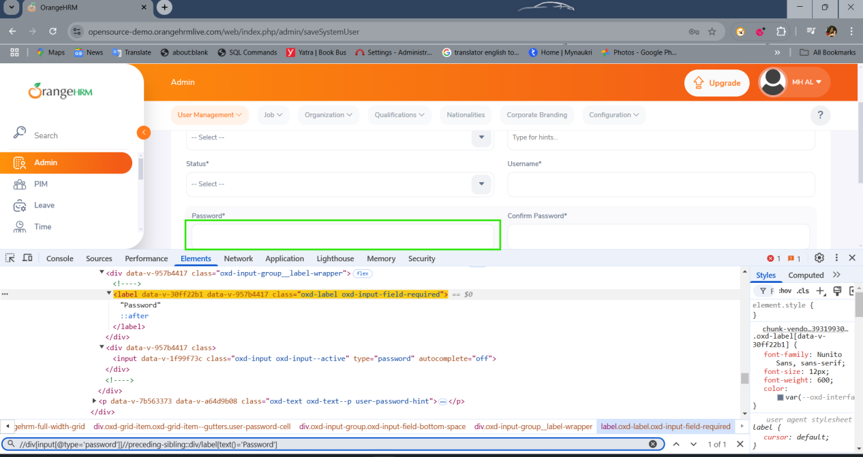

Assignment:

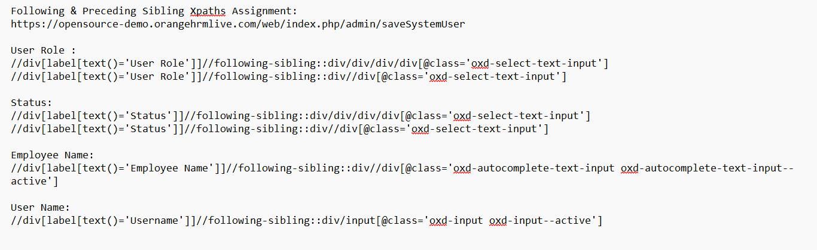

**JAR File :**

It is an collection of compiled Class codes

**Converting the files in to Jar file:**

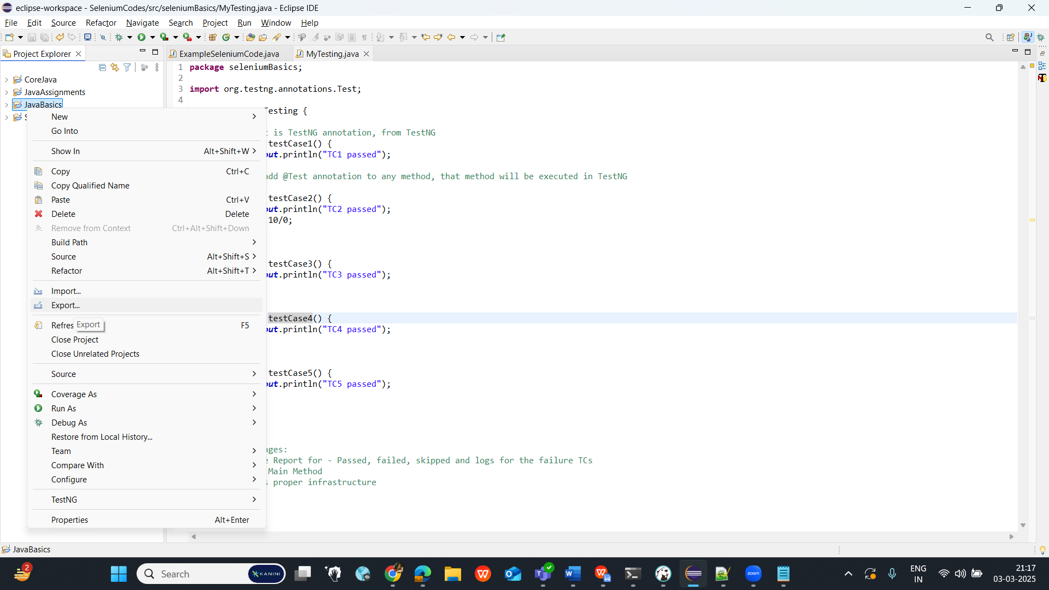

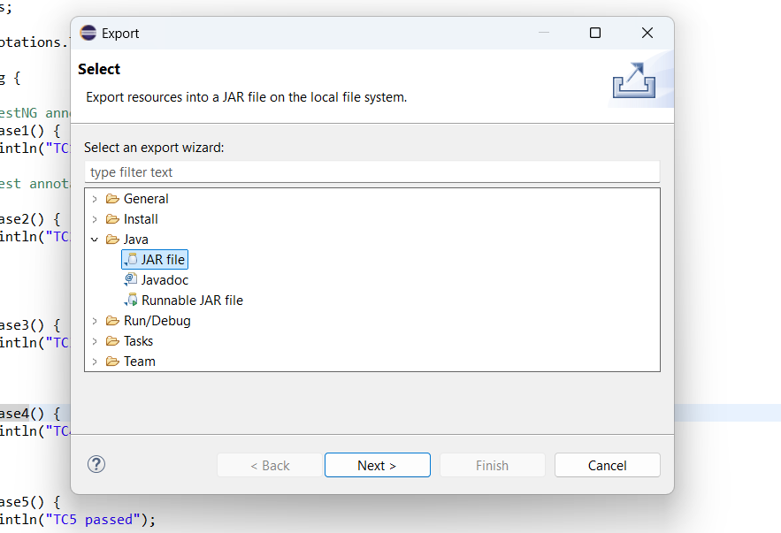

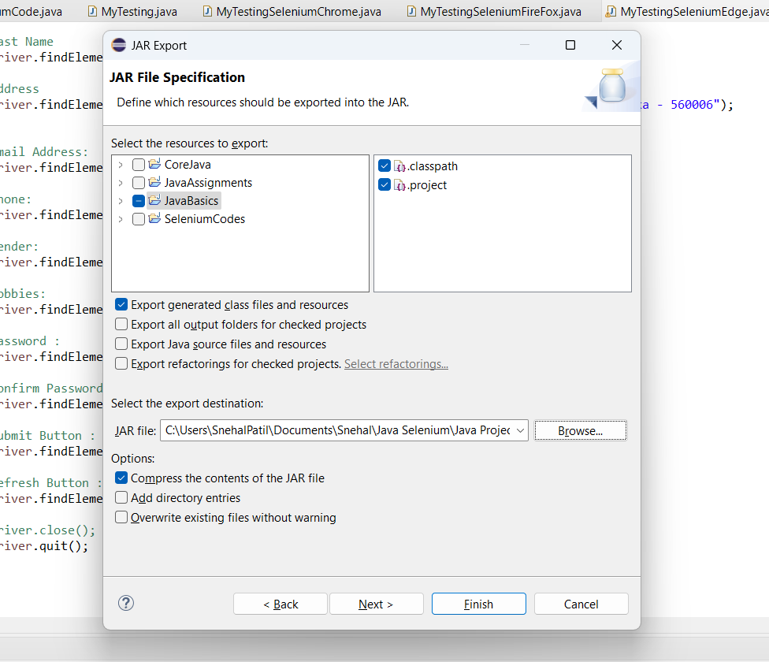

Name the file where we want to keep the Jar files and click on Finish.  
  
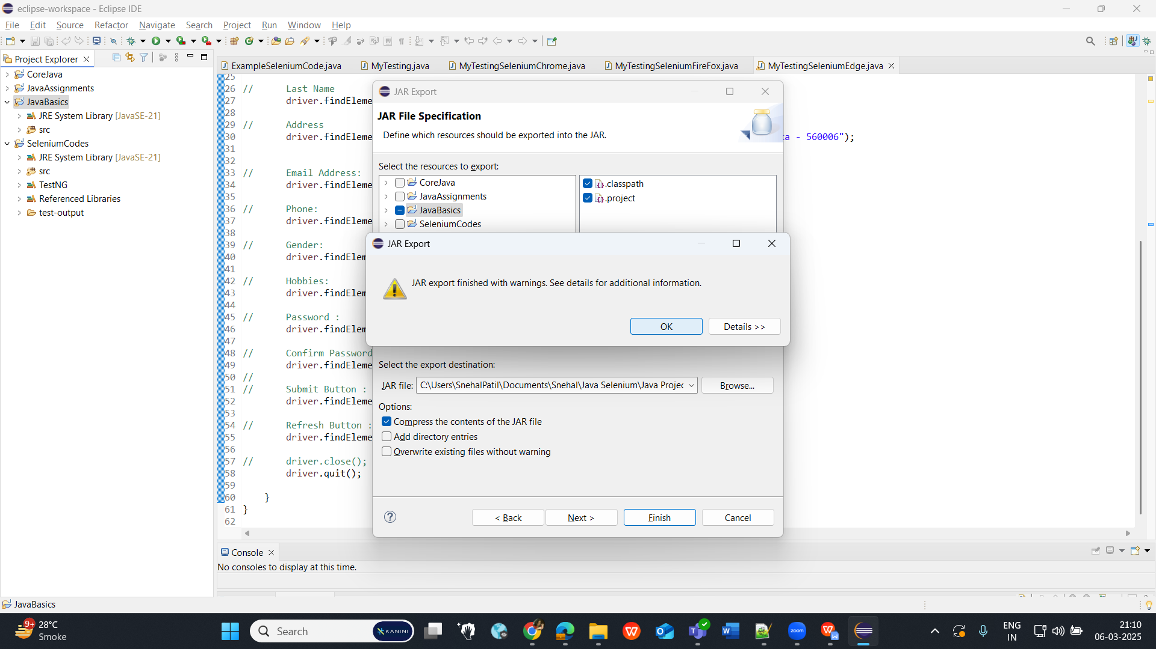

* Install Java Selenium (Jar file) through Selenium.dev

**How to configure Selenium (Jar file) in our Java Projects:**

1st approach:

Through website we have downloaded Java selenium Jar file and we configure it with project1, then only the Project 1 will understand the Selenium codes.

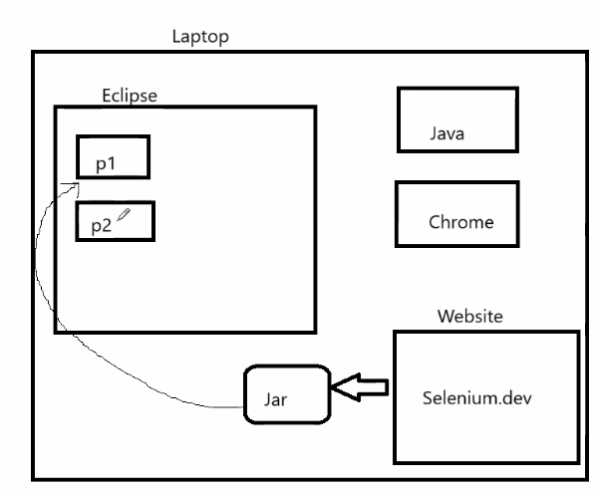

**2nd approach:**

In Eclipse, we need to just add the dependencies (dependency code) under POM.xml file which communicates with the Maven Repository. Maven repository will automatically install the required Jar files to the Maven Project.

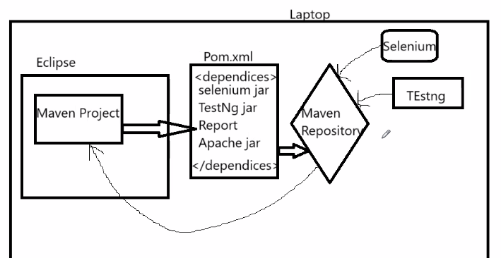

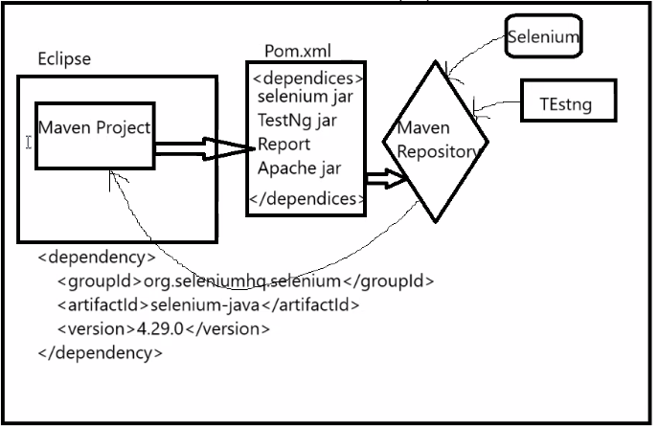

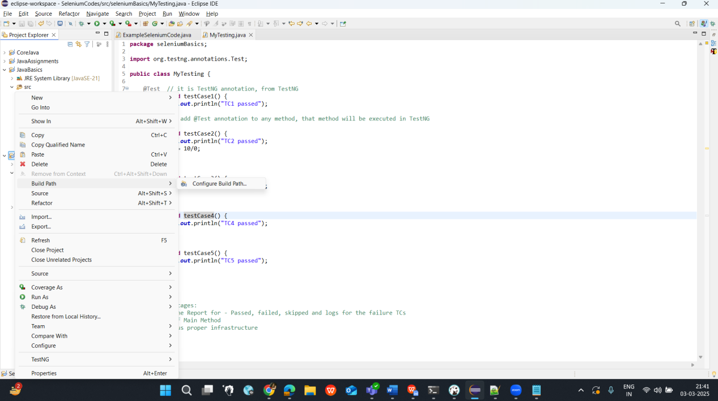

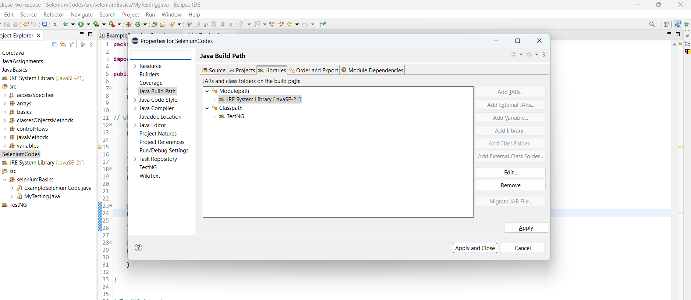

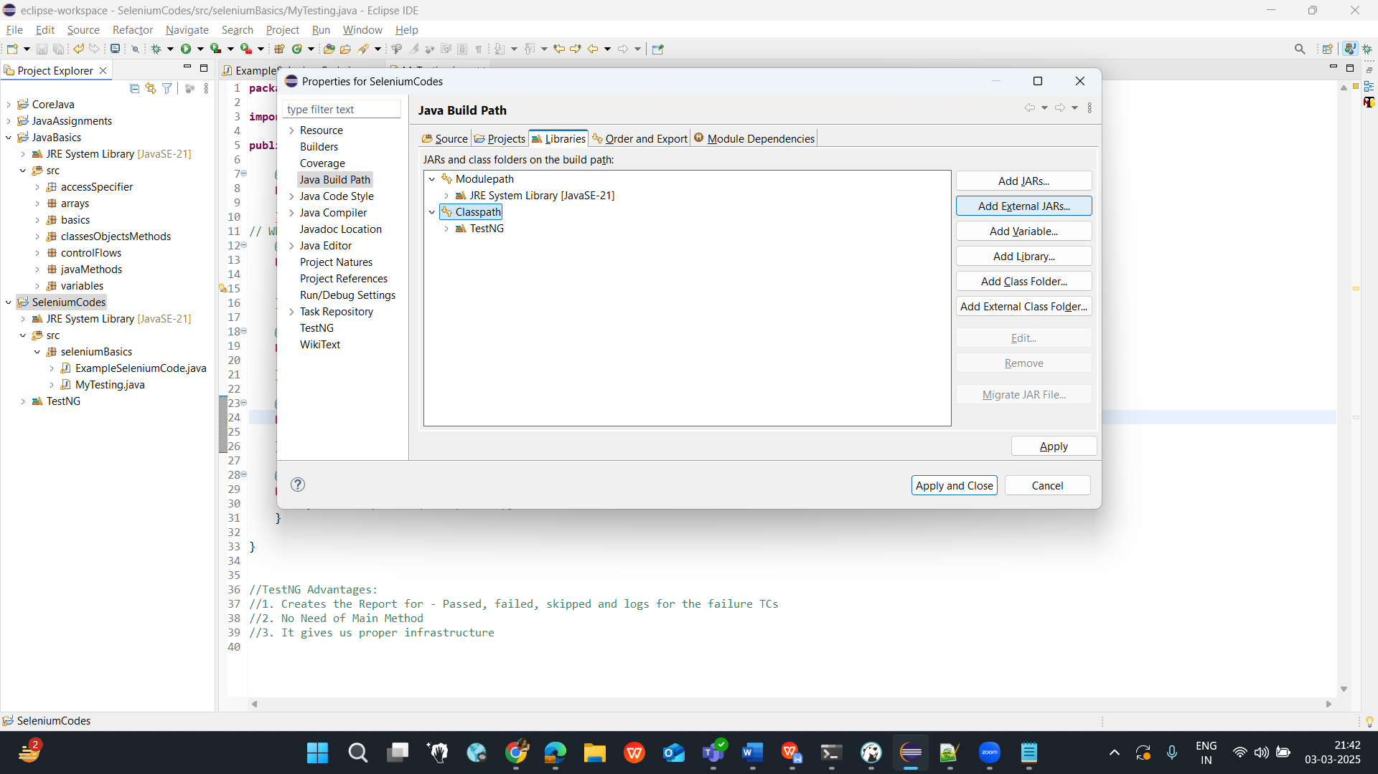  
  
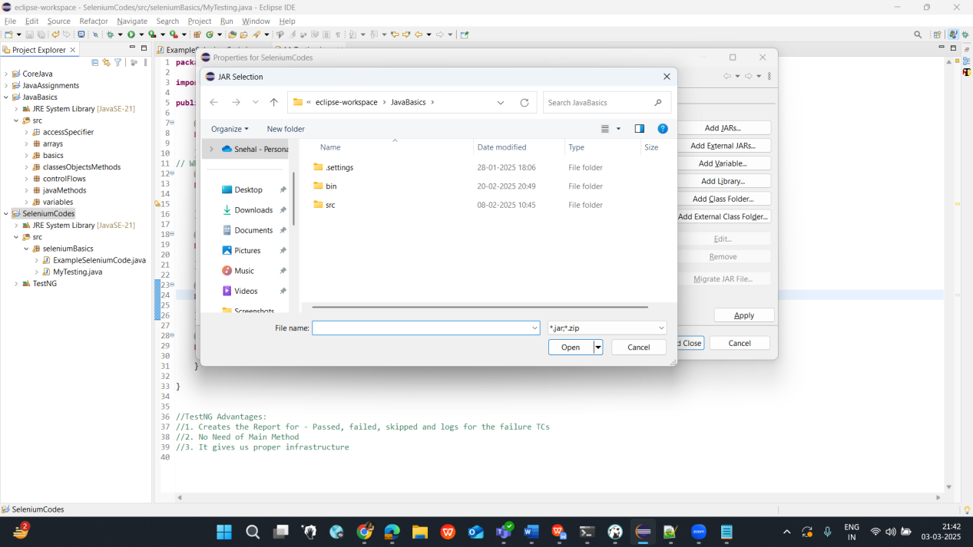

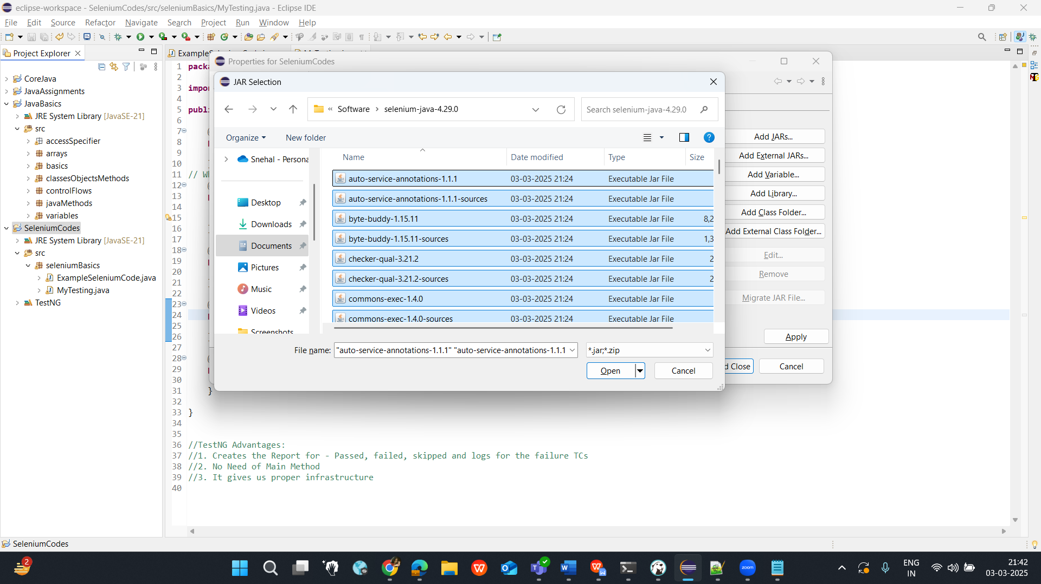

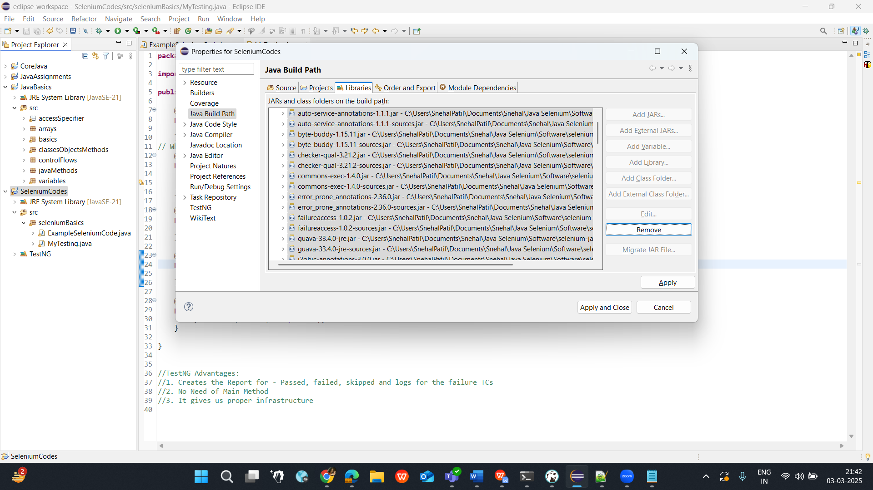

Click on Apply and Close.

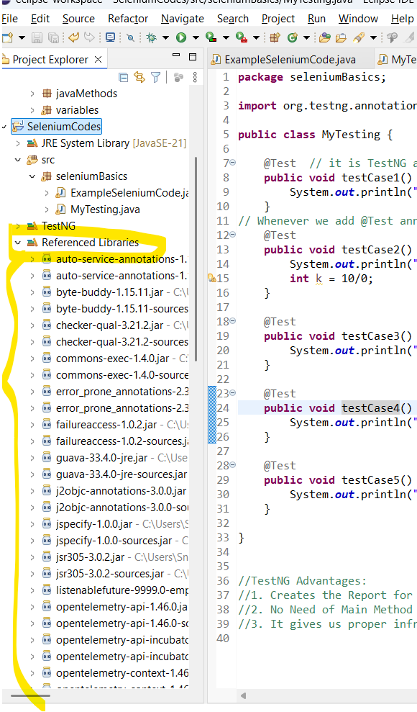

**Selenium Coding :**

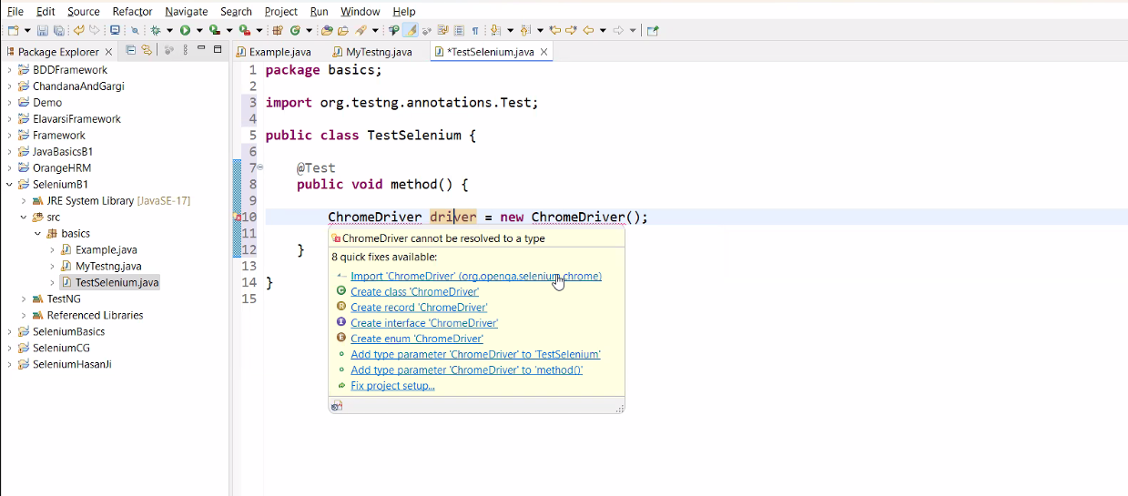

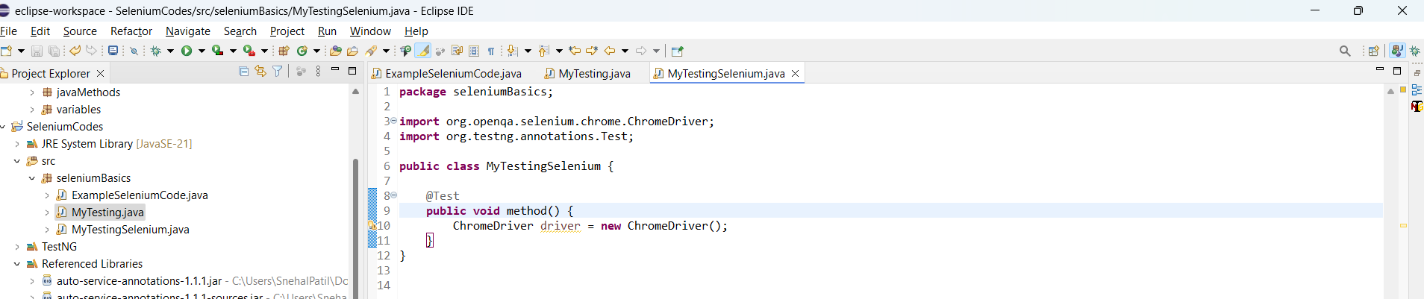

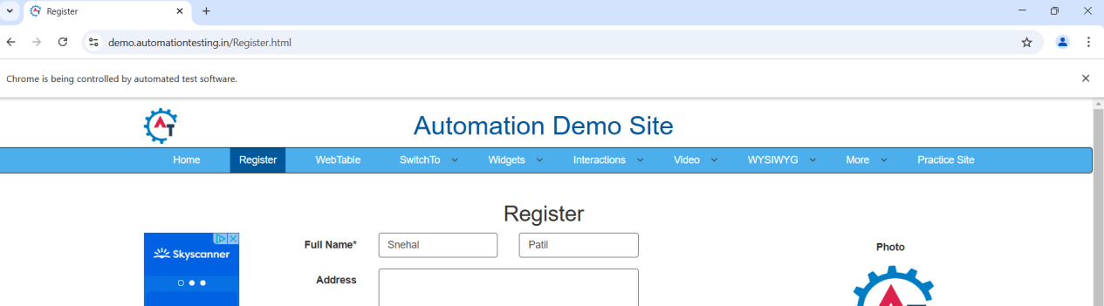

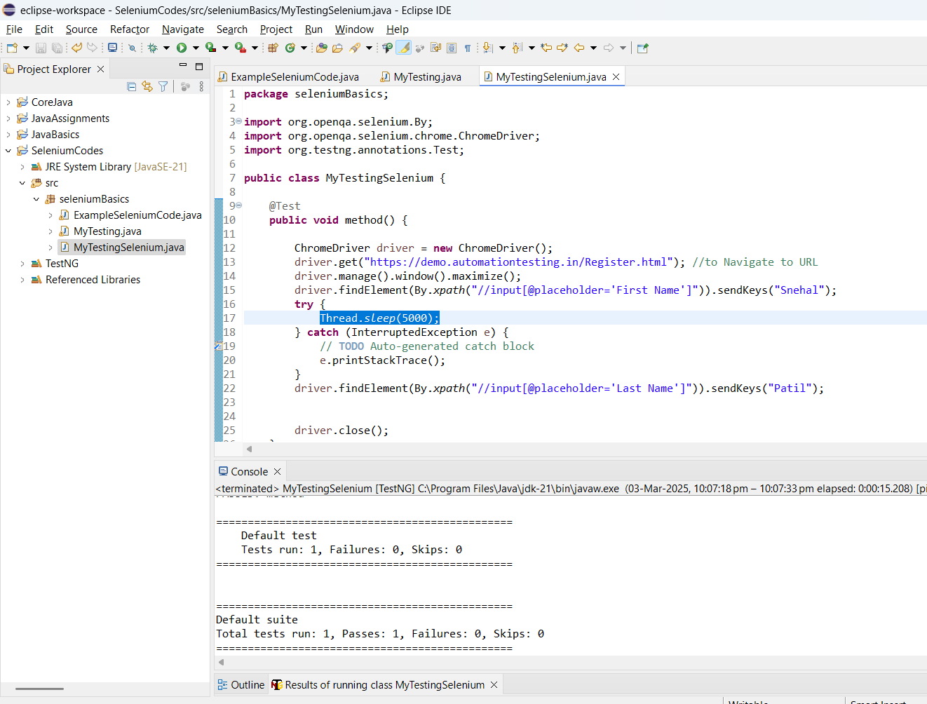

driver.close(); // this will close the current window

driver.quit(); //will close all tabs at a time  
  
Catched exception for thread.sleep() hence, we are using try and catch method.

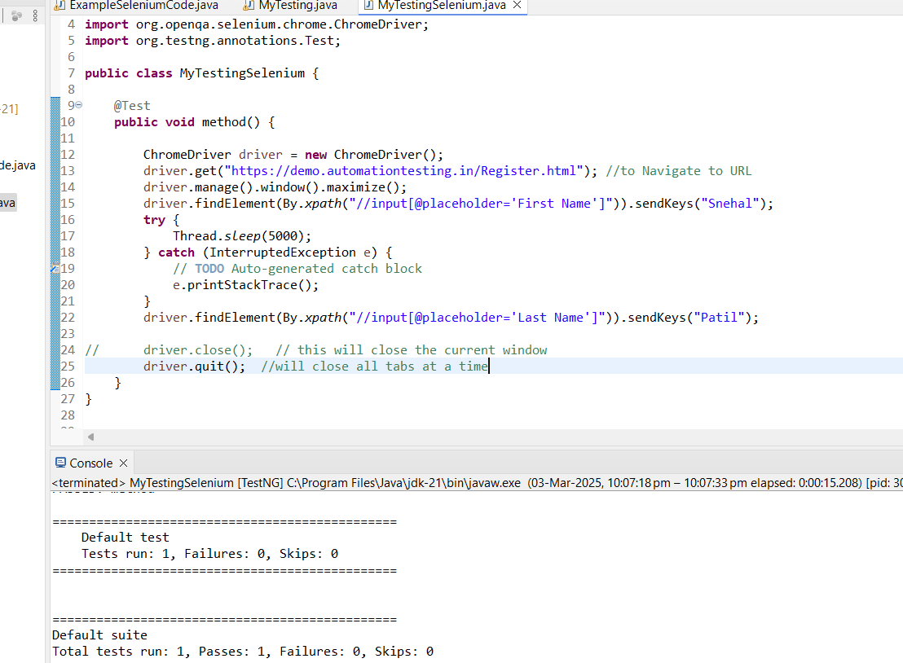

Debugging exception:

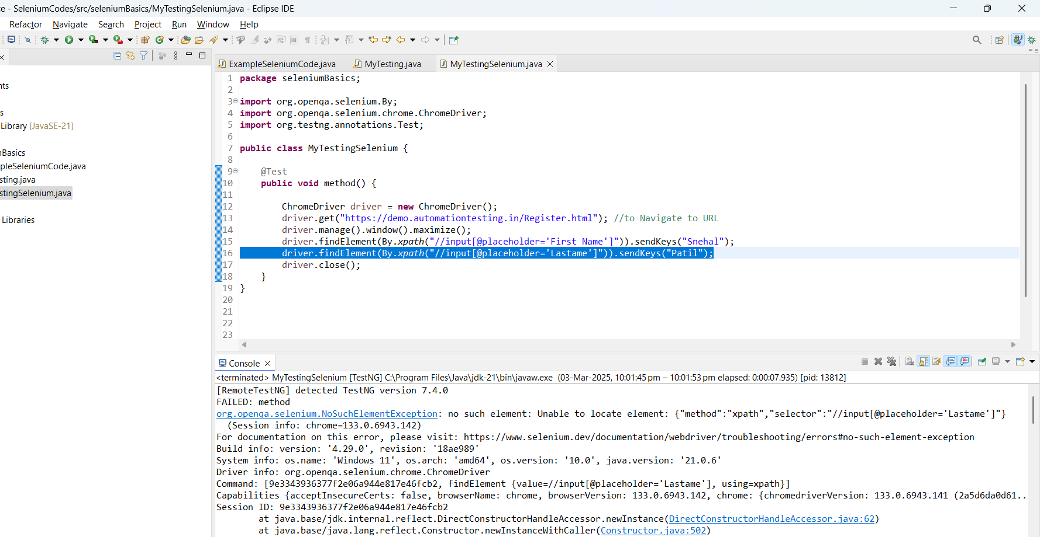

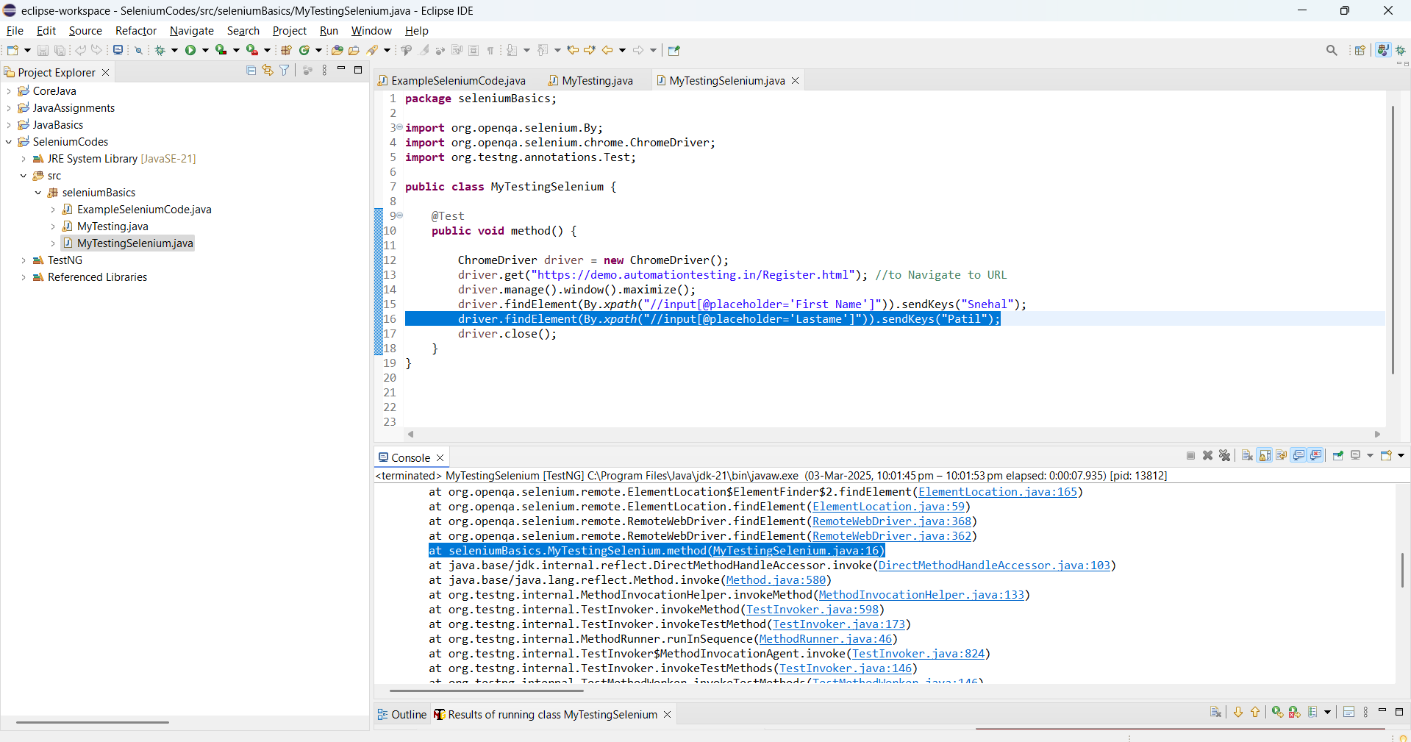  
  
Assignment :  
// Create class Test Form on Chrome and Try to automate the other fields

// Create Test Form class for the Firefox and Try to automate the other fields

//Create Test Form class for the Edge and Try to automate the other fields

**CLASS 5( Day 24):**

To avoid the multiple Try catch method for different timeslot, we just declare the Global variable and call in all the places wherever required.

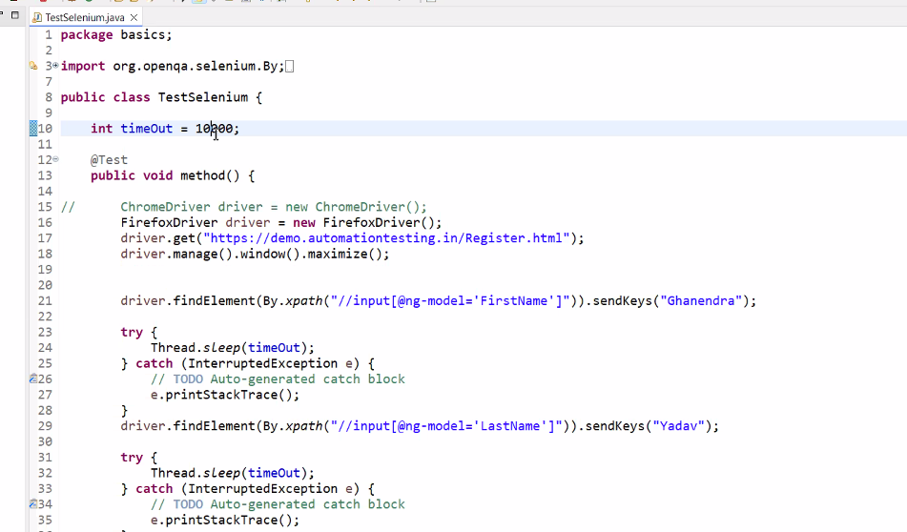

-------------------------------------------------------------------------------

Exception Handling using Try Catch method for the elements not present in the UI:

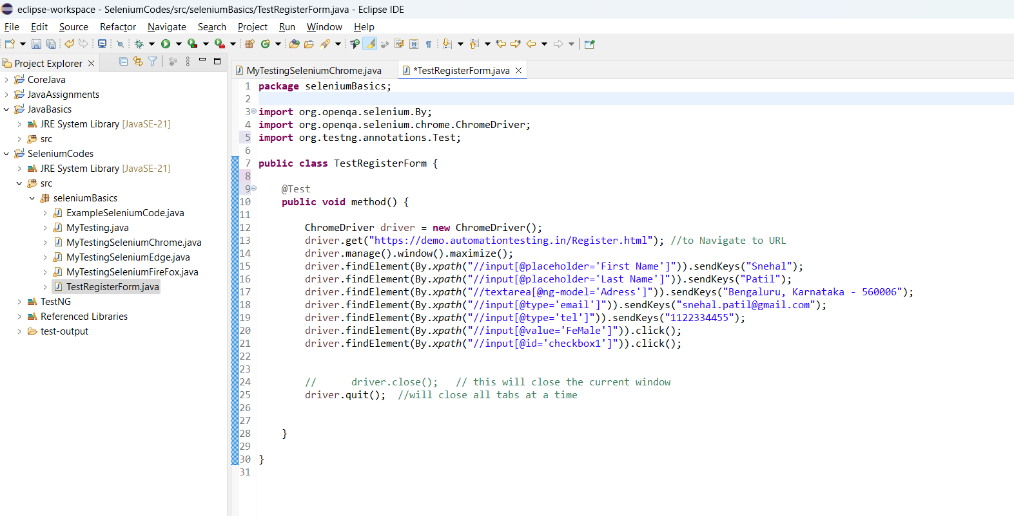

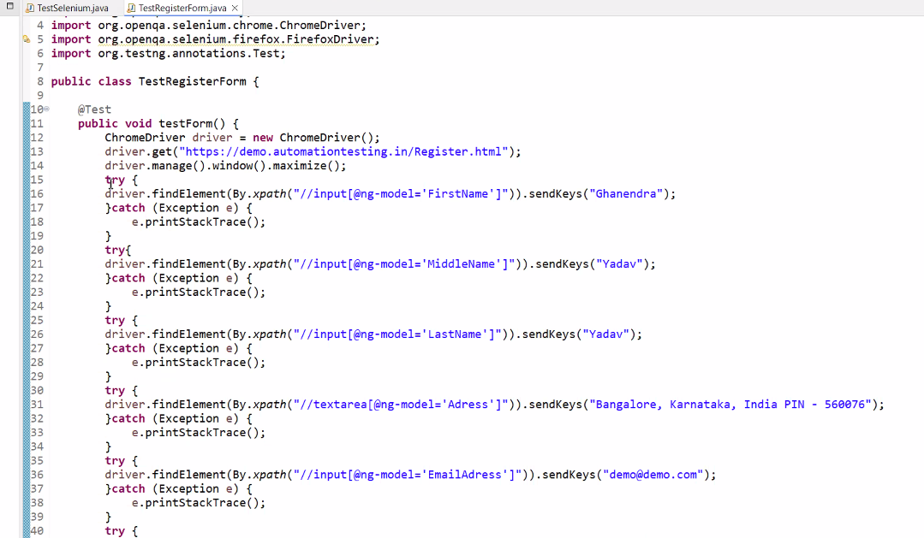

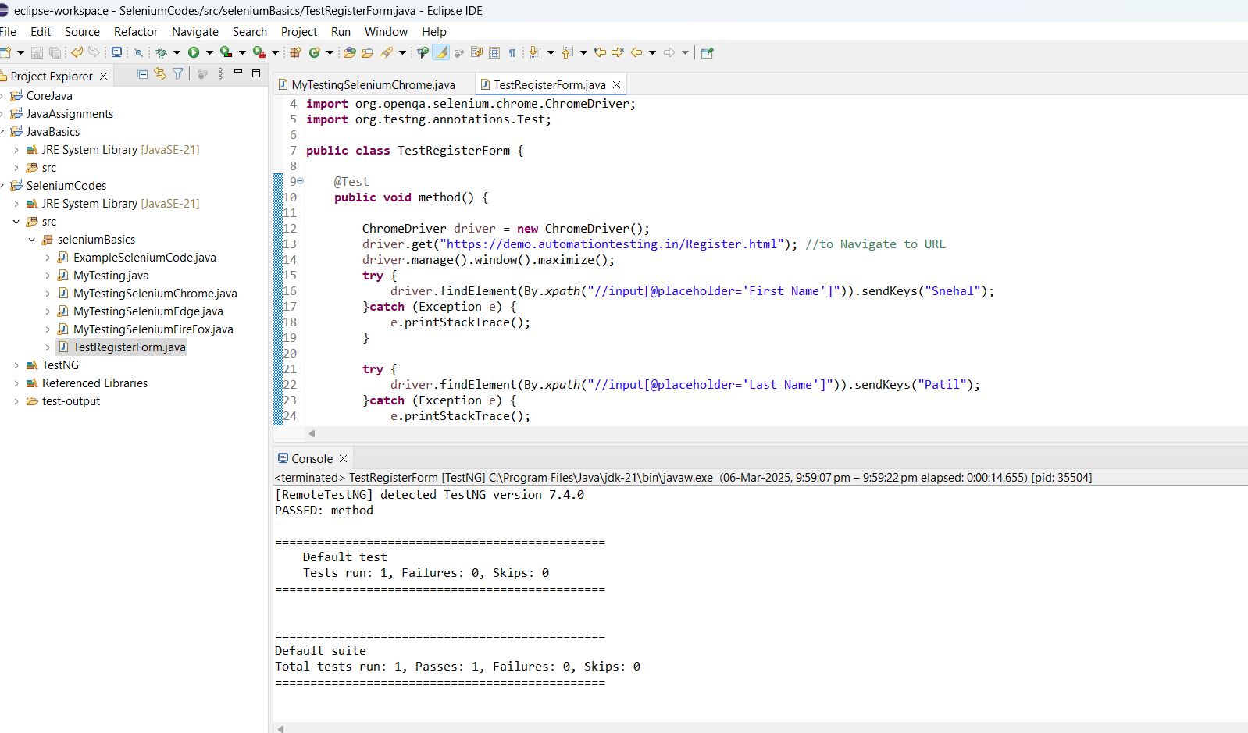

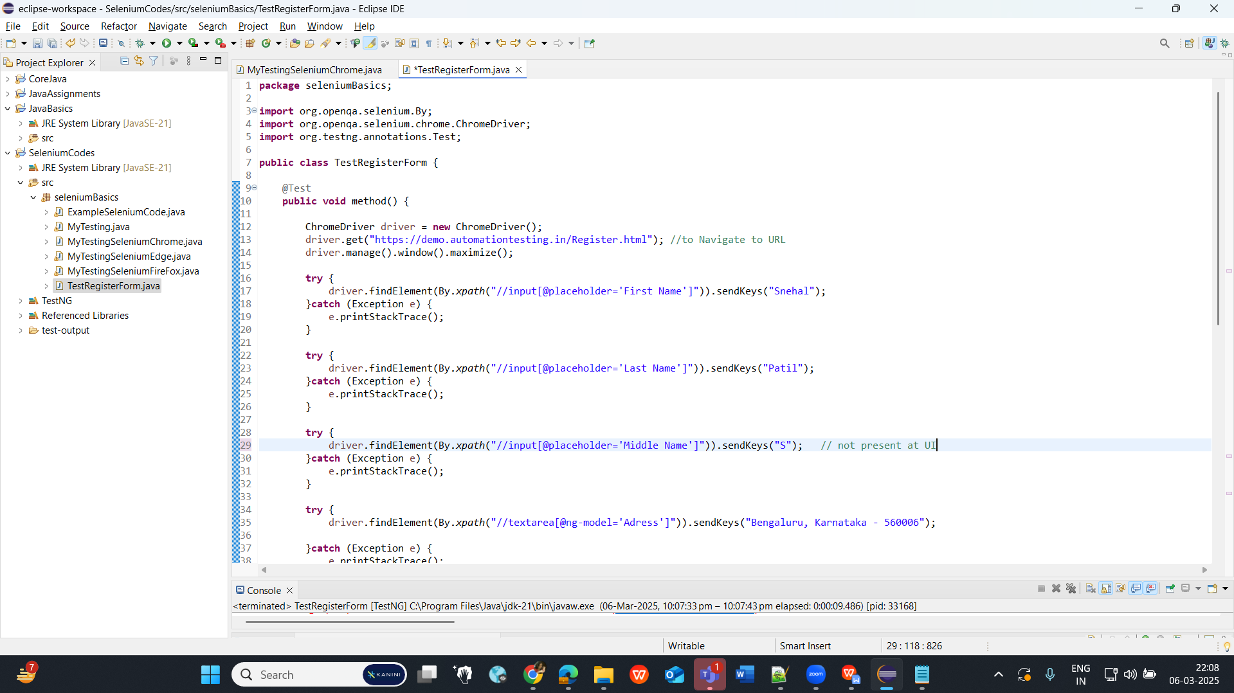

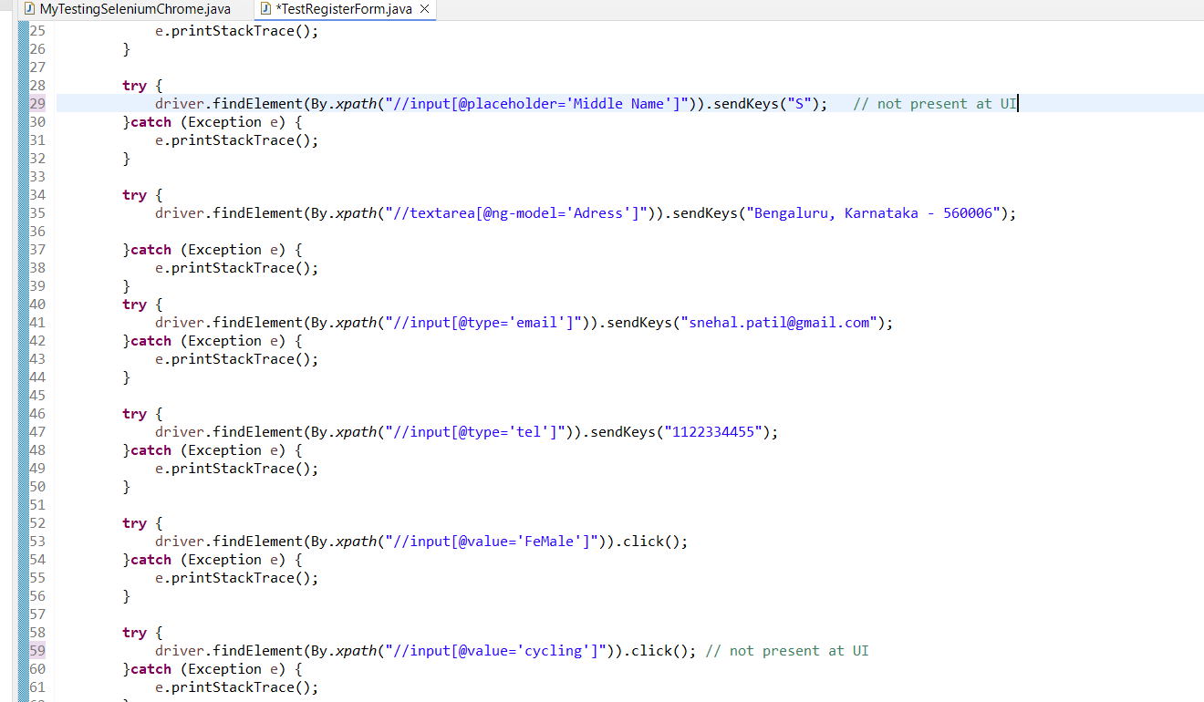

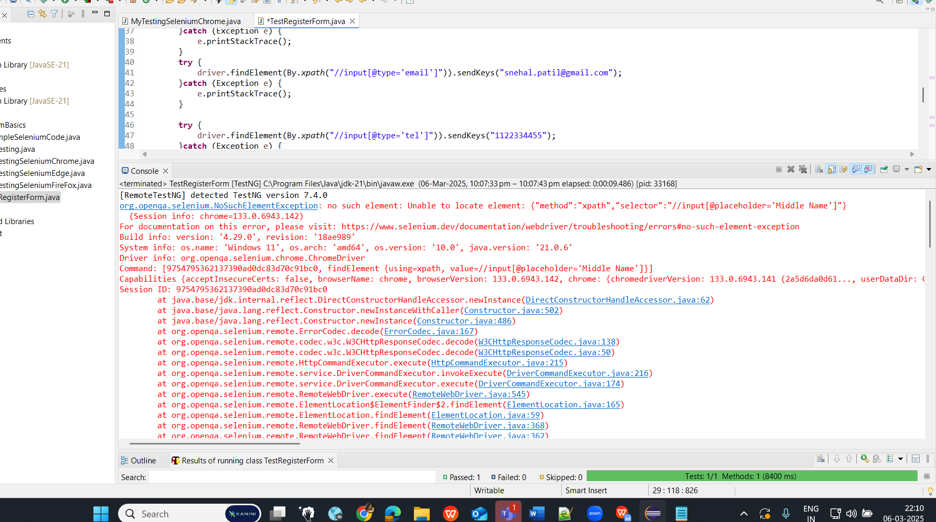

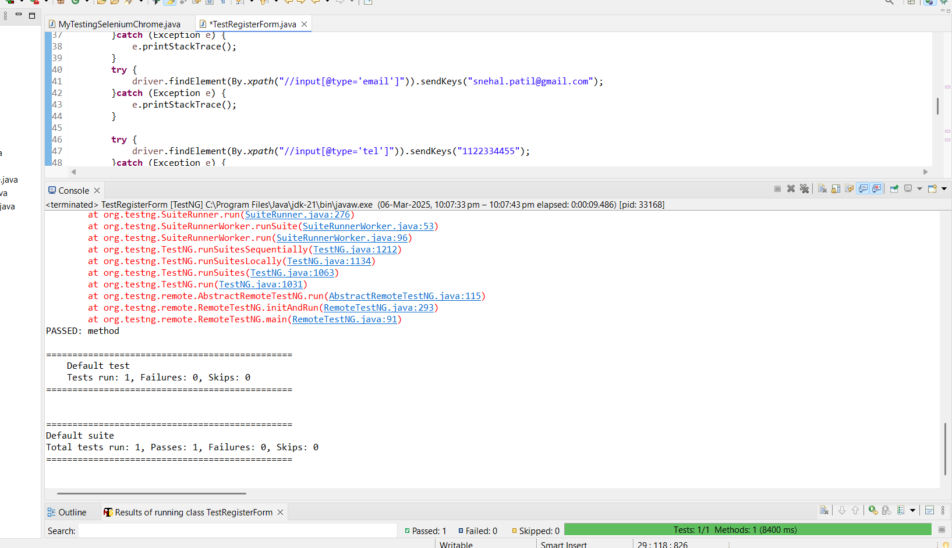

**CLASS 6(Day 25):**

1. Even if there are 2 exceptions still system shows as Test cases Passed.  
   2. In case more than 100 Tcs and There will be multiple false conditions / missing fields and there we can’t manually check for all the missing fields.

To overcome from these 2 issues, we use :

**Assert.assertTrue(testResult);**

* AssertTrue will always accepts ‘True’ parameter.
* If the parameter is false, it will fails the TCs.

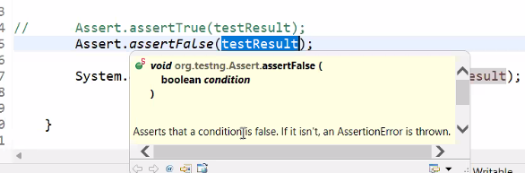

To overcome from 2nd issue, we use this:

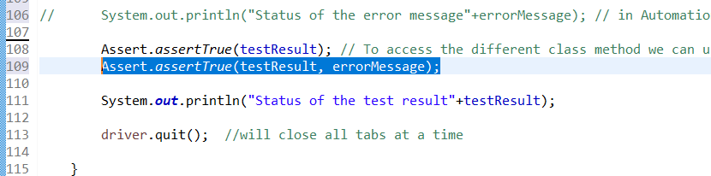

Code:

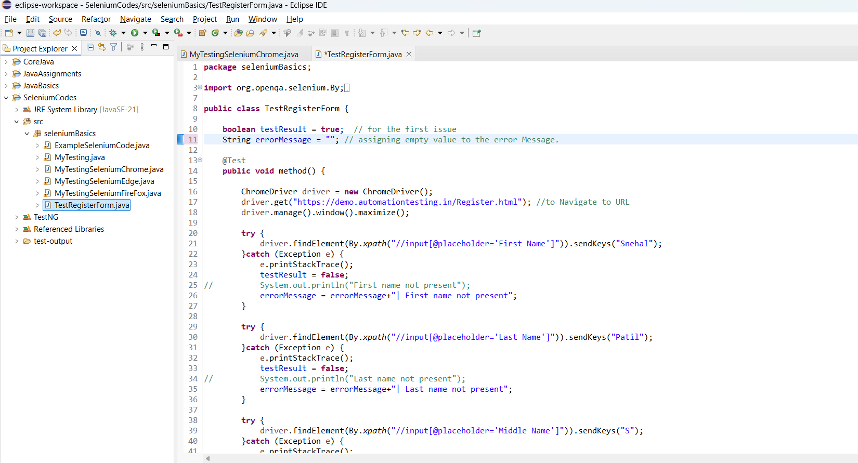

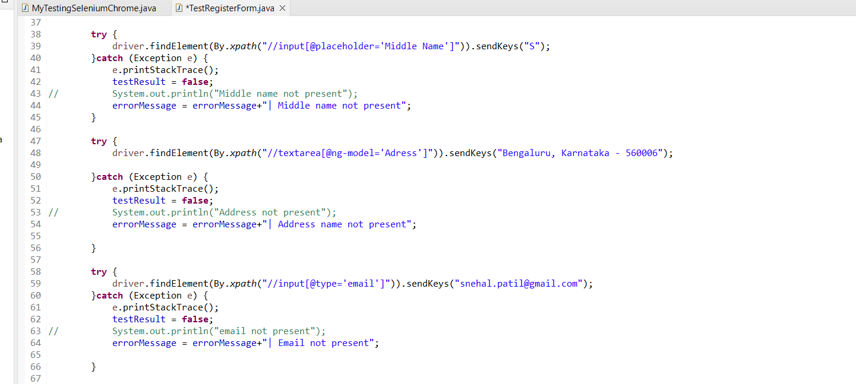

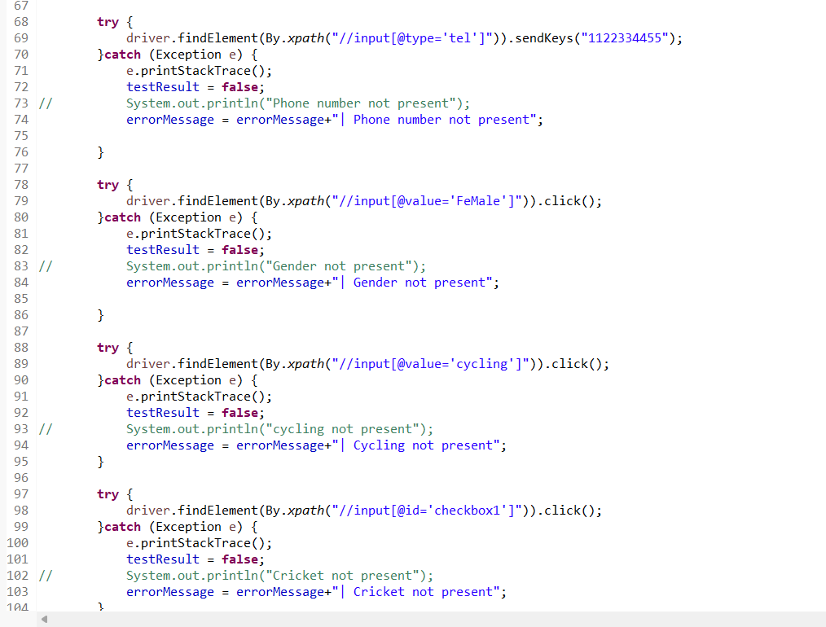

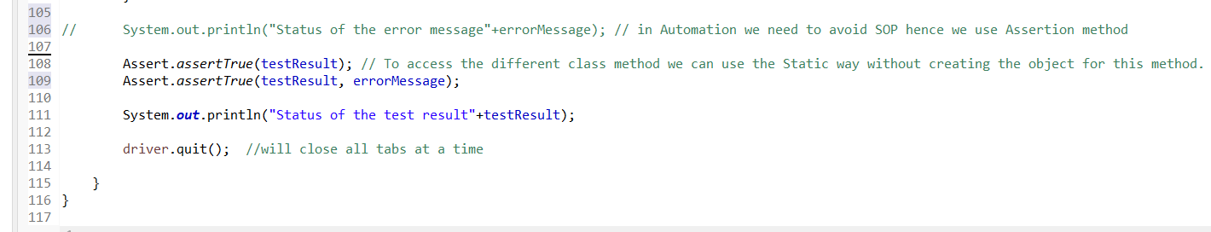

Code Result:

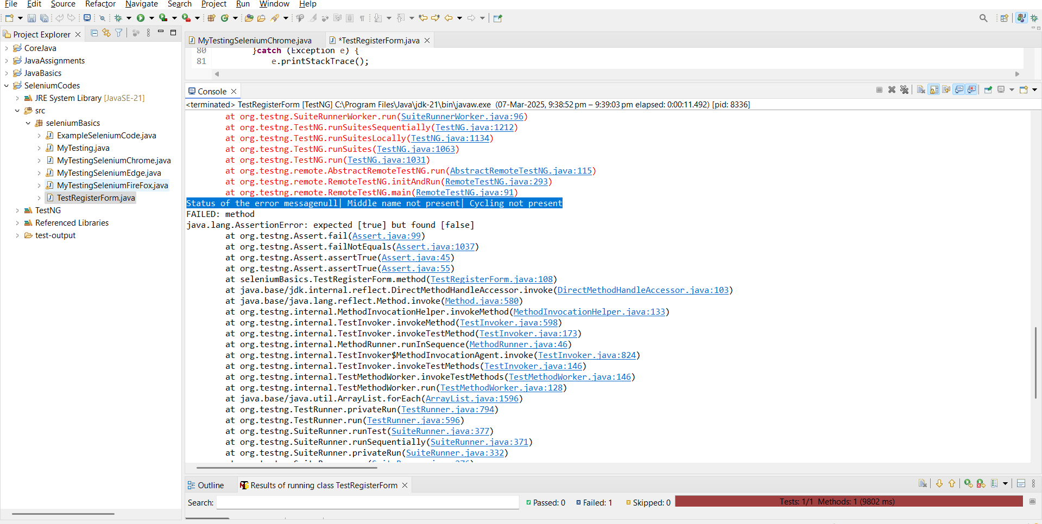

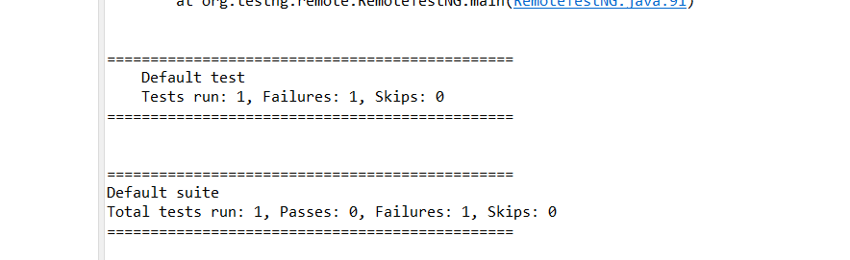

**How To Add proper Validation for our Test cases:**

* **CheckBox Validation:**

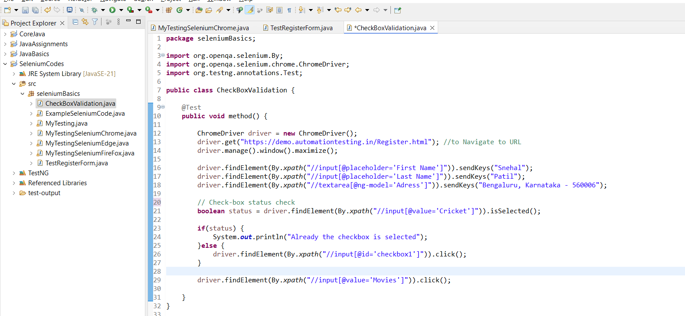

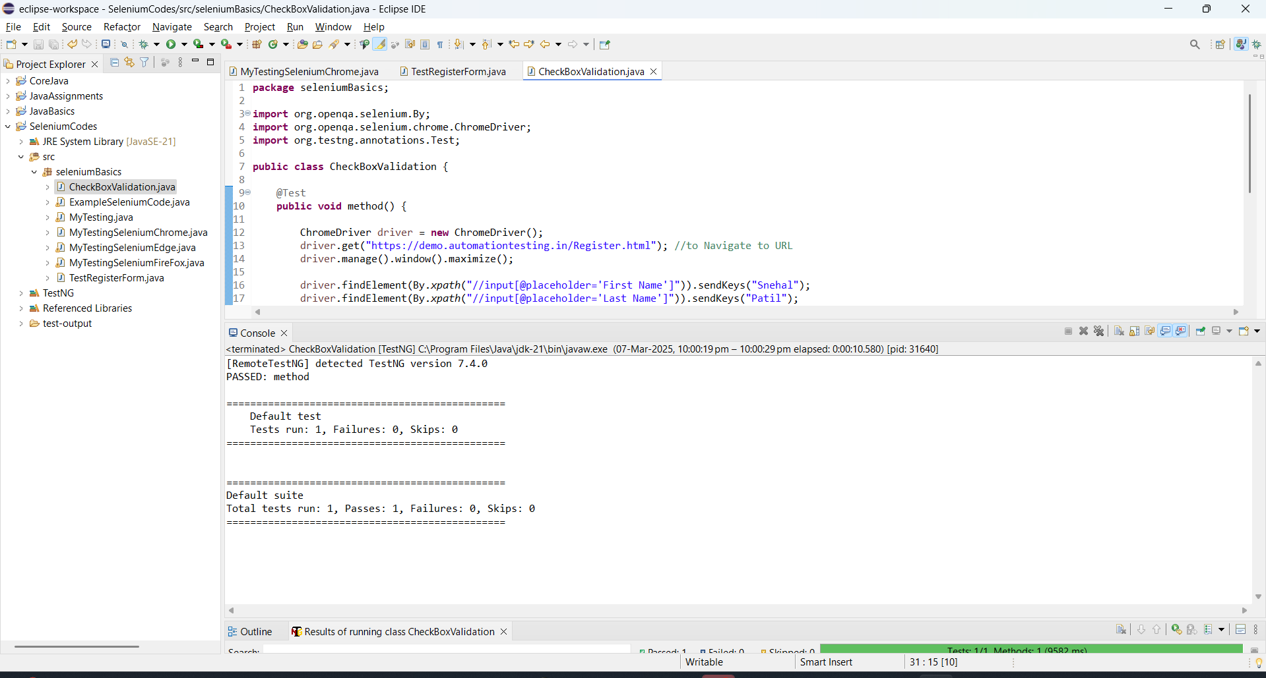

**CLASS 7: (Day 26)**

* **Text Validation:**

While validating the text, avoid taking text value in the Xpath.

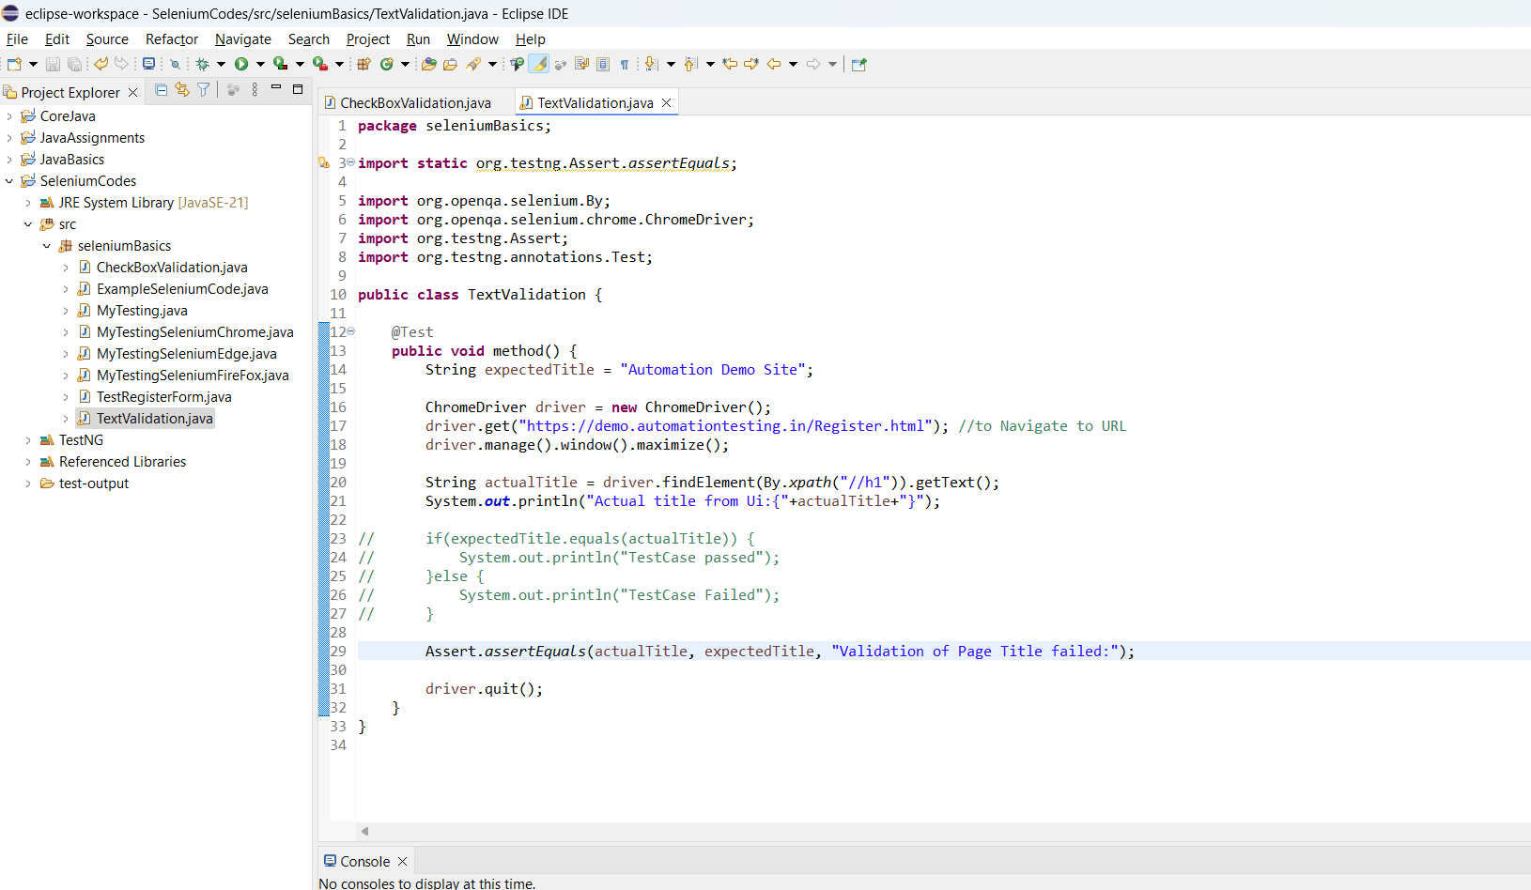

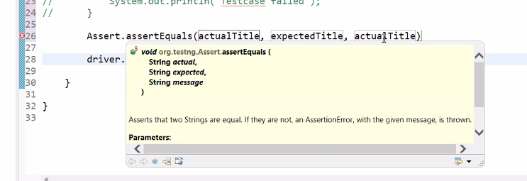

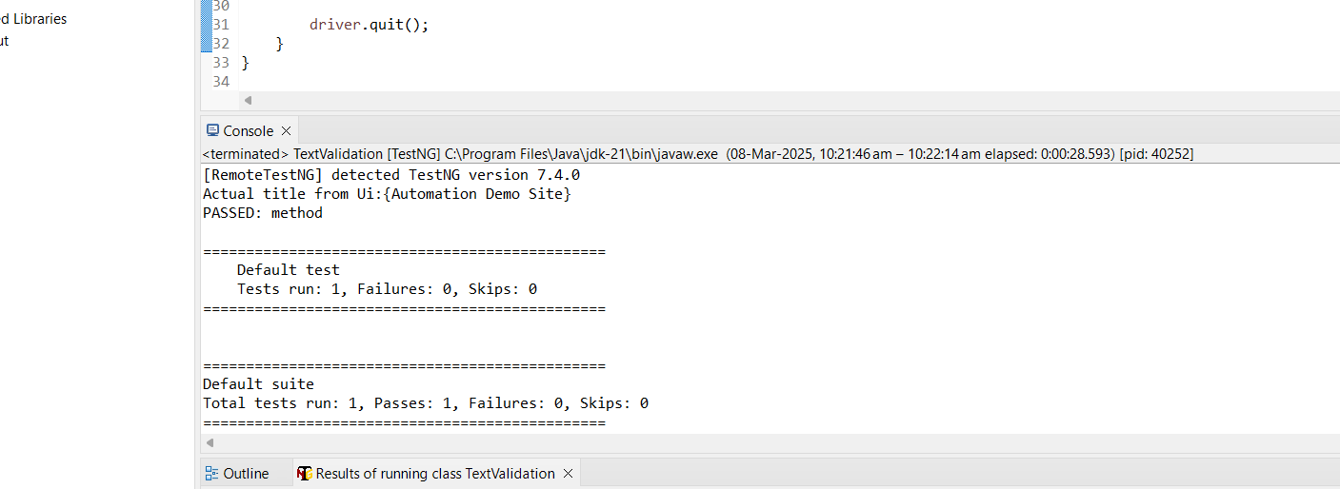

* **Select Dropdown:**

**Search and Select ->**

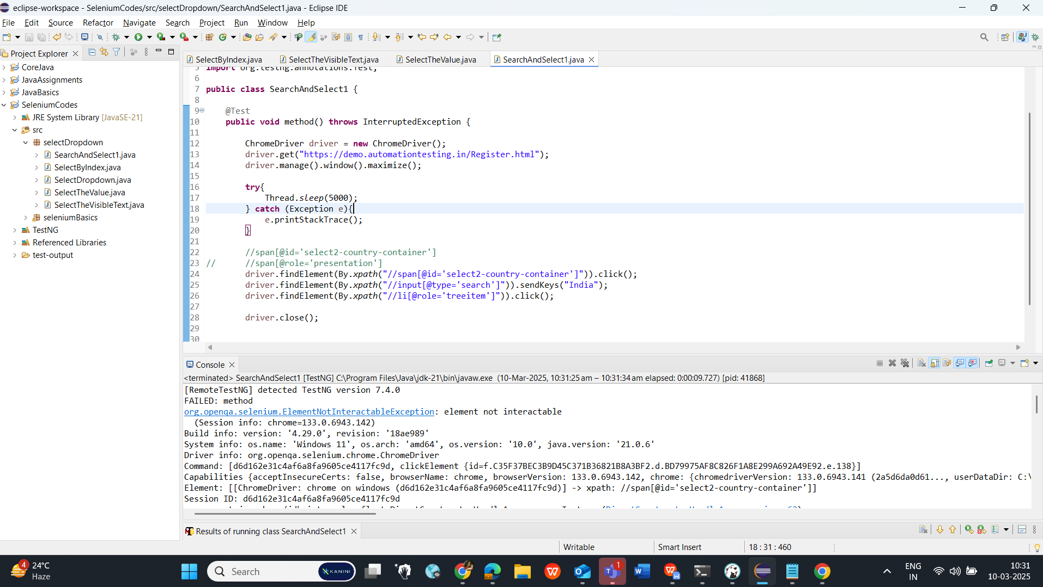

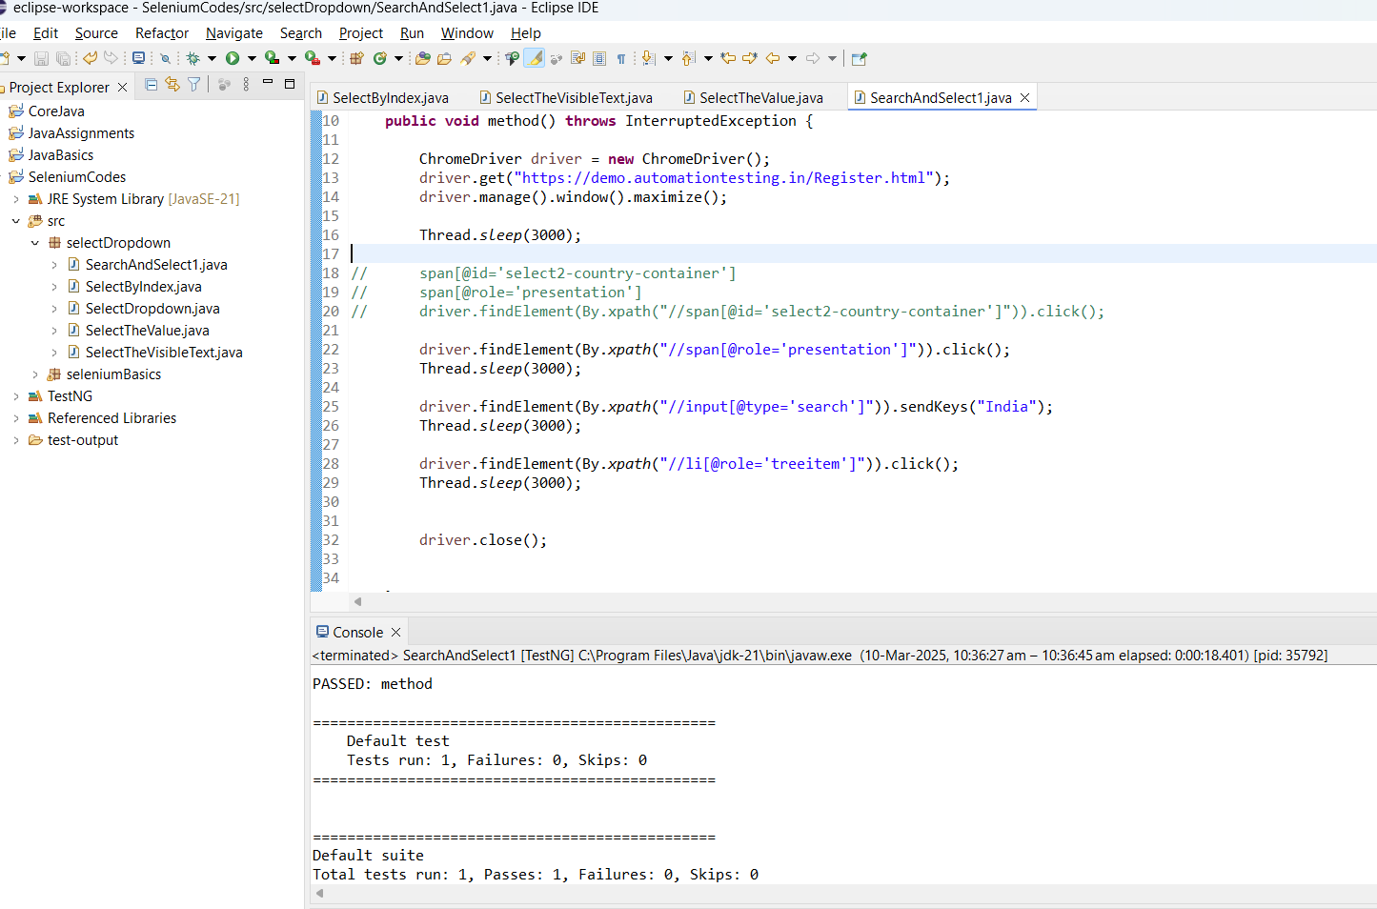

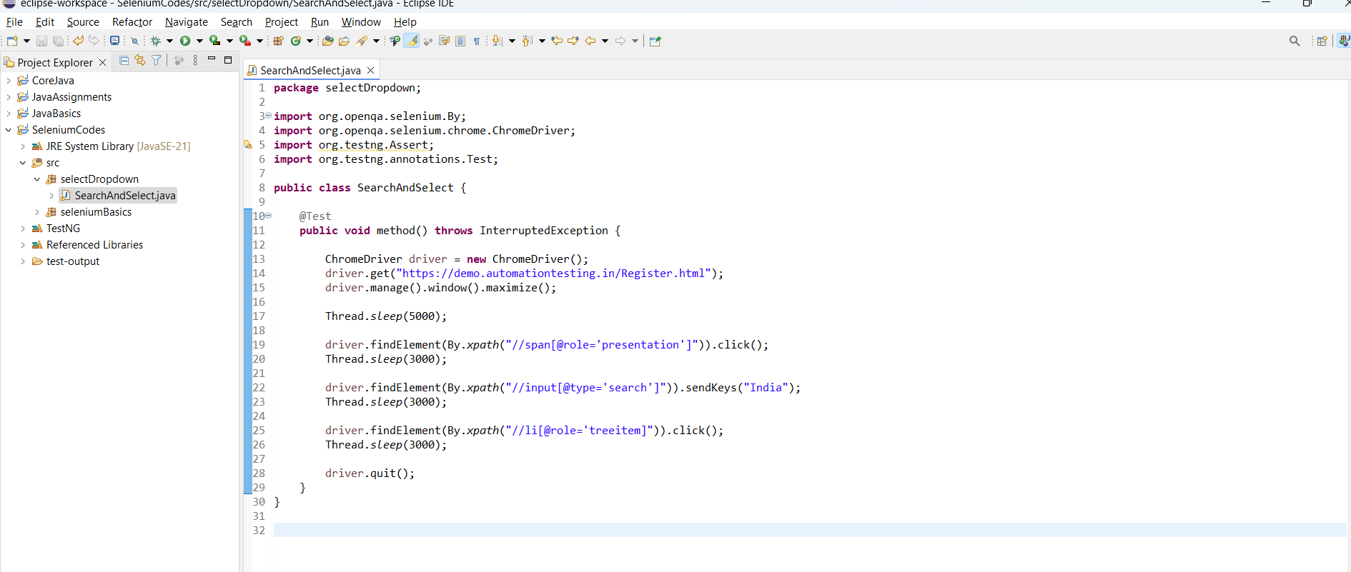

**Select from the dropdown :**

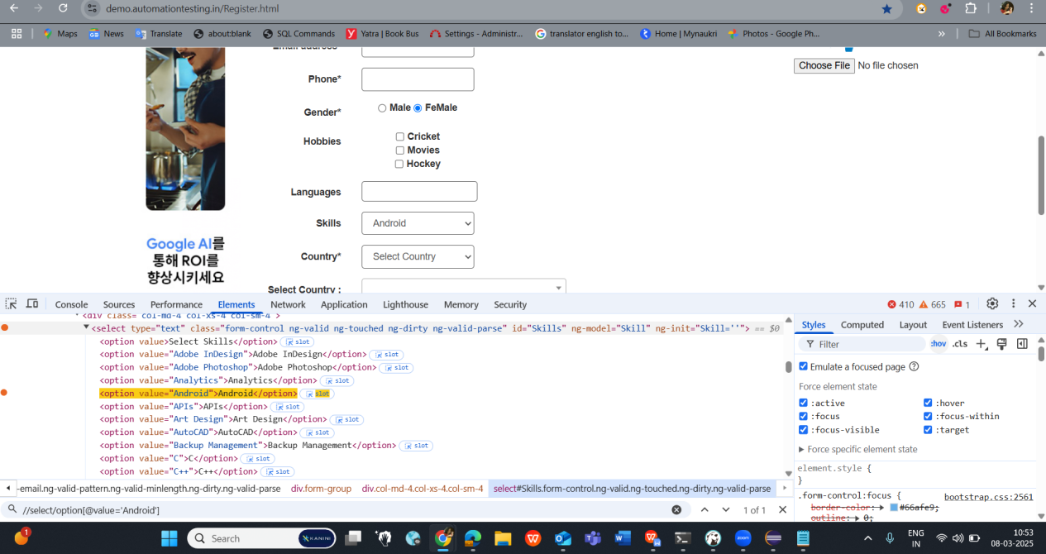

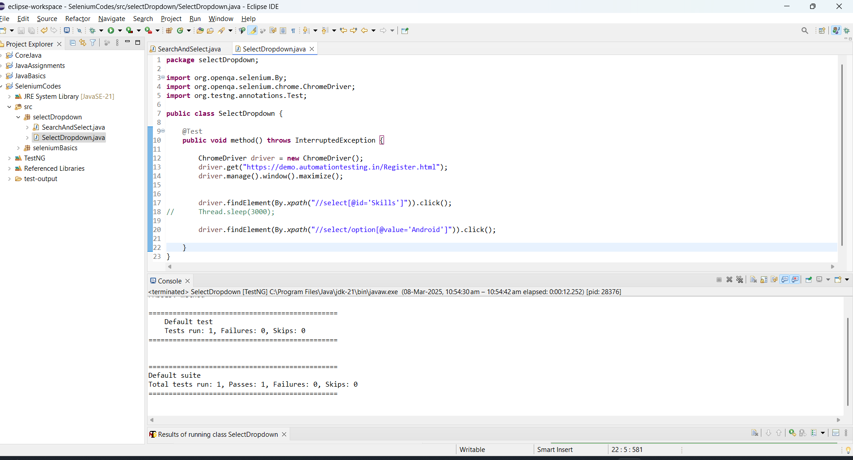

* Whenever the Select dropdown has the Select html tag, we have one more way to find the element.

SelectByVisibleText() -  
  
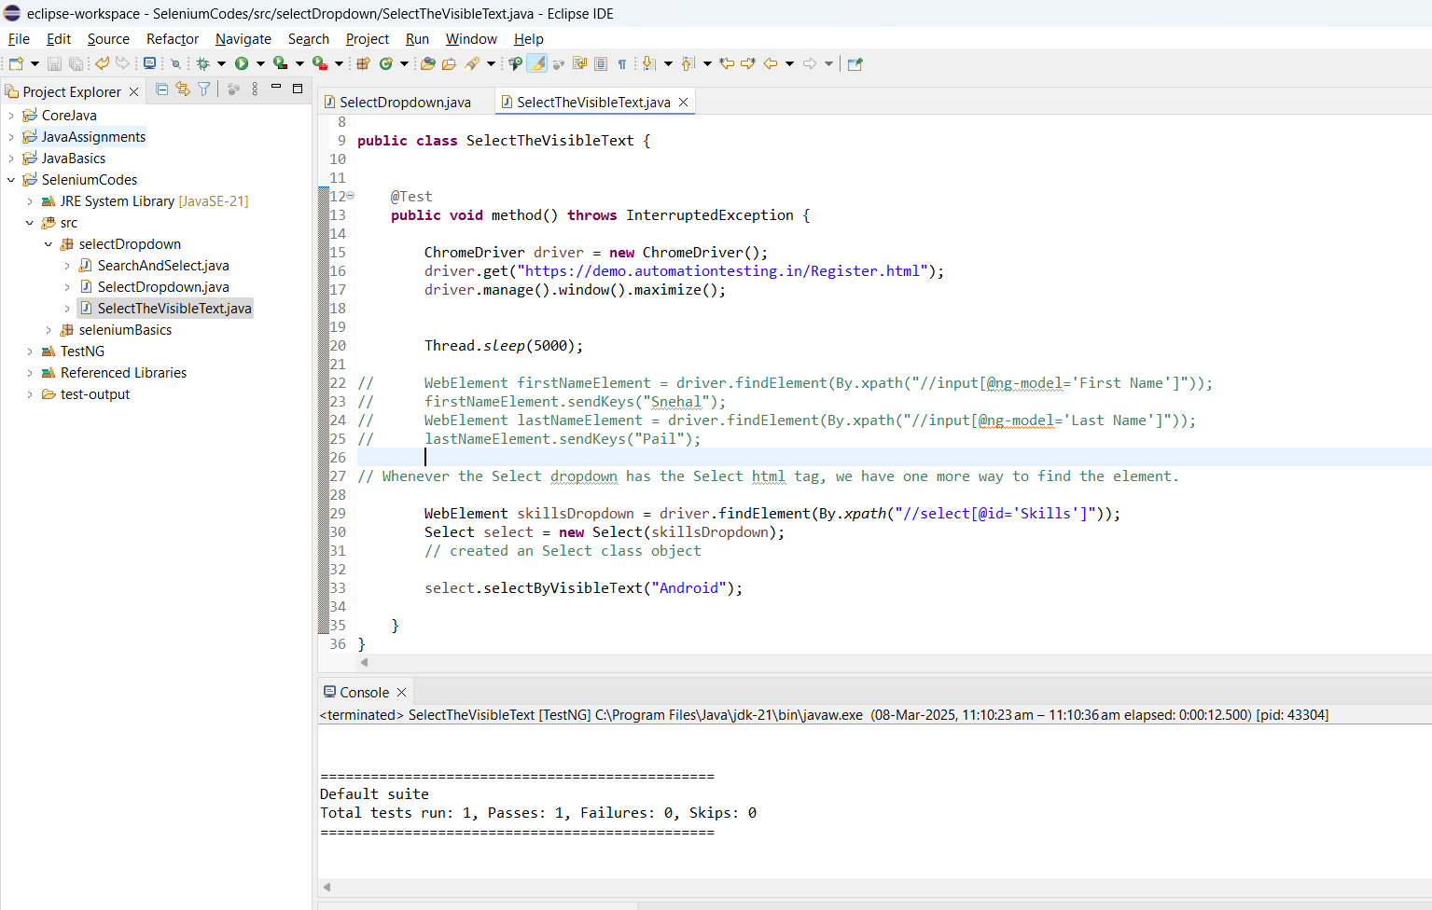

SelectByValue():

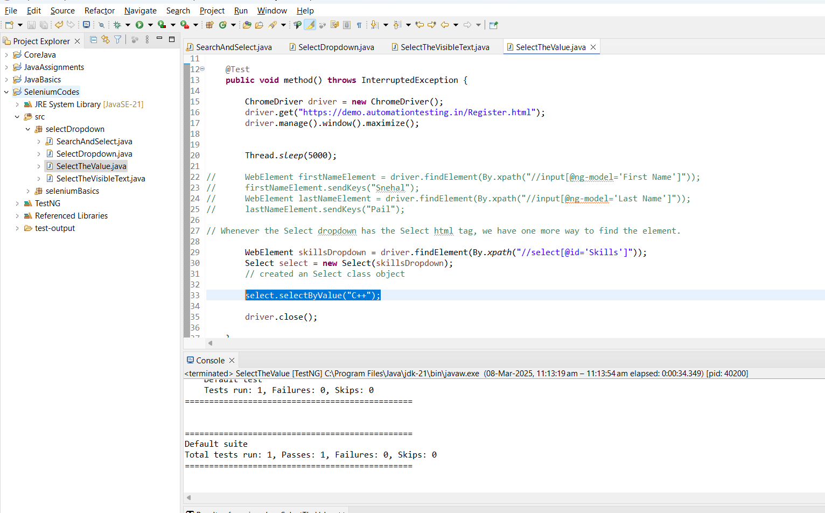

SelectByIndex():

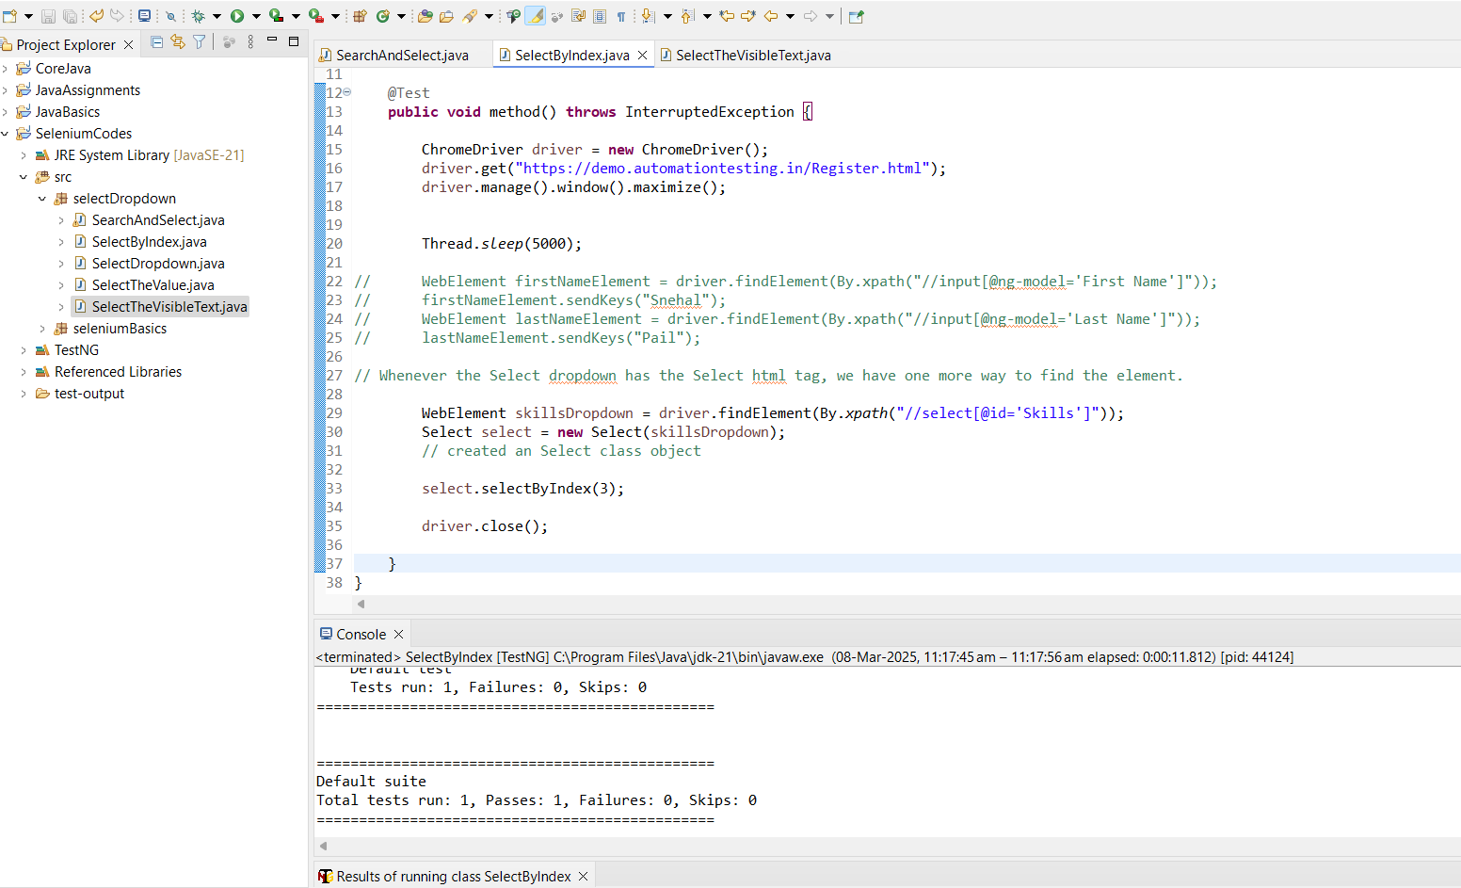

* select.selectByContainsVisibleText("**Adobe**");

// we can give partial text to search

While searching the values, if multiple value contains same name, in that case TestNg always selects the 1st visible text.

* How to print the selected value from the UI dropdown in the console->

getFirstSelectedOption()

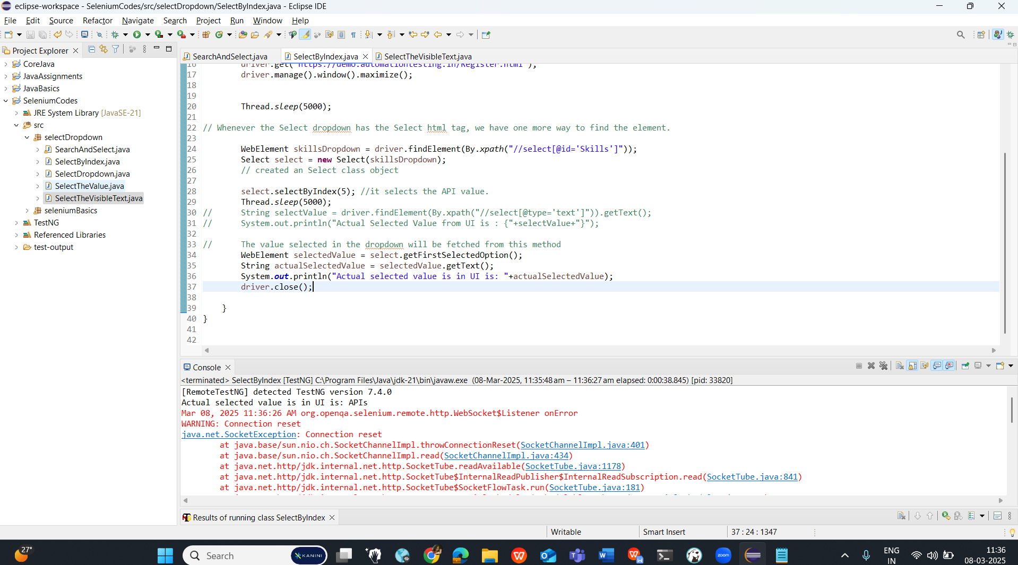

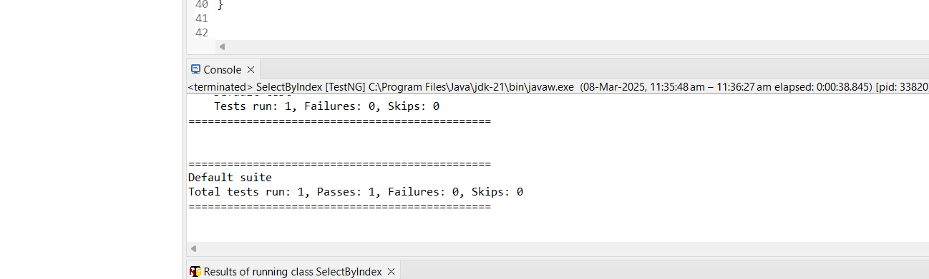

SelectByVisibleText () **and** SelectByValue():

**SelectByValue()**: refers to the option tag which has the Attribute value

**SelectByVisibleText()**: looks for the Hardcoded visible value or the Inner text of the tag.

**CLASS 8: (Day 28 )**

**CLASS 21: (Day 28)**

<https://demo.automationtesting.in/Alerts.html>

* **AlertBox > Alert with Ok Button**

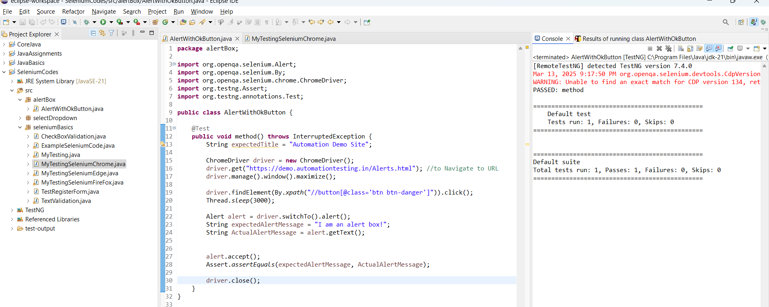

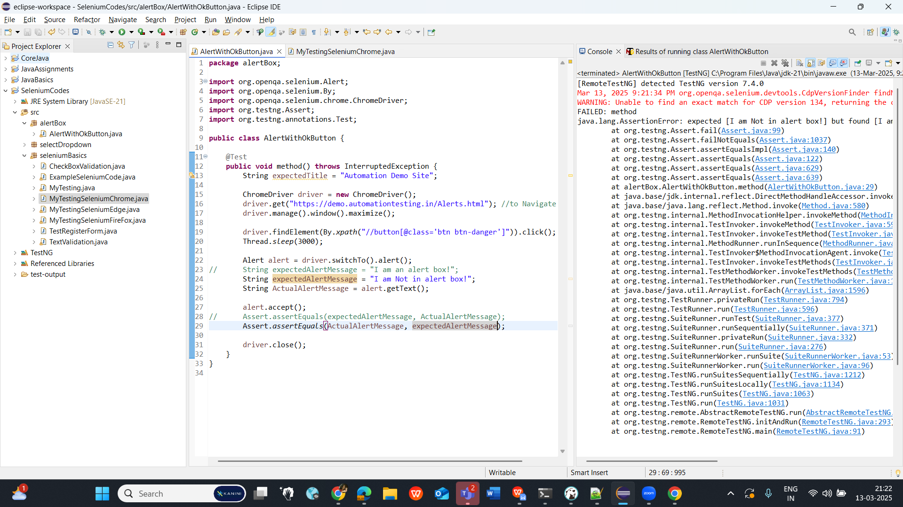

**Alert with Okay and Cancel Button:**

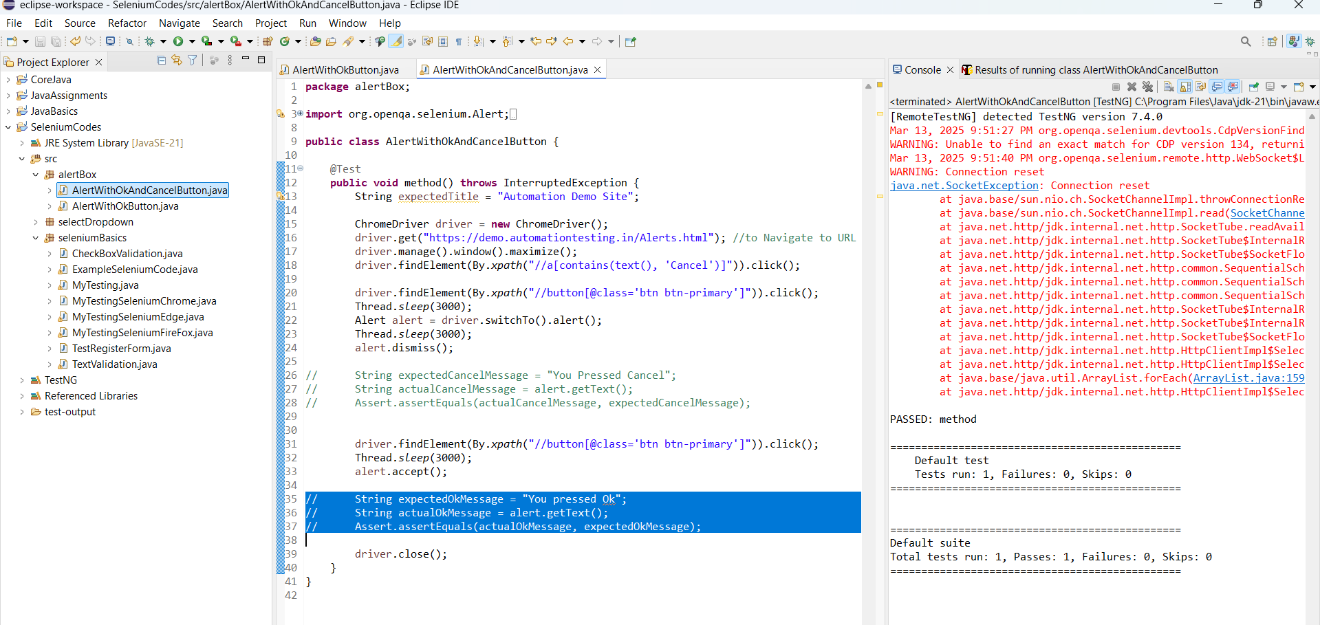

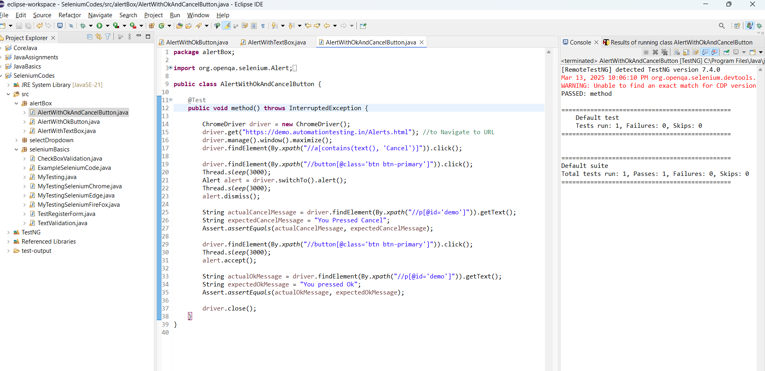

**Alert with TextBox:**

**(Assignment)**

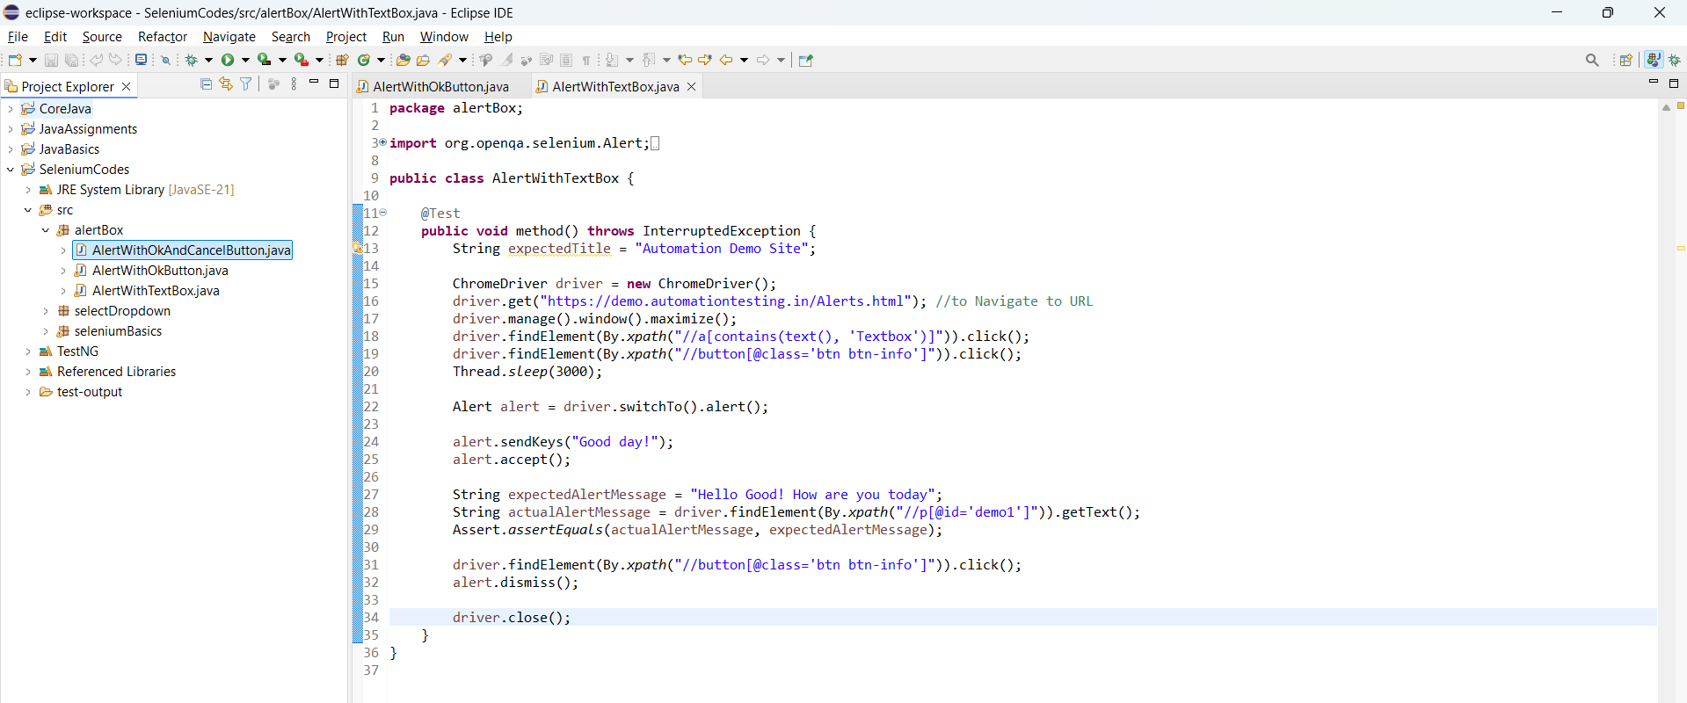

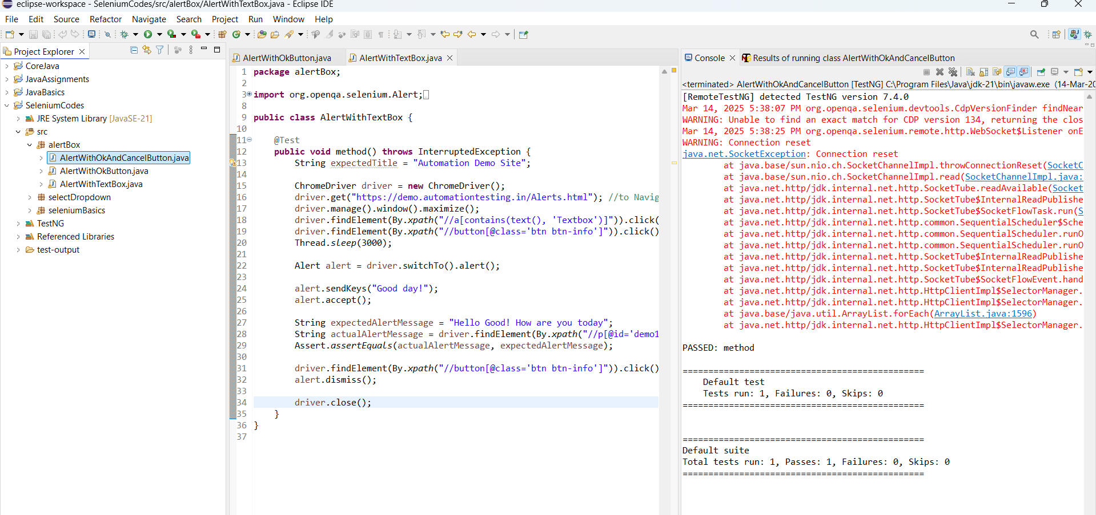

**CLASS 9: (Day 29)**

**Different Types of Locators:**

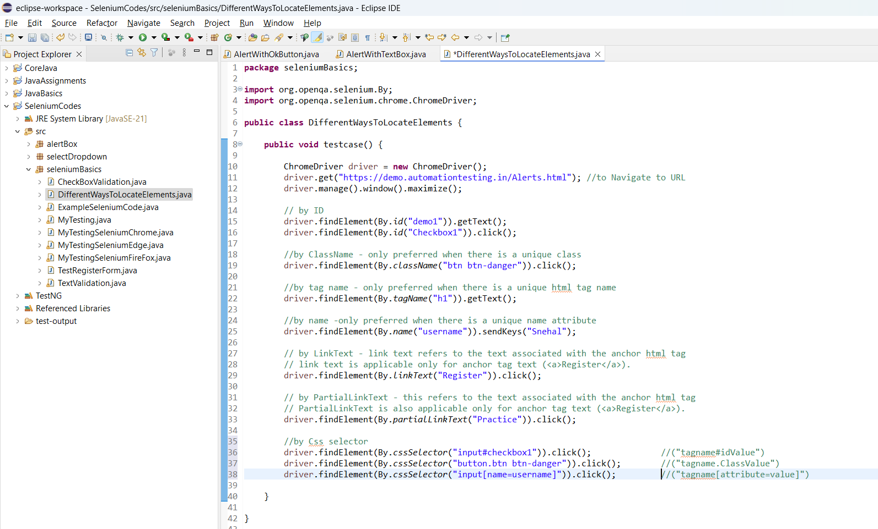

* Install the SelectorsHub extension to the browser.  
  <https://selectorshub.com/>

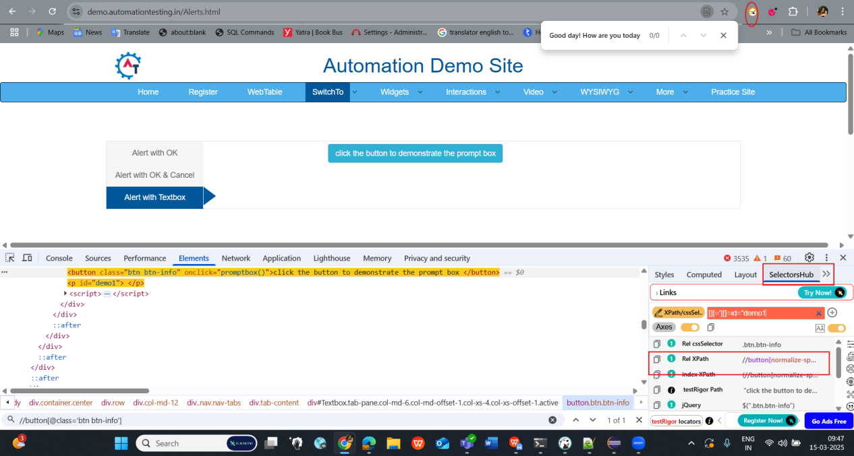

**Difference Between Relative Xpath and the Absolute Xpath:**

* Absolute Xpath starts right from the HTML tag and scans each element from the HTML tag.  
  Takes time if we consider the performance.
* Relative Xpath is best preferred when we consider the performance wise.

Here we have moved to Java concept.

**CLASS 10: (Day 30)**

Multiple Tab Handling :

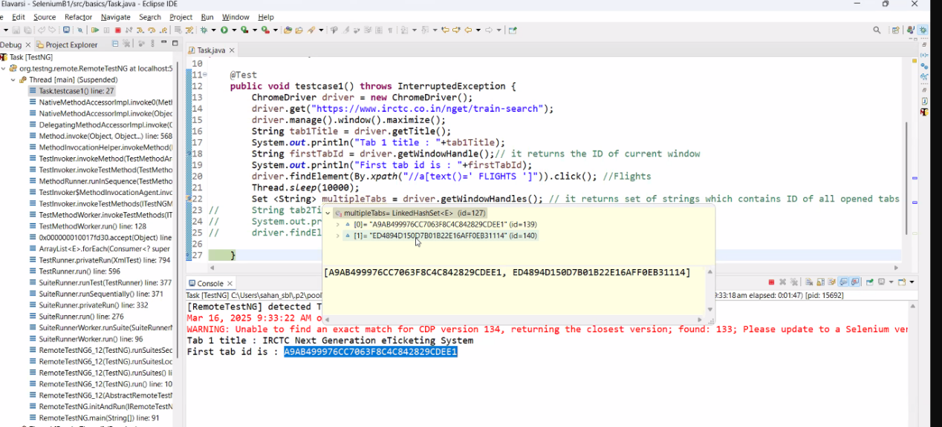

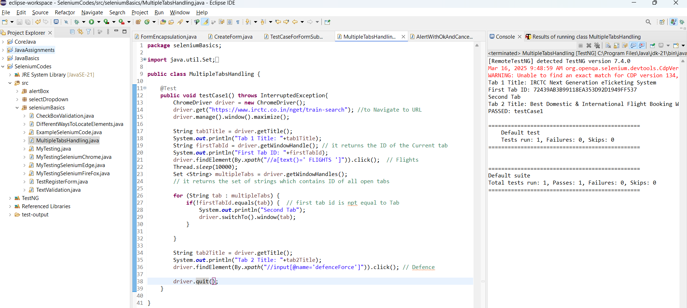

Multiple Windows:

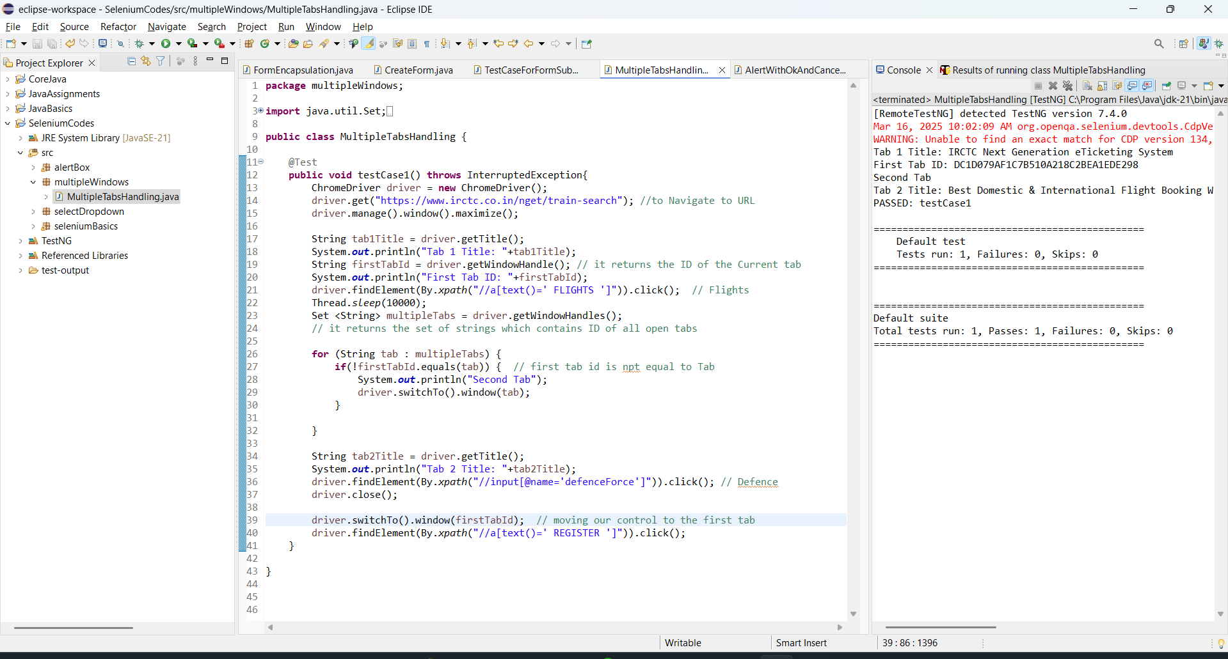

**CLASS 11: (Day 31)  
  
TIME OUT:**

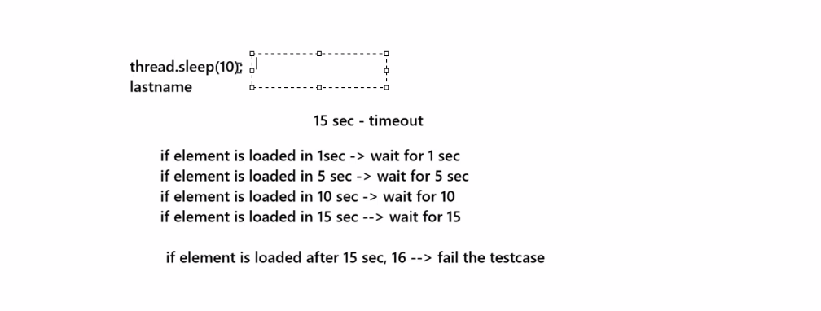

// with Implicit Wait for right Xpath -> 4.39s

// with Implicit Wait for wrong Xpath -> 8.9s

// with thread -> 9.5s

// without thread -> 6s

// timeout -> if element exists, perform the operation.

// if the element is not displayed, wait for the element till max timeout.

* Where and all the Implicit wait is applicable ->   
  we feed the Implicit wait to the driver hence,

wherever we are using "driver." there everywhere Implicit wait is applicable throughout the code.

* Till when the Implicit wait is alive?  
   until Driver.close() gets executed.

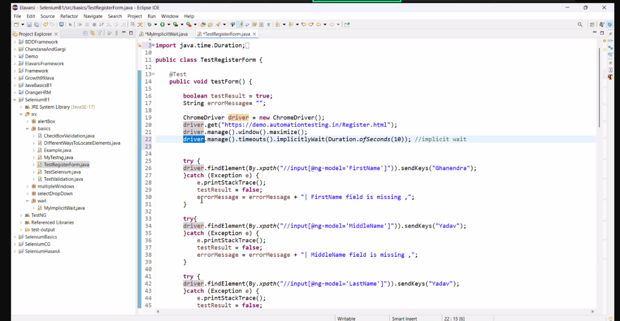

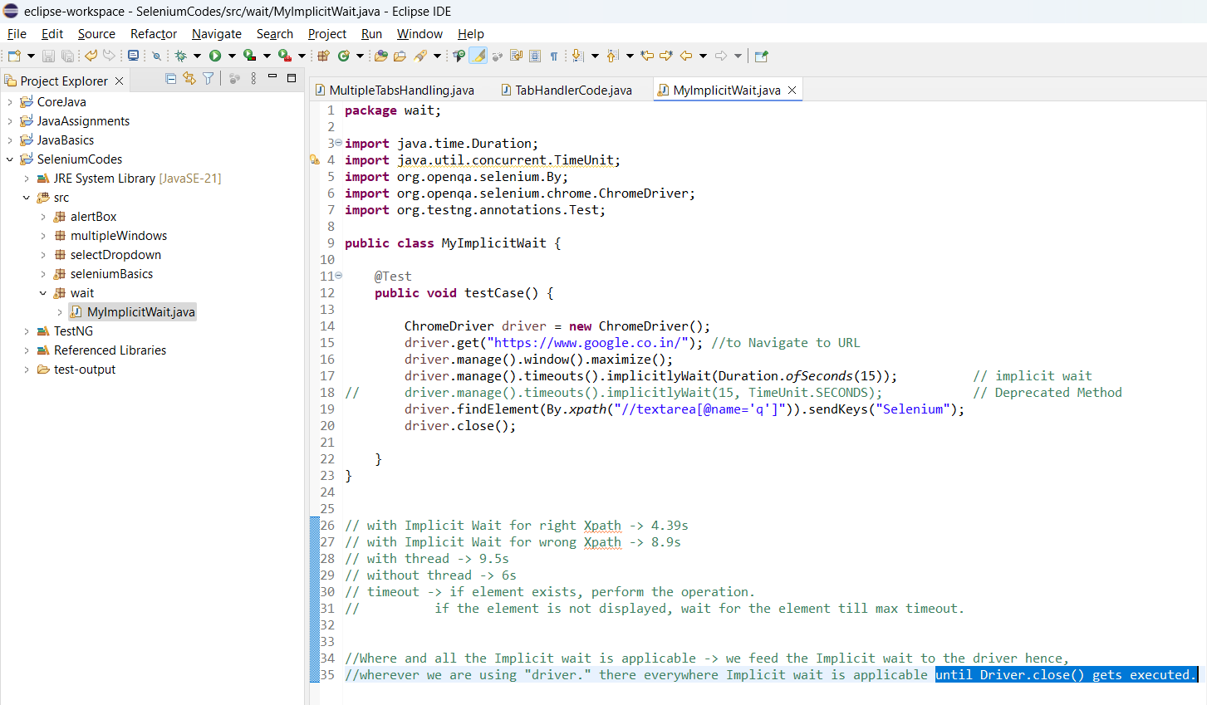

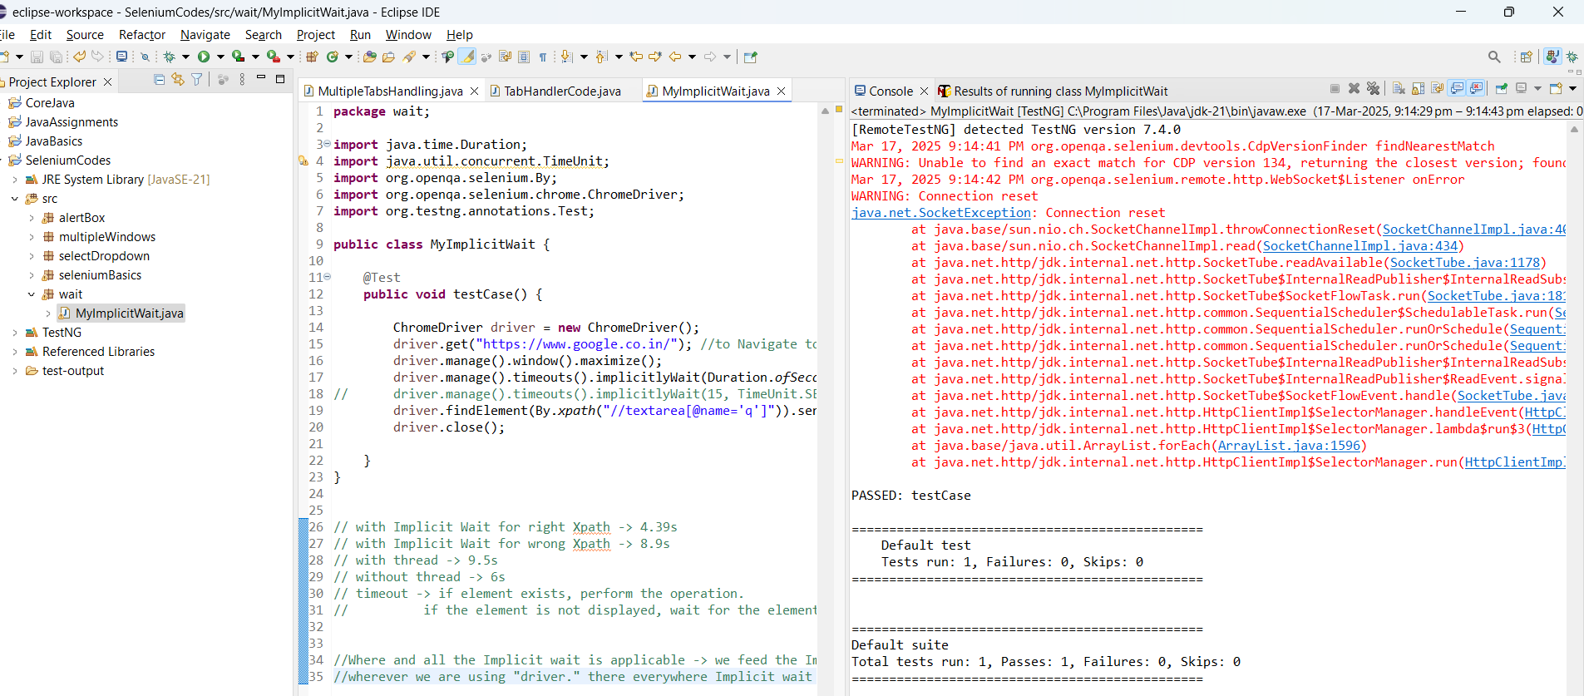

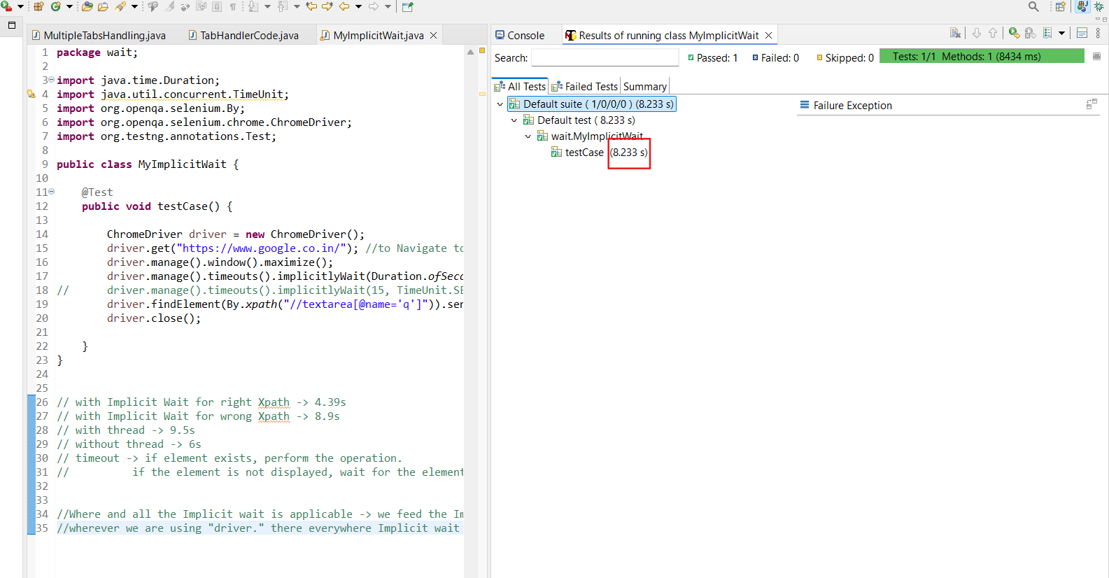

// pageLoadTimeout is only applicable for the respective page only.

// if we navigate to any other / new page, the same pageLoadTimeout is not applicable.

// Every new page new PageLoadTimeout should be added.

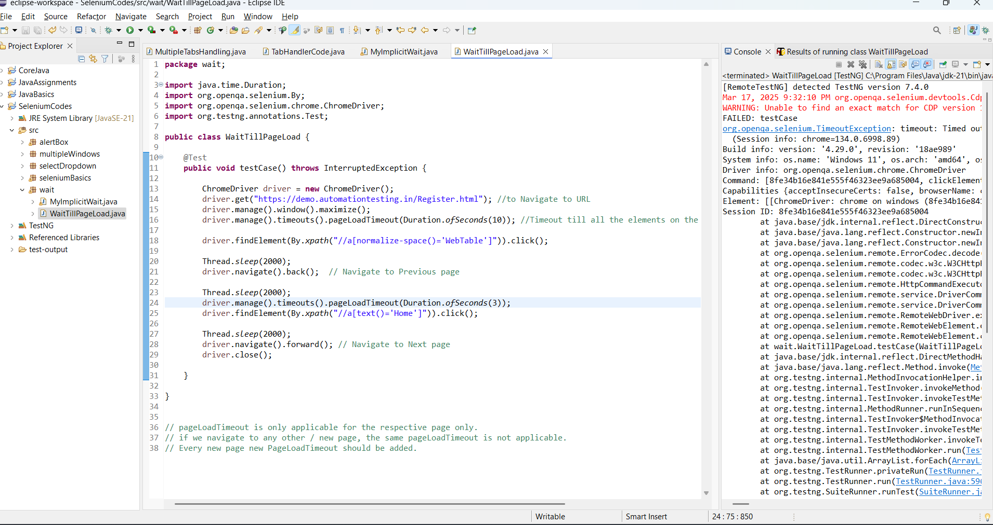

* **Browser back and forward Button handling:**

driver.navigate().back(); // Navigate to Previous page

driver.navigate().forward(); // Navigate to Next page

**CLASS 12: (Day 32)**

Explicit wait is applicable to only the specific class.

We can use implicit and Explicit wait in a same class.

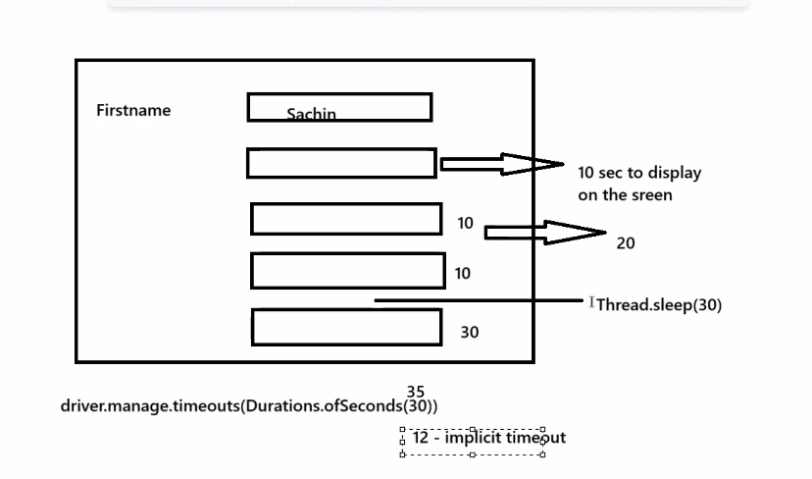

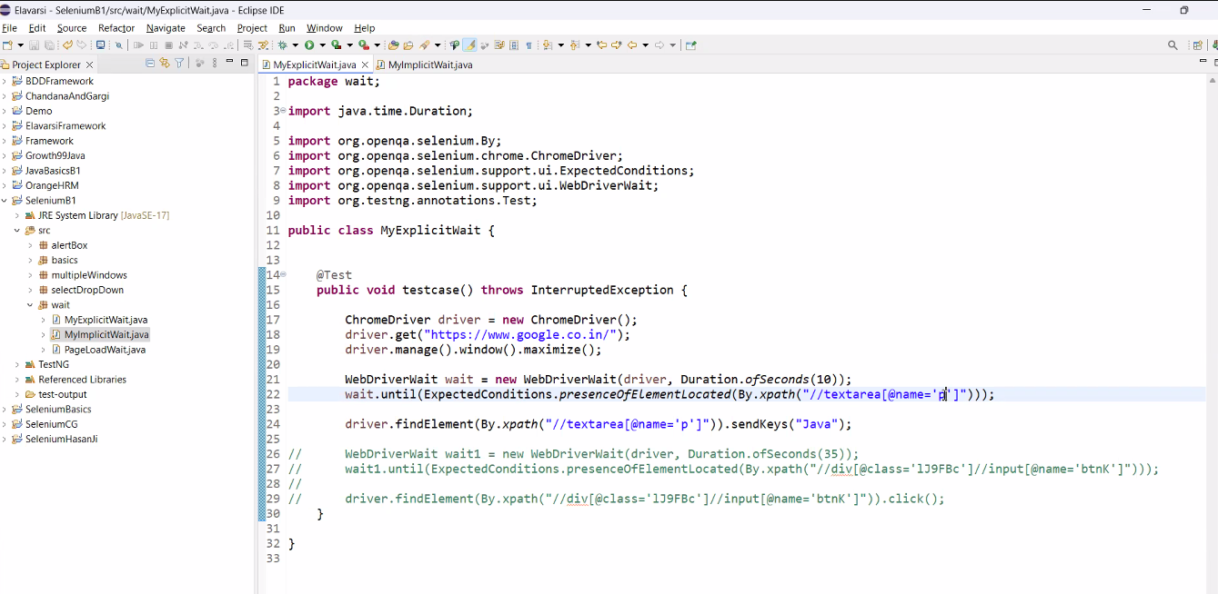

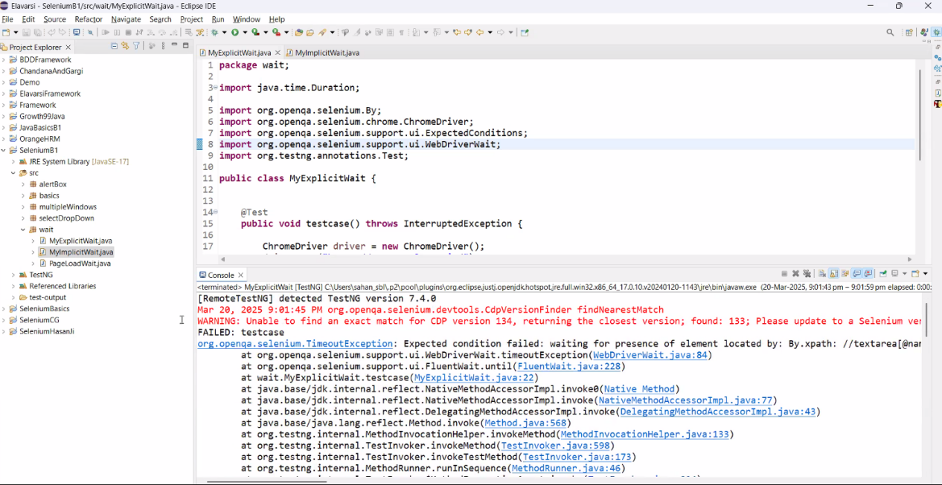

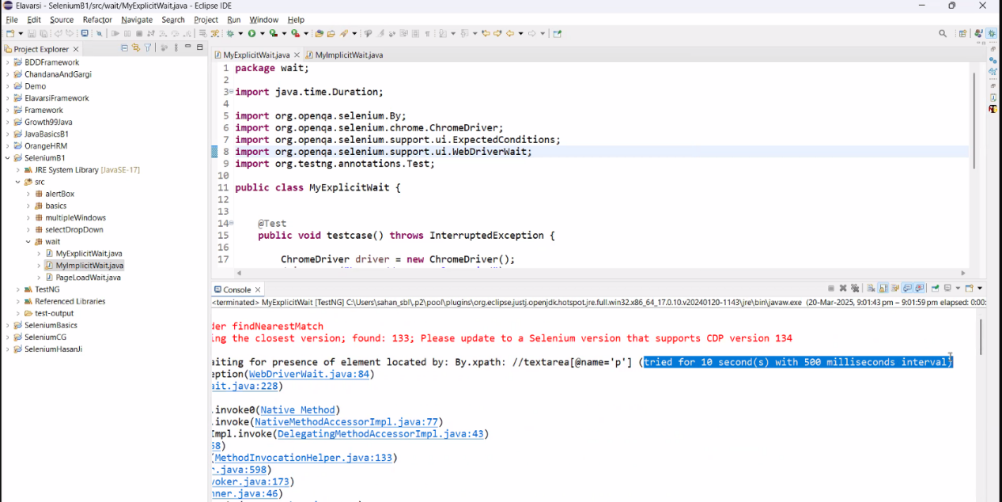

Every 500 ms it loops itself to search the element.

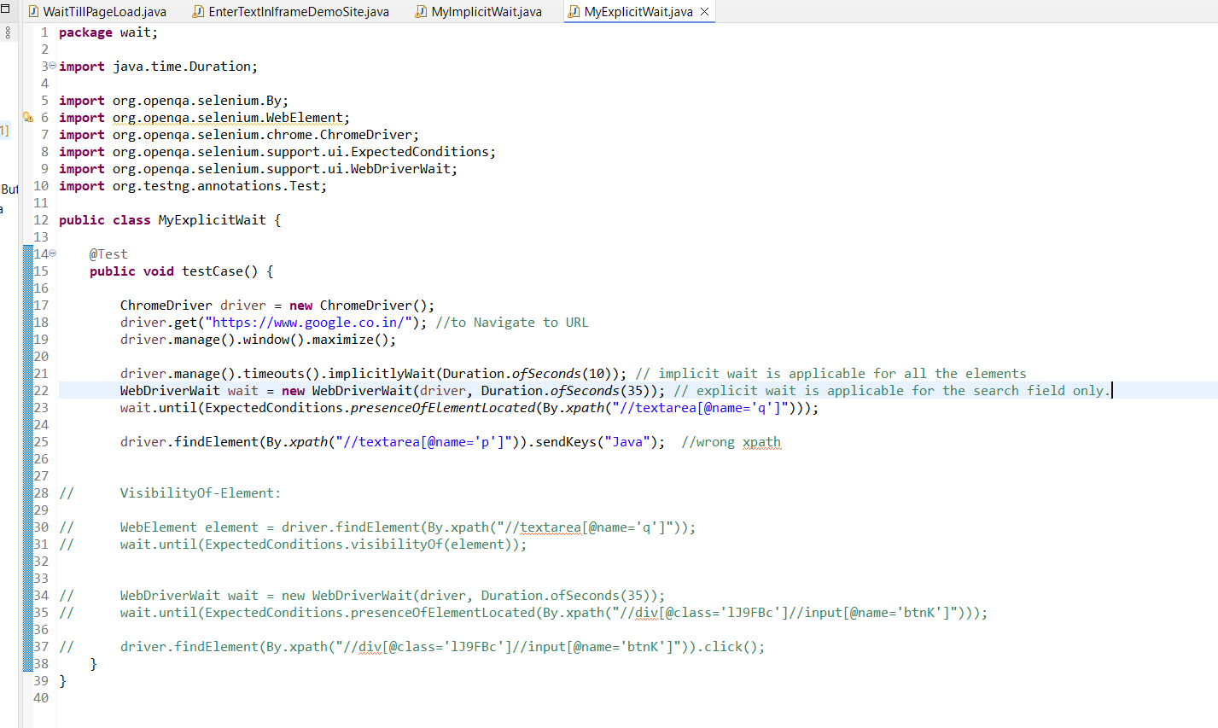

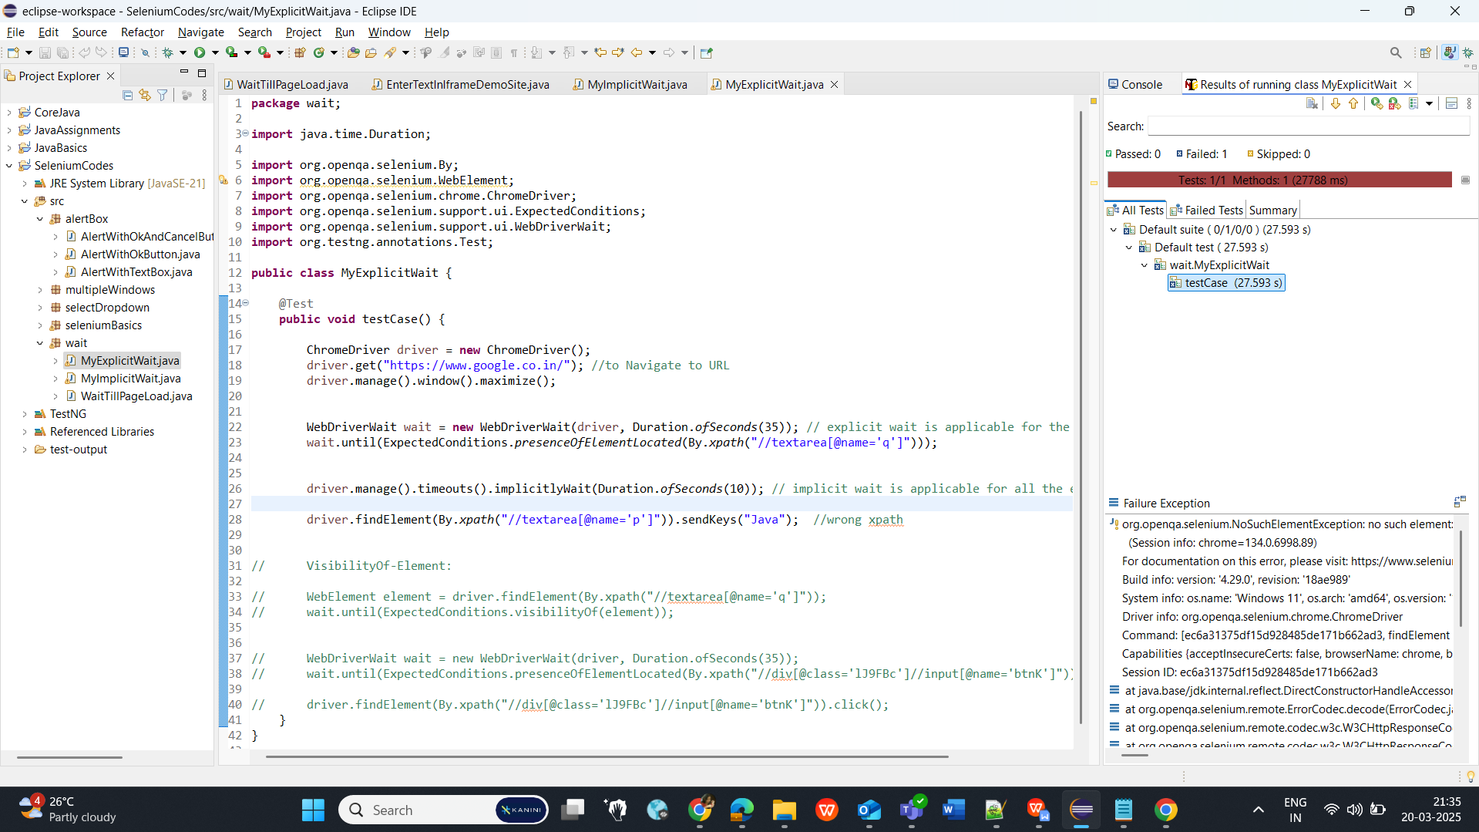

**CLASS 13: (Day 33)**

**iFrame :**(WebPage inside the WebPage)

**Driver.switchTo.frame();**

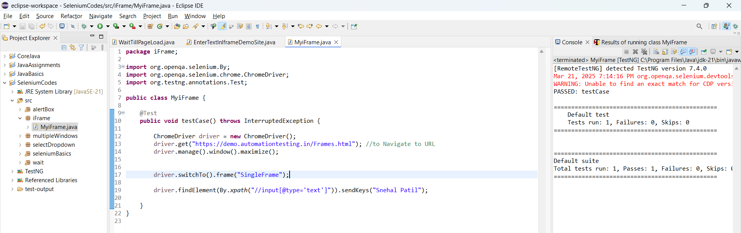

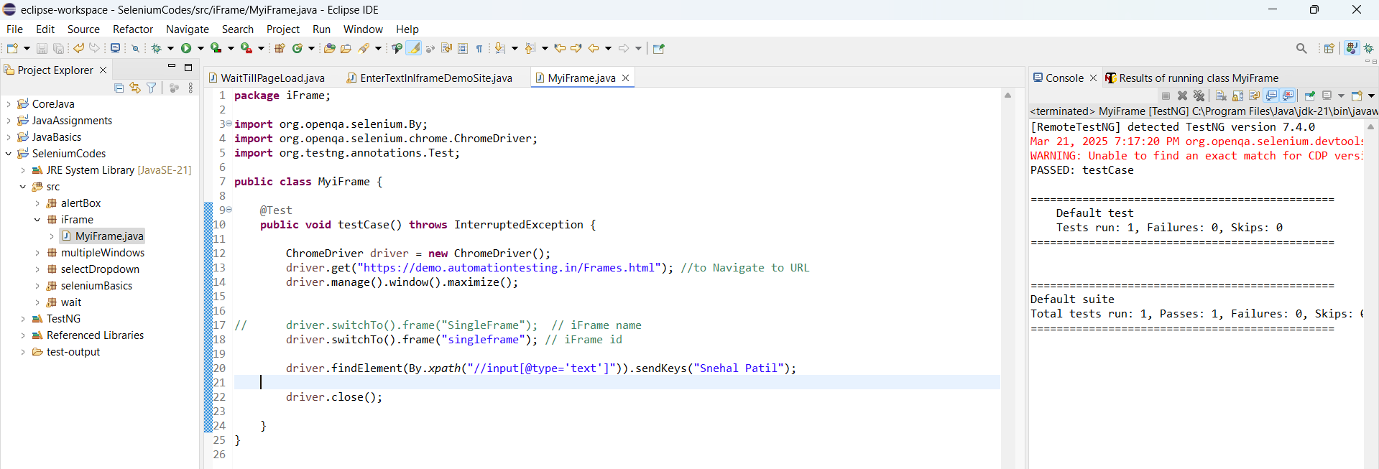

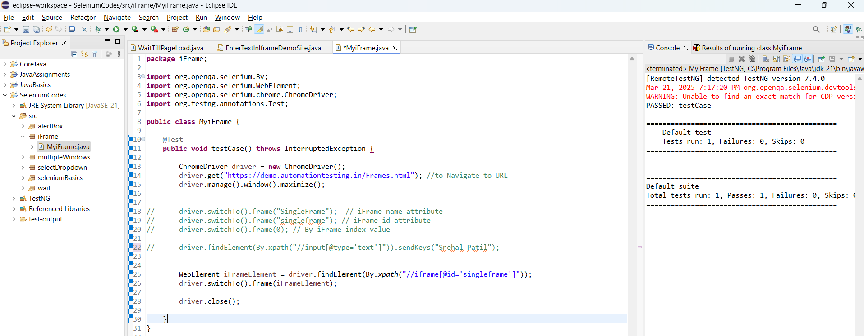

**Multiple iFrame :**

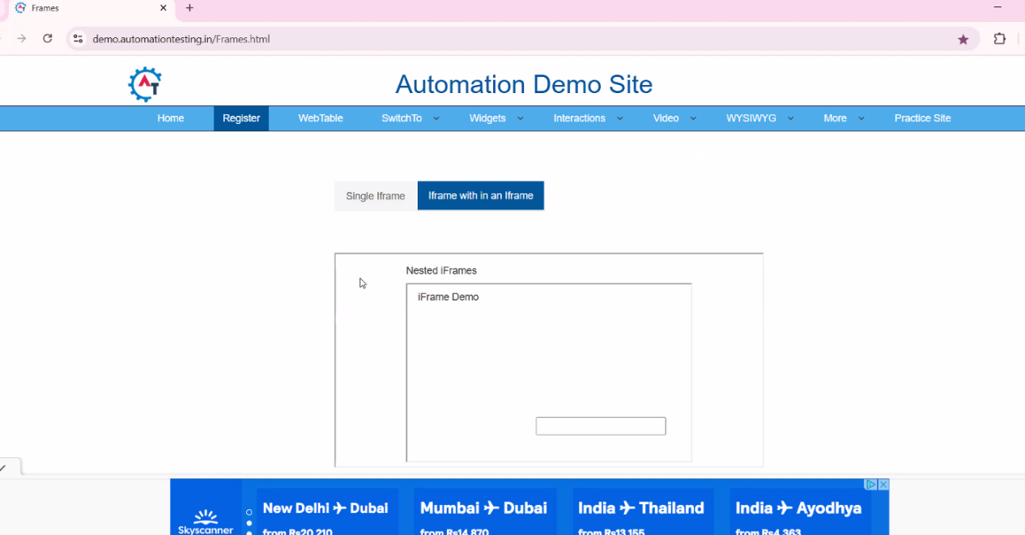

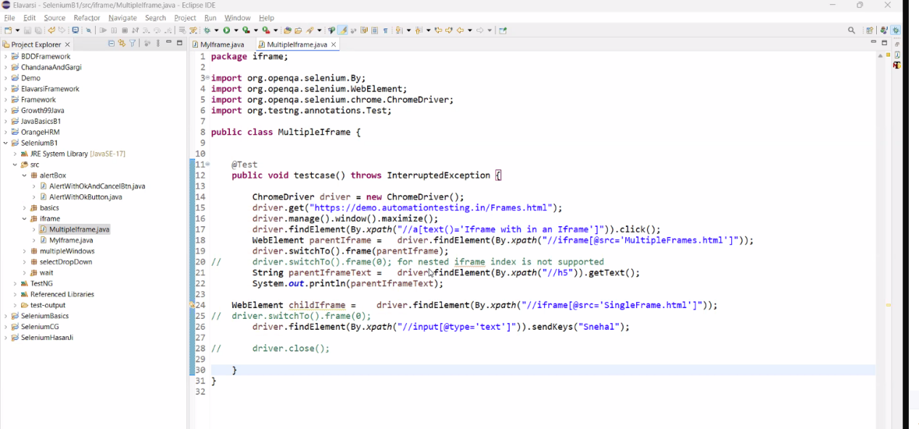

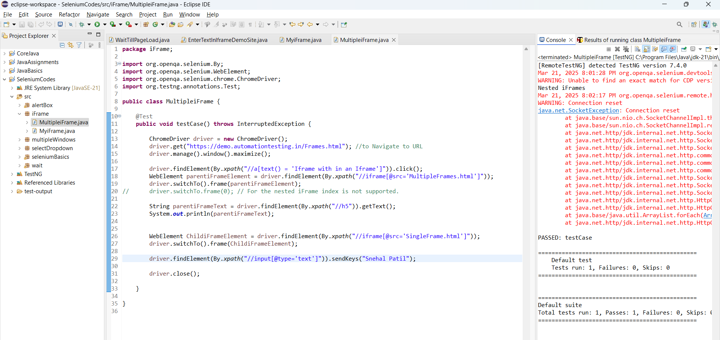

**Navigate Back to Child iFrame to Parent IFrame:**

driver.switchTo().parentFrame();   
// it moves the control from child frame to parent frame

driver.switchTo().defaultContent();

// it moves the control from frame to main frame

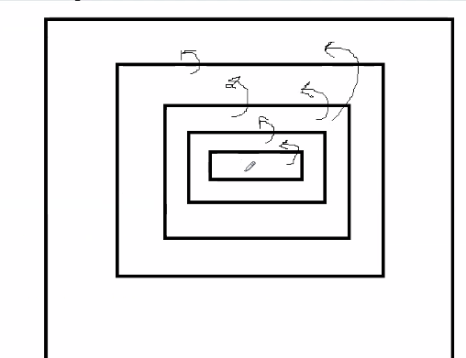

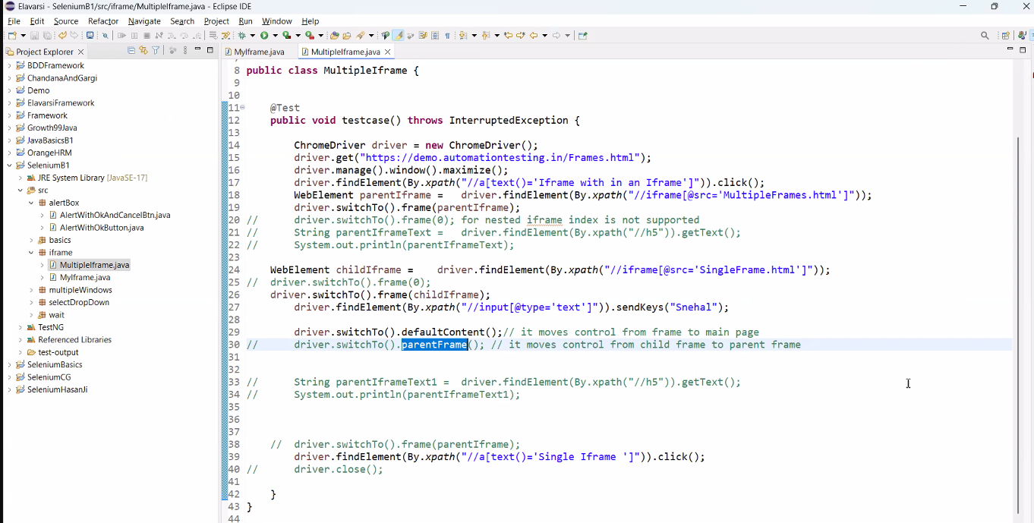



**CLASS 14: (Day 34)**

* **Whenever we are doing multiple events, then we have to go ahead with Action class.**

myActions.dragAndDrop(srcElement, destinationElement).build().perform();

// while using action class we have to use Build() and perform() along with Action class.

* **Drag and Drop:**

https://jqueryui.com/resources/demos/droppable/default.html

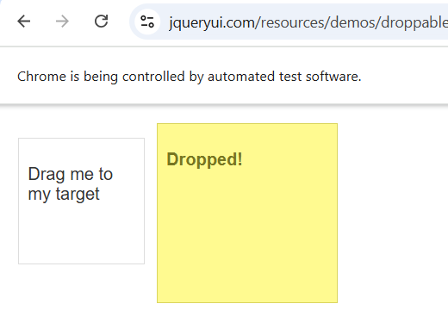

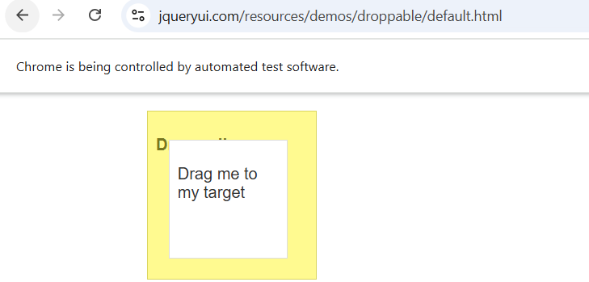

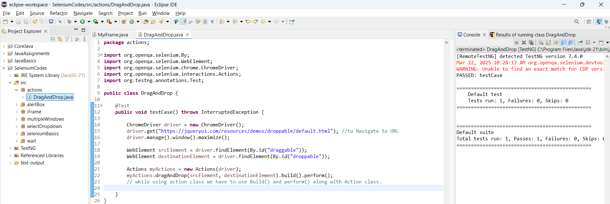

* **Convert the Lower case value in Upper case:**

myActions.moveToElement(firstName).keyDown(Keys.***SHIFT***).sendKeys("snehal").build().perform();

// moveToElement() mouse hovering on the element but will not perform any action.

myActions.contextClick(firstName).keyDown(Keys.***SHIFT***).sendKeys("snehal").keyUp(Keys.***SHIFT***).build().perform();

// contextClick(firstName) will go and right click on the element we have passed.

myActions.click(firstName).keyDown(Keys.***SHIFT***).sendKeys("snehal").keyUp(Keys.***SHIFT***).build().perform();

// click() will click on the element we have passed.

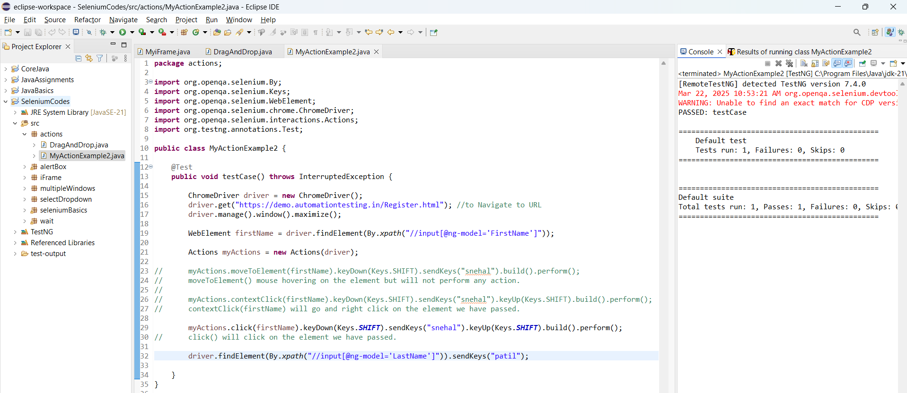

* Multiple Events:

1st approach: Direct way

// myActions.moveToElement(switchTo).build().perform();

// driver.findElement(By.xpath("//a[text()='Windows']")).click();

2nd approach: Multiple steps

// myActions.moveToElement(switchTo).build().perform();

// myActions.click(windows).build().perform();

3rd approach: single step

myActions.moveToElement(switchTo).click(windows).build().perform();

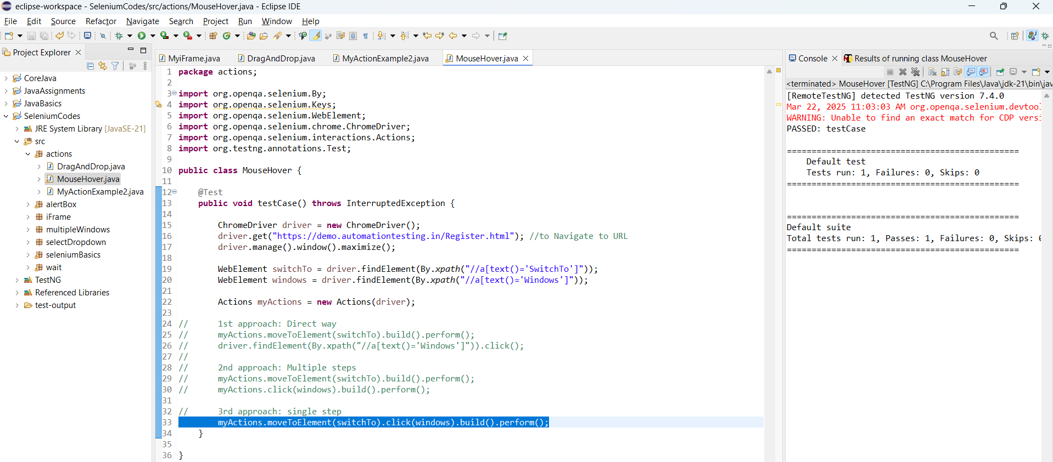

* How to Take Screenshot:

<https://mvnrepository.com/artifact/commons-io/commons-io/2.18.0>

Download the Jar file to support FileUtils and configure it to the buildpath.

2 liner Code To take a screenshot:

TakesScreenshot screenshot = (TakesScreenshot)driver;

File srcFile = screenshot.getScreenshotAs(OutputType.***FILE***);

// Storing the screenshot taken in a Destination folder file.

FileUtils.*copyFile*(srcFile, **new** File("path along with name for the screenshot"+randomNumber+".png"));

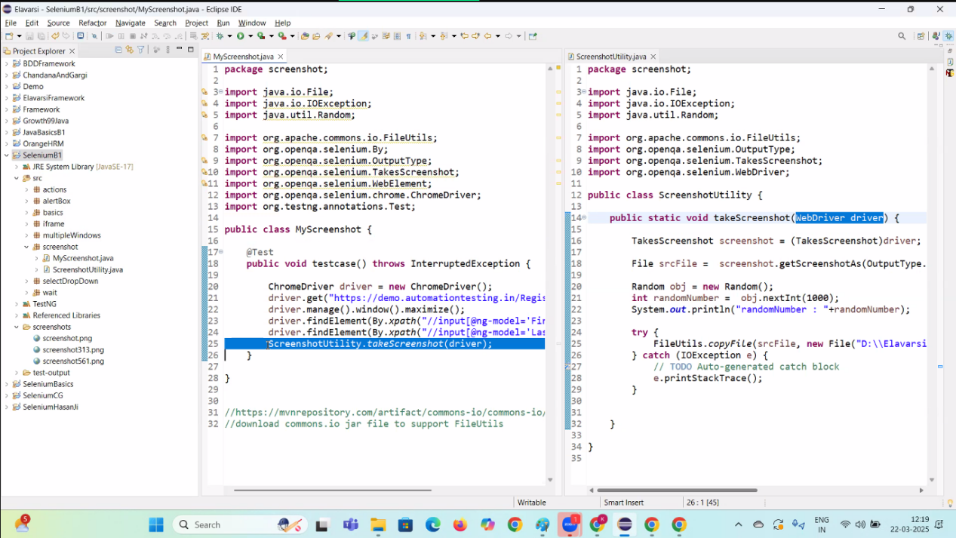

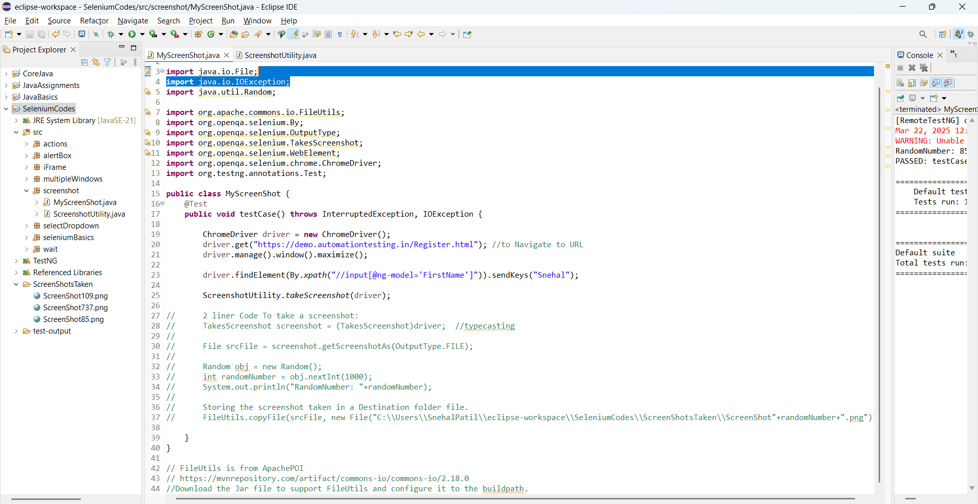

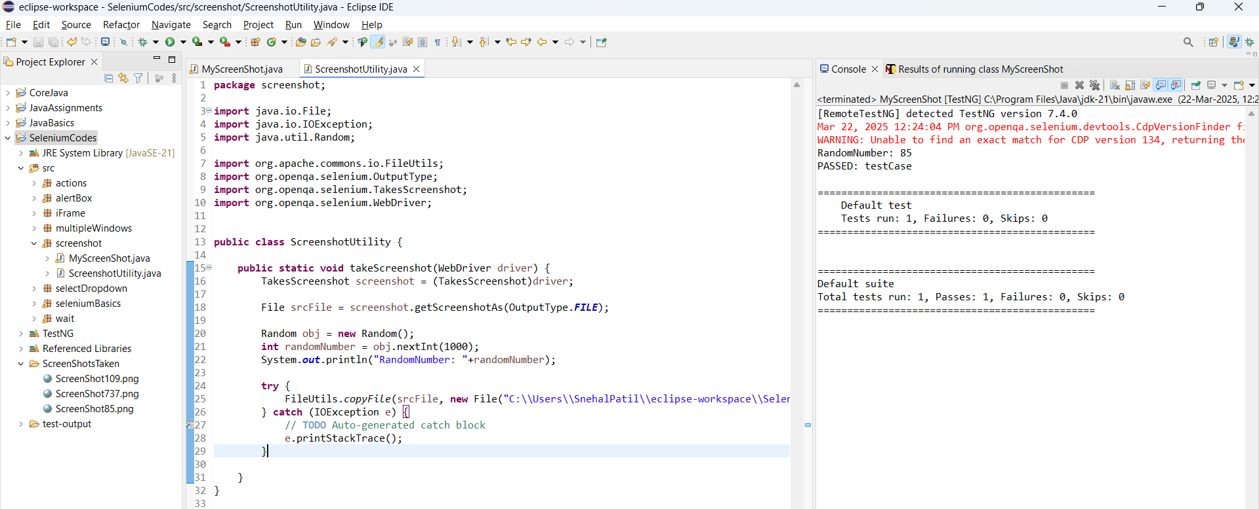

**CLASS 15: (Day 36)**

**WebTable:**

When the HTML code has the html tag as <table>

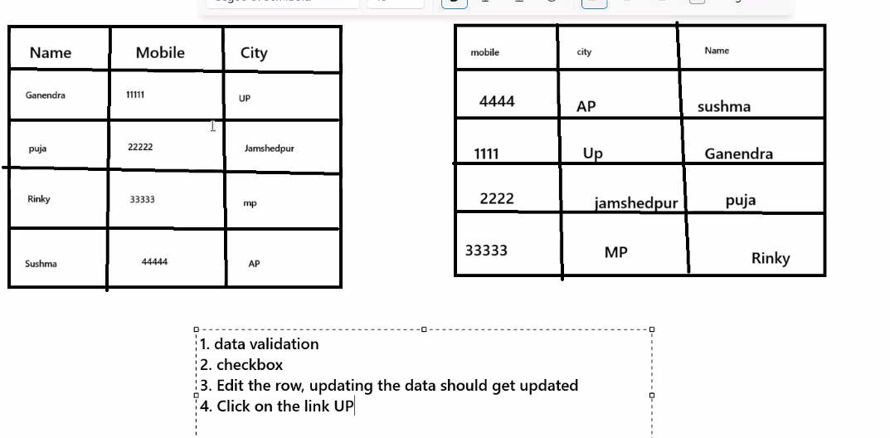

**We need to understand 4 entities to work on WebTable:**

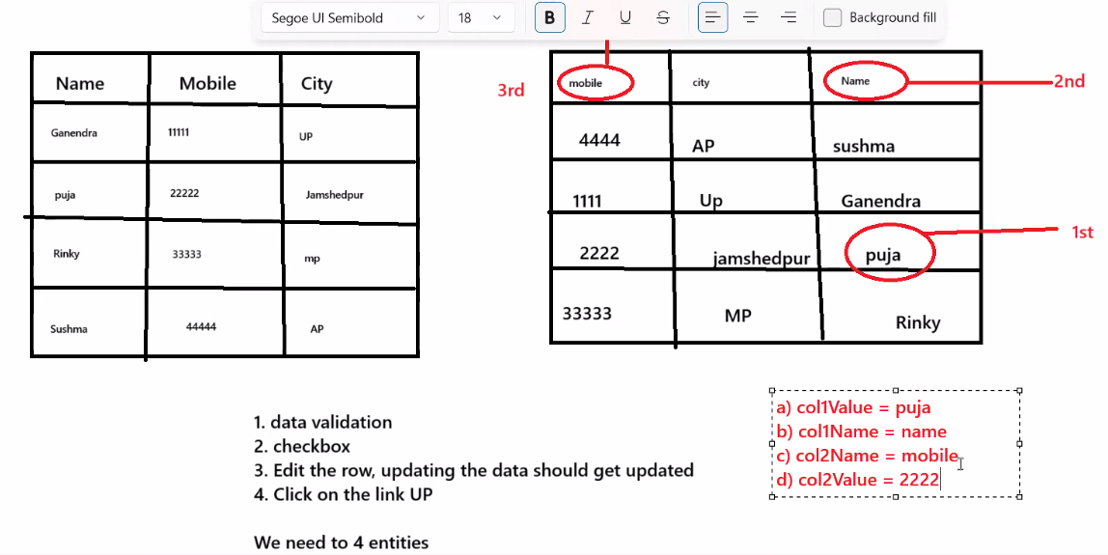

Example:

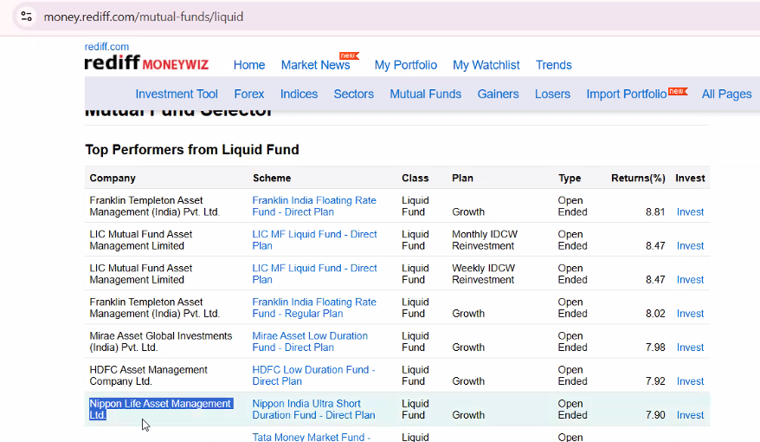

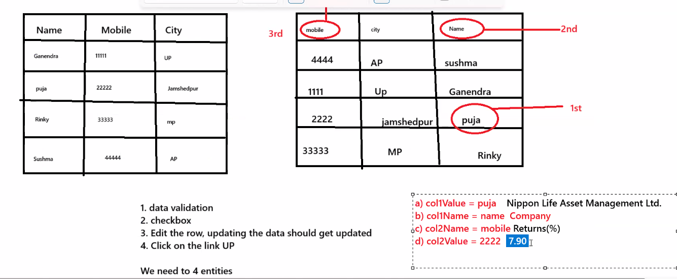

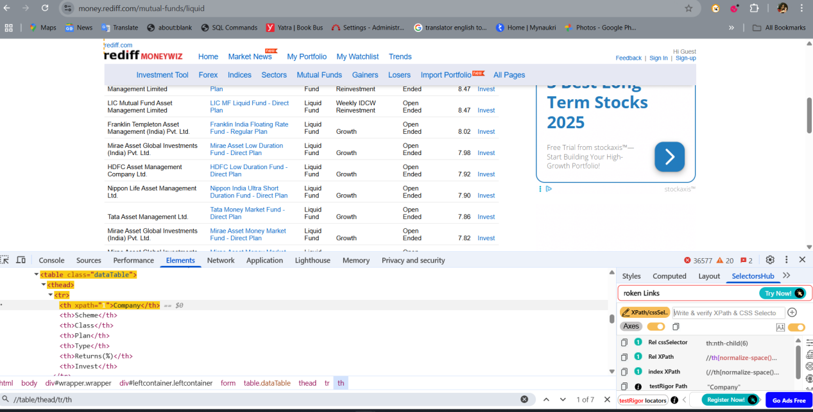

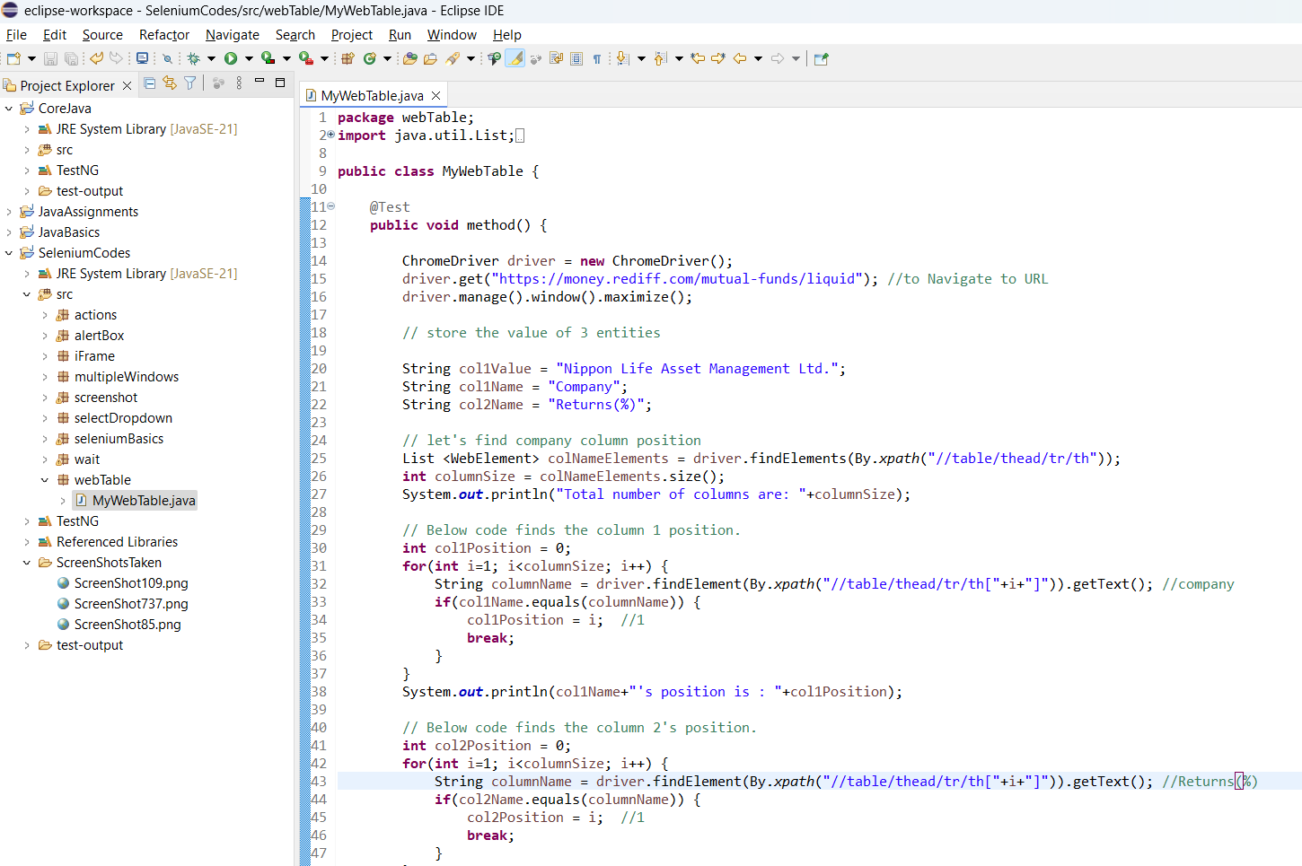

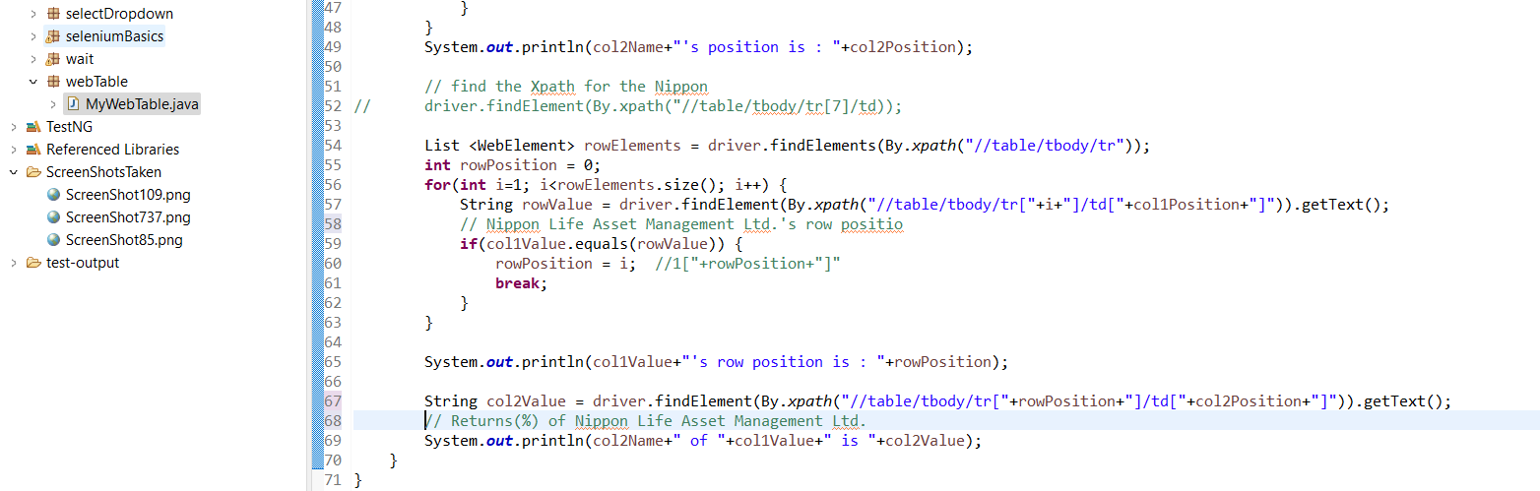

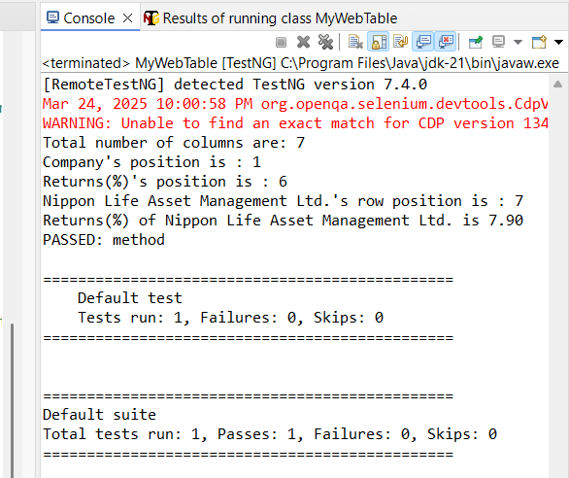

Created util classes for the column position and the Row Position and used->

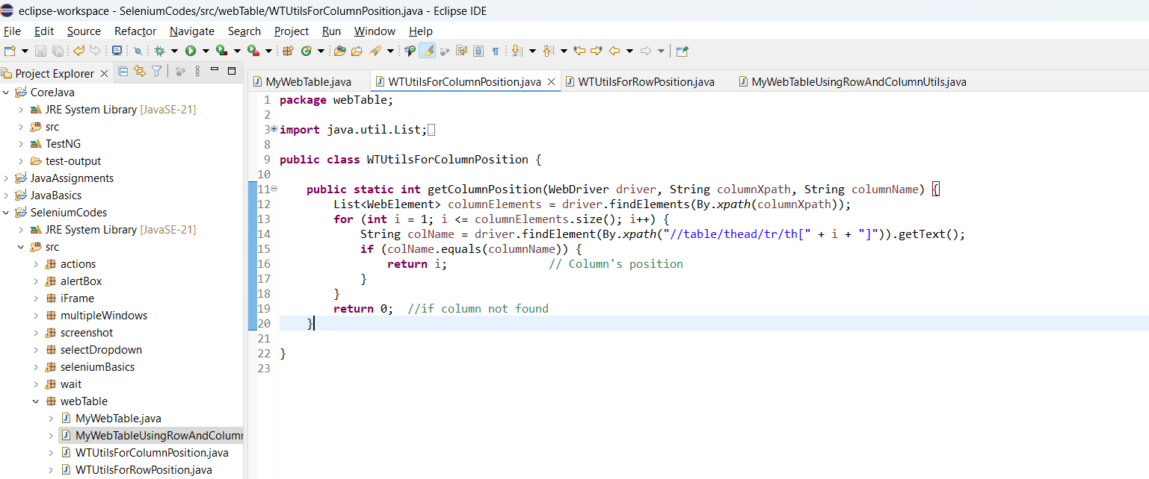

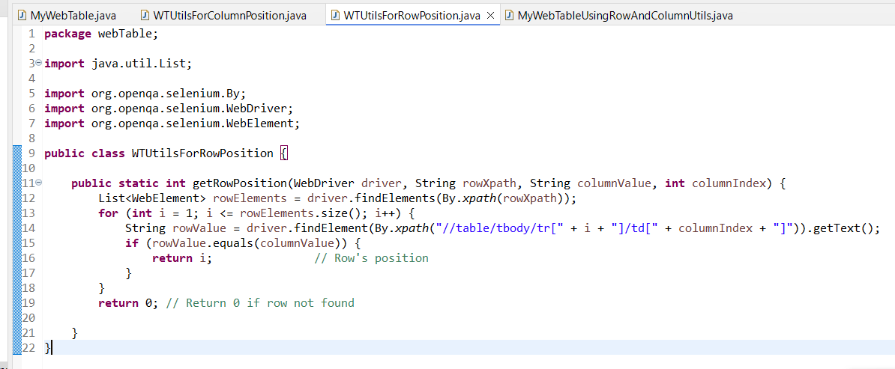

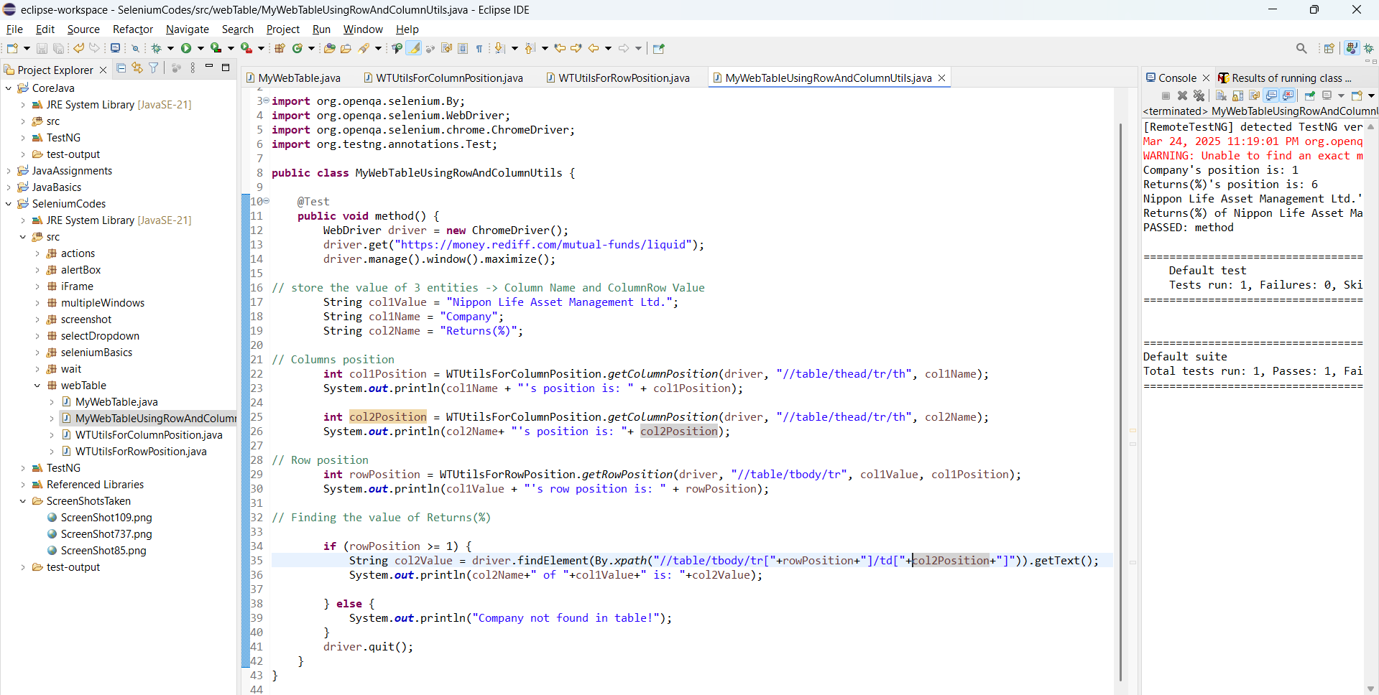

**CLASS 16: (Day 38)**

Right click on SRC  
Go to Properties  
Go to location, click on “show in system explorer”

Open src folder,

Click on new tab, open desktop in new tab, copy the extracted MyTestNG

Paste in the 1st tab > in SRC folder.

Now refresh the src folder under selenium codes in the Eclipse

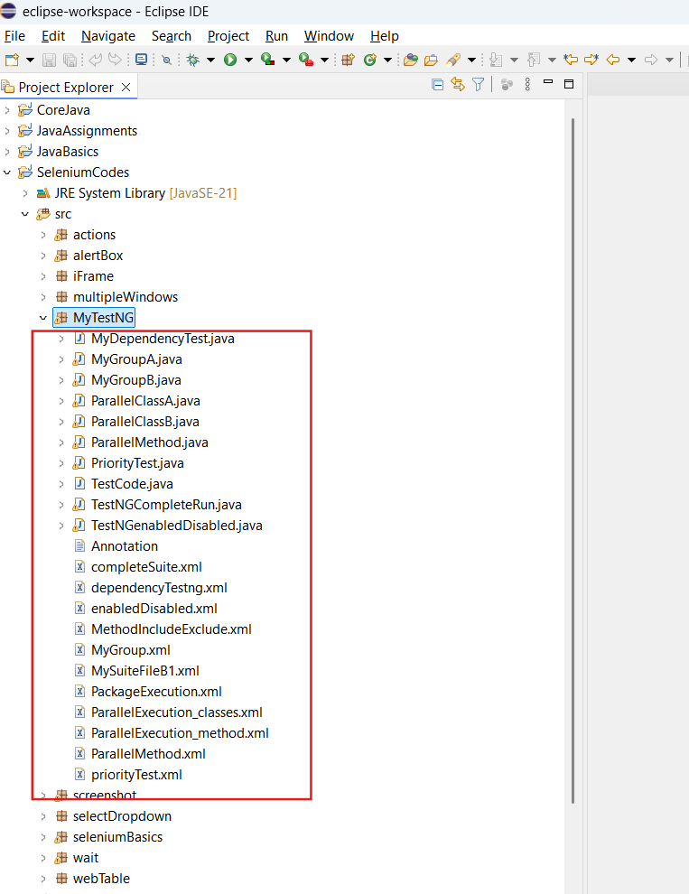  
  
  
**Syntax (Structure) for TestNG XML file :**  
for more information refer - https://testng.org/

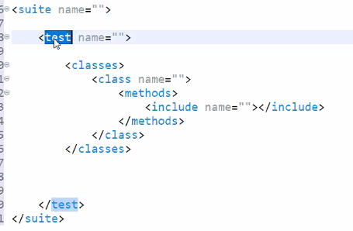

Convert all the classes to TestNG

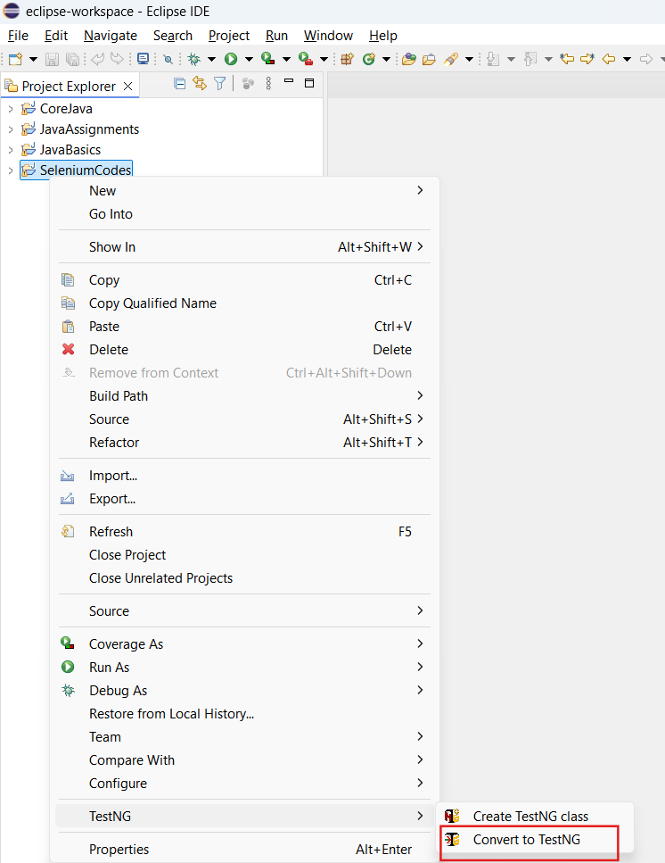

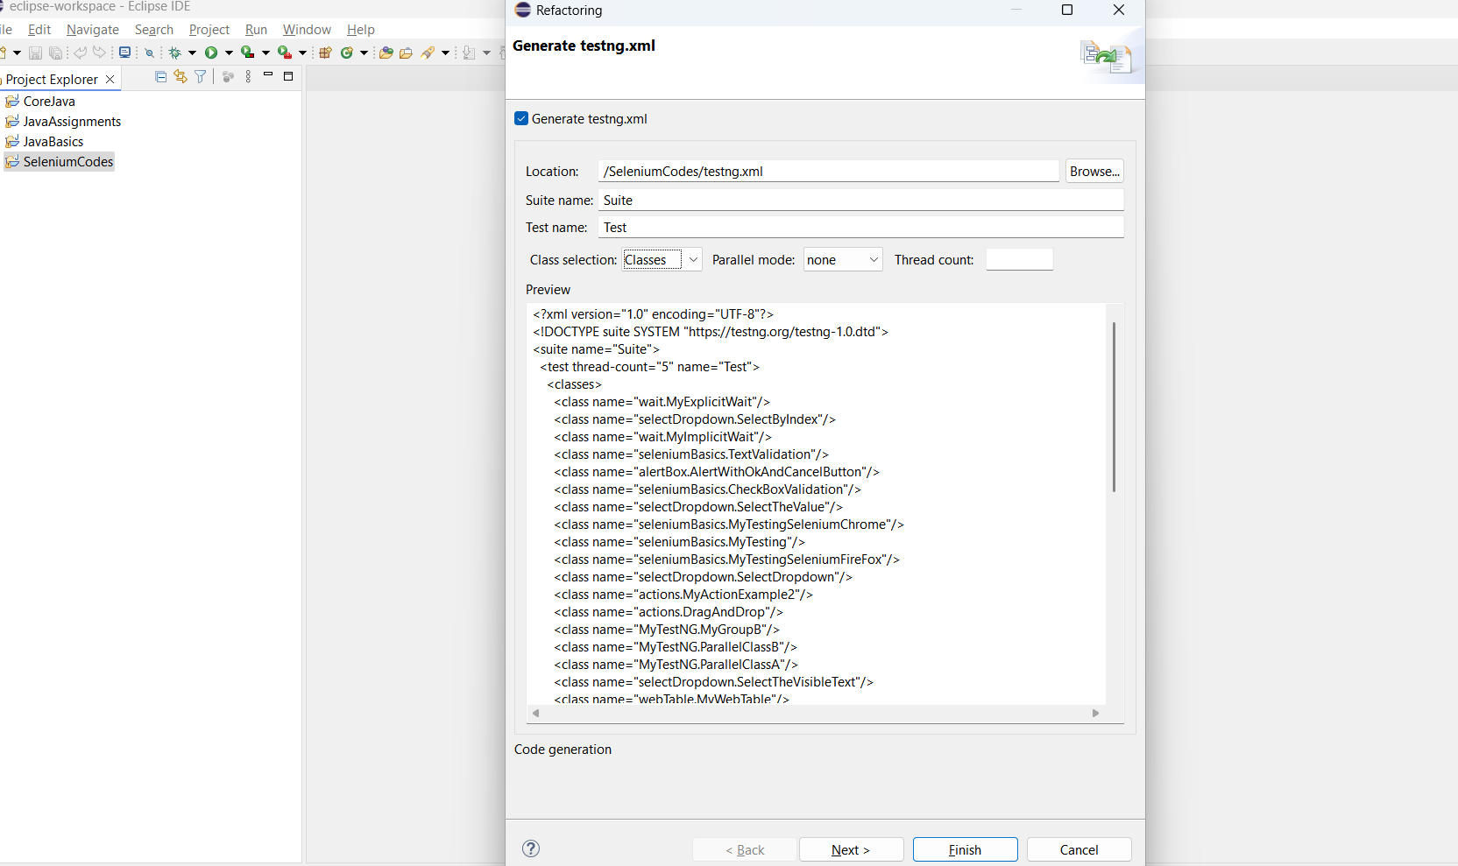

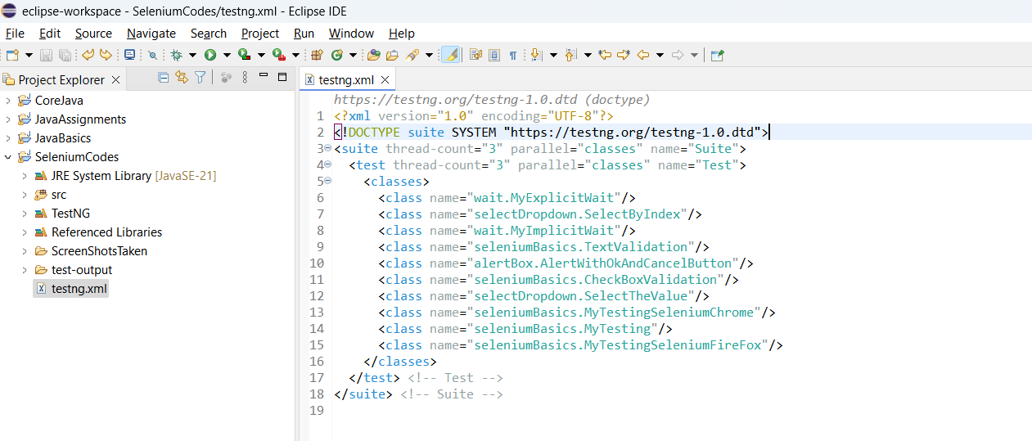

**Annotations:**

(interview questions on these)

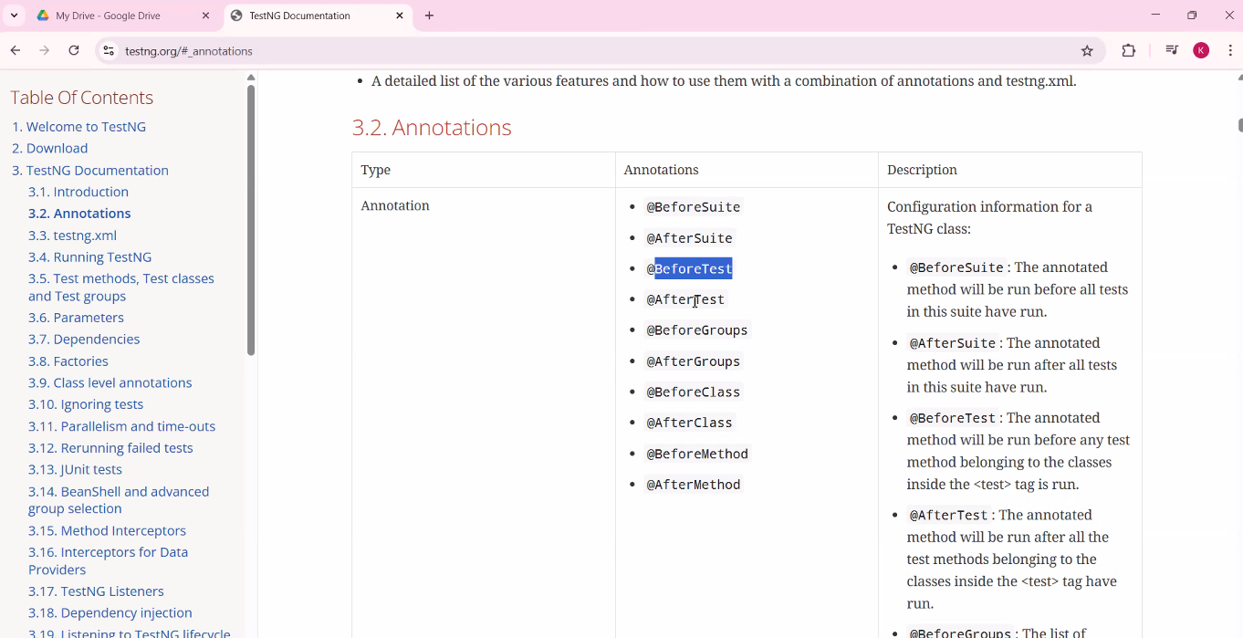

@BeforeSuite - The method marked as @BeforeSuite is going to run before the execution of the entire suite starts.

@AfterSuite - The method is going to run after the execution of the entire suite.

@BeforeMethod - The method is going to execute everytime before any other / @Test method.  
  
@AfterMethod - The method is going to execute everytime after any other / @Test method.

Example:  
  
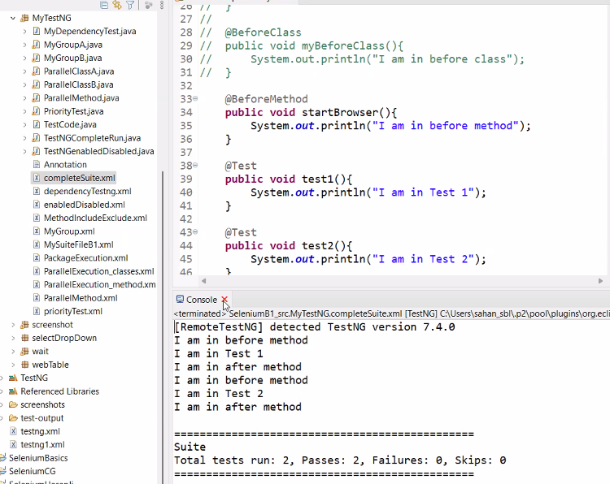

**@BeforeClass** - Before each class, this class will be executed  
  
**@**AfterClass - after each class, this class will be executed.

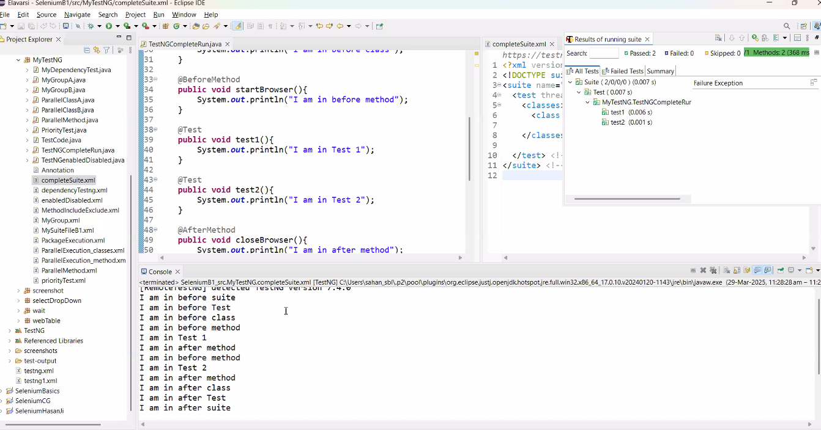  
  
  
**dependsOnMethods -**It means the test methods will get executed if the passed method in the dependsOnMethods is executed successfully. Refer the below example -

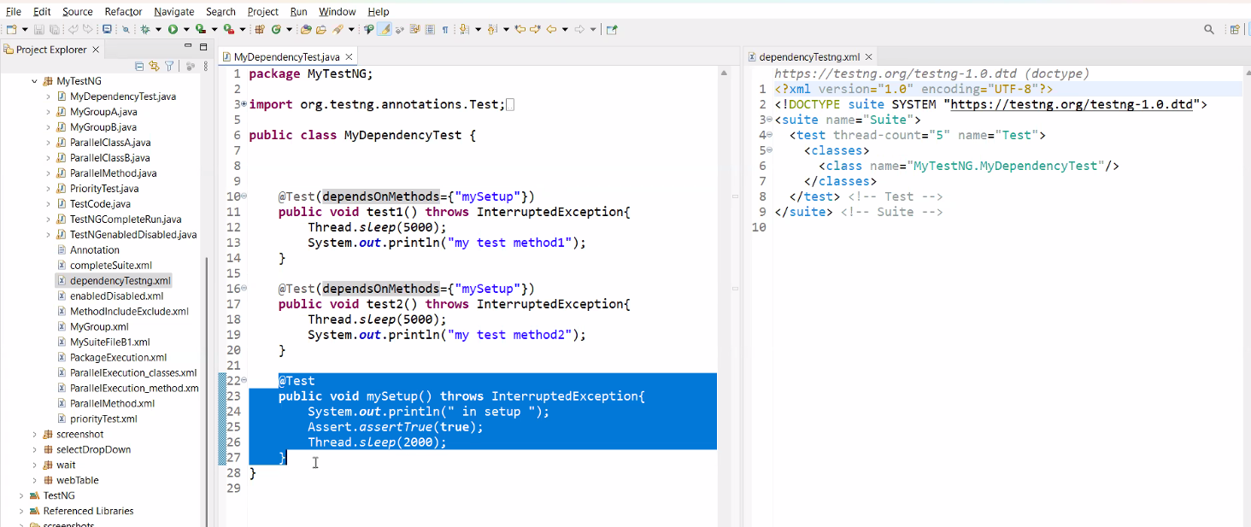  
  
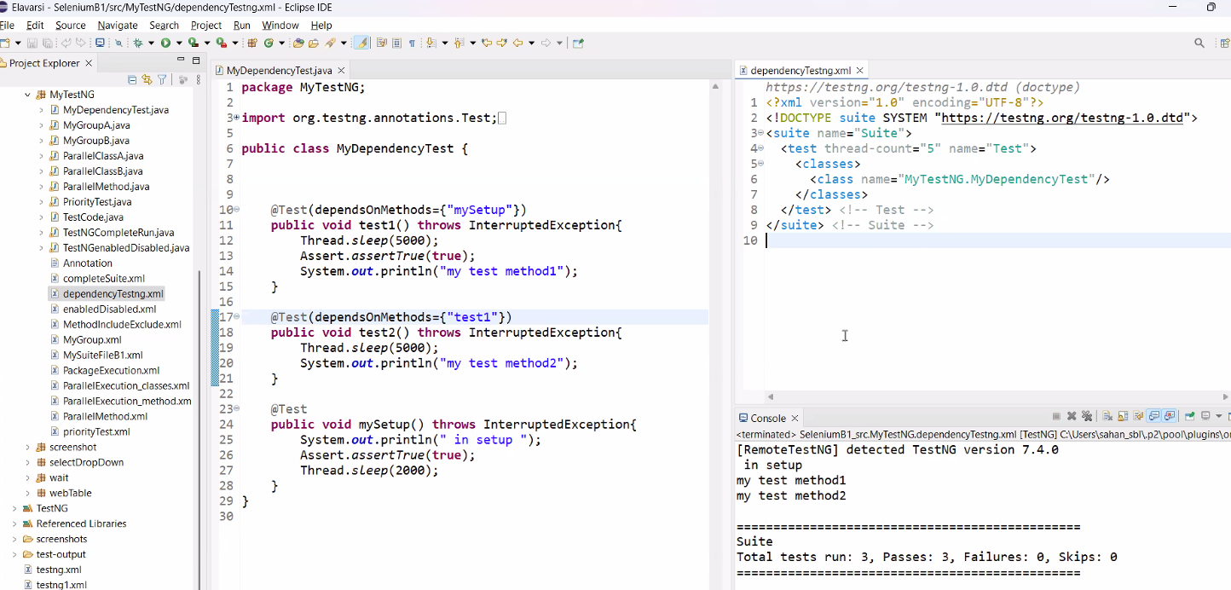

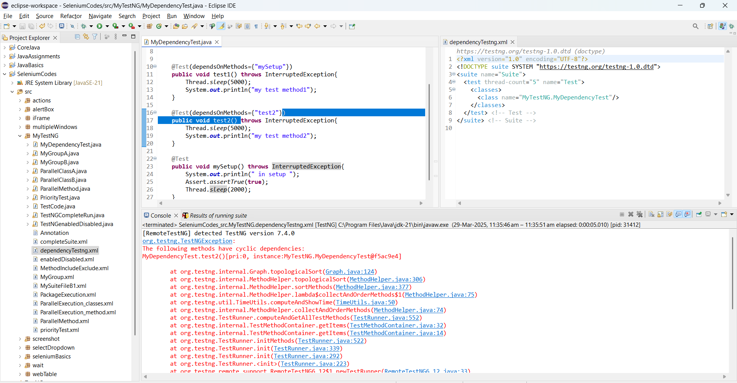

**Group tag:**

Using group tag, we can group the Test cases.

**Priority tag** : we can prioritize the test cases using priority tag.

**Enabled tag** - we can enable / disable the test cases.

**Include / Exclude tags in XML file** - Include marked Methods Test cases will only get executed.

**CLASS 17: (Day 39)**

**Upload File :**

We can’t automate the window’s pop-up directly using selenium.

* Only in the case we can automate the window’s pop-up directly using selenium code -  
  where the input tag & attribute should have type = "file".

